
2025/26
Strive for Excellence
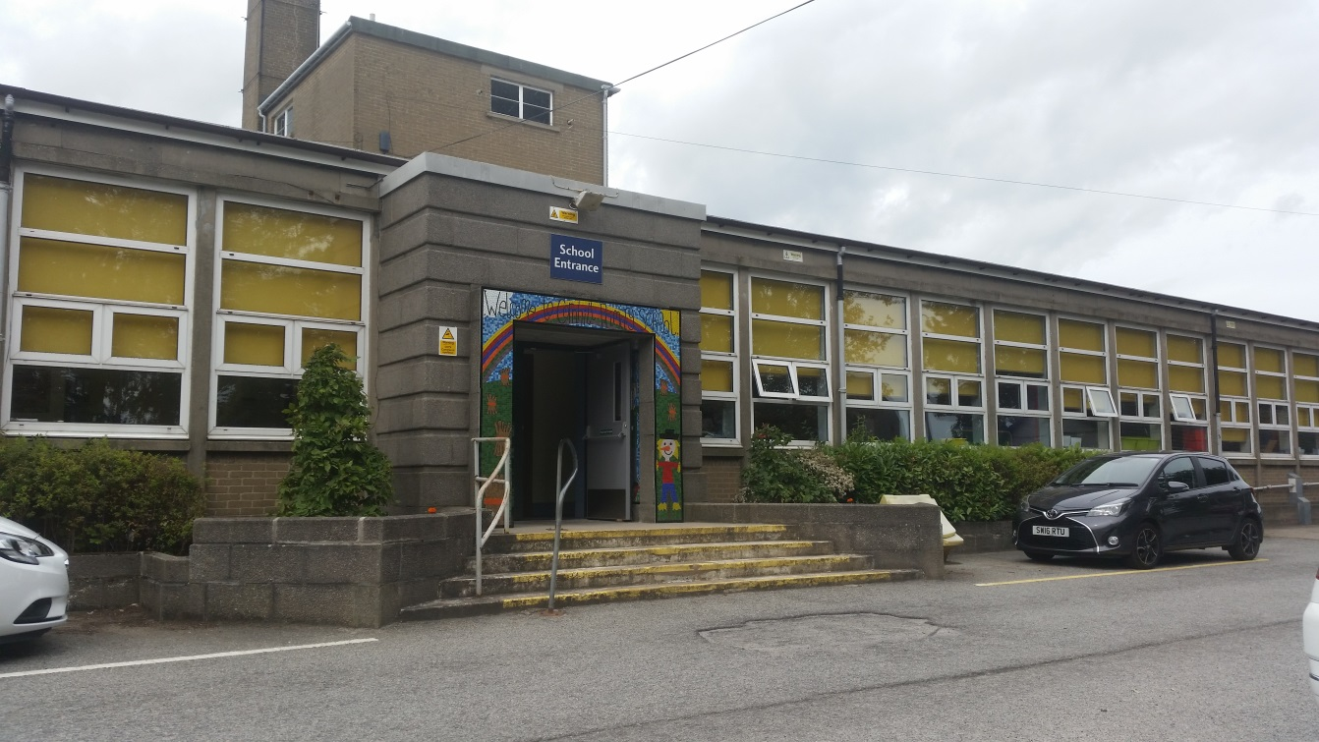
Cornhill Primary School Handbook
Contents
Page
2 | Welcome to our School
Section 1 - General School Information
3 | School Information
5 | School Hours
6 | Attendance, Absence and Punctuality
7 | Communication - emergency closure and emergency contacts
8 | Enrolment – Nursery, Primary 1, other year groups
9 | Induction and Transition
12 | School Lunches
12 | School Playground
13 | School Uniform
15 | P.E. Kit/Mobile Technology and Mobile Phones
15 | Fire Drill
15 | After School Club
Section 2 - Curriculum & Assessment
16 | School Ethos/Aims/Values
18 | Curriculum for Excellence/Curricular Areas
23 | Homework
24 | Pupil Voice & Leadership
25 | Extra-Curricular Activities/Outdoor learning/Instrument Tuition
26 | School Policies/ Attainment, Assessment and Reporting
Section 3 - Pupil Welfare & Support
29 | Promoting Positive Behaviour/Anti-Bullying/Respect
31 | Support for Learners/Additional Support Needs
33 | Child Protection & Safeguarding
33 | Health care
35 | Insurance
35 | Playground Safety and Security
Section 4 - Parent Involvement
36 | Parent Council/Parent Helpers
Section 5 - School Improvement
38 | Quality Assurance and Improvement Planning
38 | School Priorities
Section 6 - Additional Information
39 | Staff List
41 | Concerns and Complaints
42 | Useful Contacts

Please note that while the information in this handbook is correct at the time of printing, some minor changes may occur by the time it reaches parents.

Welcome to Our School!
At Cornhill School we all strive to create a learning environment in which all children can enjoy and gain as much as possible from their nursery/primary school years, thereby preparing them well for the future and an interest in lifelong learning.
At Cornhill School, every child is important, and we want school to be a happy and meaningful experience where confident and positive attitudes are encouraged allowing pupils to develop independence and ownership over their learning journeys. We value and promote attributes to encourage our learners to be respectful, focused, self-motivated, resilient and inquisitive.
At Cornhill School we are committed to promoting the health and wellbeing of everyone in the school community through our whole school initiatives and our trauma-informed approaches. Community links are a valued part of school life.
We work and develop links with many partner agencies and groups within the community, for example with Active Schools, Mudpies, Rev. Ian Aitken, Barnardo’s and The Russell Anderson Foundation to enrich the learning experiences we provide for our learners.
We recognise the benefits to our pupils, parents, staff and partners when working together and we aim to provide a school in which all adults and children feel welcome and work together in partnership. We have a committed Parent Council, and many parents and community members help as Paired Readers, with outdoor learning experiences, or school trips.
The information in this handbook is designed to familiarise parents with our aims, objectives and organisation. The school specific information should also be read in conjunction with Aberdeen City Council ‘A Guide to Education and Children’s Services 2020/21’ at https://www.aberdeencity.gov.uk/sites/default/files/2019-12/Integrated%20Children%20%26%20Family%20Services%20Guide%202021.pdf
We are always very happy to see or speak to parents to discuss in greater detail any of the general points outlined in this handbook.
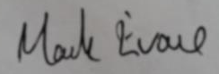
Mark Evans - Head Teacher
Please note – “Parent” includes guardian and any person who is liable to maintain or has parental responsibilities (within the section 1 (3) of the Children (Scotland) Act 1995) in relation to or has care of a child or young person.

Section 1: General School Information

School Information
Cornhill Primary School
Cornhill Drive
Aberdeen
AB16 5BL
Tel: 01224 483234
Email: cornhillprimary@aberdeencity.gov.uk
Website: www.cornhill.aberdeen.sch.uk
School Information Line 0870 054 1999 PIN: 011250
Cornhill School is co-educational and non-denominational and provides up to two years pre-school and seven years of primary education. Cornhill School is part of the St. Machar School Associated Schools’ Group (ASG). Other primary schools in this ASG include Woodside School, Kittybrewster School, Sunnybank School, Seaton School, Riverbank School and St. Peter’s School.
Cornhill School was built in the 1950s. The current school roll is approximately 400 pupils and is organised across 16 classes. There is a Nursery roll of 120 pupils organised into 3 Nursery classes incorporating a range of times and termly patterns.
The management team consists of the Head Teacher, two full time Depute Head Teachers, and a Principal Teacher, all of whom have some class teaching commitments.

Head Teacher – Mr Mark Evans
(1.0) Depute Head Teacher– Mrs Beki Bennett
(1.0) Depute Head Teacher – Mrs Kerry Lawrinson
Principal Teacher (Nursery) – Miss Gillian Devlin
The school staff comprises twenty-two full or part-time Teachers, a Nursery team of fourteen, a team of fourteen part-time Pupil Support Assistants (PSAs), a permanent PE specialist, a Barnardo’s worker, and instrument tutors for guitar and drums. The office staff consists of the school administrator and a part-time office support worker.
The school works closely with a range of other support agencies and volunteers in order to provide the best possible experience for children with additional support needs. PSAs work in classes with children and supervise the children at lunch and break times. The Active Schools Coordinator, along with RADS and our PE Specialist, provide a range of additional active and sporting activities for the children after school and across the St. Machar Associated Schools Group.
The main school building houses two of the three Nursery rooms, sixteen classrooms, an Enhanced Learning Room called The Den, a Nurture Room called The Hive, two small breakout rooms for group learning, and a gym/dining hall.
Nursery 3 is located in a separate, demountable building in the playground behind the Infant classrooms.
All children, from Nursery to Primary 7 make frequent use of the school playground and have access to the school garden and the adjoining playing field.

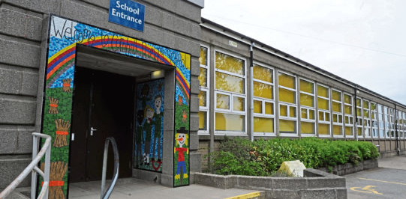

School Hours
All classes commence at 9.00am and finish at 3.00pm. Dinner times are staggered with each class having 45 minutes at either 12.00-12.45pm, 12.15-1.00pm, or 12.30-1.15pm.
Break for all Primaries is 10.30 – 10.45am.
Nursery 3, Morning Class: Drop off at 8am/8.30/9.00 and pick up between 12.30 and 12.55pm. Nursery 3, Afternoon Class: Drop off between 1.00 and 1.15pm and pick up any time up until 5.55pm.
Nursery 1&2, Full Day Class: Drop off between 9.00 and 9.15am and pick up between 2.40pm and 3.00pm. (Term time only)
Please note that the school car park is for staff use only. Children should never walk through the school car park. Parents and visitors must report and sign in at the main door / reception when arriving and leaving the school.
From 9.00am until 3.00pm the playground is used by the school classes for P.E. and outdoor learning. Please walk through the playground (no scootering or cycling) and keep young children near to you for their safety and the safety of the children in school. Please ensure dogs are kept on a secure leash, remain outside the playground boundaries, and are always within your control. Please pick up and dispose in the bins of any faecal mess caused by your dog. It is Aberdeen City Council’s policy that no pets should be allowed into any part of the establishment, and this includes playgrounds and car parks.
Parents are reminded that they must never stop on the zig-zag lines outside the gates when delivering or collecting a child. We actively encourage children to walk to school for safety and health reasons. Roads around the school become very congested at the start and end of the day. Please refer to our Travel Plan https://cornhill.aberdeen.sch.uk/policies-2/school-policies/
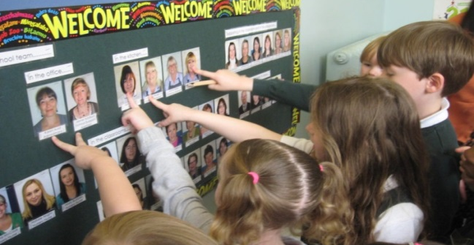
Attendance, absence and punctuality
The Education (Scotland) Act 1980 requires parents to ensure that their children receive a suitable education from the time they are five. This is normally provided through attendance at school and parents have a duty to ensure regular attendance. We ask that parents ensure that children attend school punctually as we are required to record all late arrivals to school.
Please let us know about any absence your child may have by telephone on the day or by letter in advance. A telephone call is particularly important if your child is absent in the afternoon, having attended school in the morning. Similarly, notice is required for any withdrawal of your child during school hours and a parent, or their representative, must report to the school office to collect the child. For reasons of safety, pupils are not allowed to leave school by themselves during the school day.
Schools have a statutory duty to record the attendance and absence rates of pupils. This includes both authorised and unauthorised absences.
An authorised absence is identified as an absence due to:
• bereavement
• education in another establishment
• sickness/ill health (including visits for medical appointments)
• certain sporting/artistic/cultural/religious events
Except in very exceptional circumstances family holidays taken out with the normal school holiday period will be classified as unauthorised absence. Exceptional circumstances include a written confirmation from the employer that holidays must be taken during term time. Parents should still notify the school of the intention to take children out for family holidays.
In the interests of the children’s safety, it is our policy to follow up all unexplained absences. If a child is going to be absent parents are asked to telephone the school before 9.30am. Any unexplained absence is followed up with a phone call to the parents or emergency contact.
We follow the Local Authority attendance procedures which may include (but are not limited to) letters being issued, and communication with the Home School Liaison Officer.

Communication
Parents are kept informed about school life via newsletters which are sent out as emails at regular intervals. Please ensure you have provided your up-to-date email address. Copies of newsletters are also posted on the school website http://cornhill.aberdeen.sch.uk/
Our website is updated regularly, and each class has its own Seesaw app (Nursery-P6) or Google Classroom (P7) to further share information.
Through the GroupCall messaging system, we use text and emails to keep parents informed of events and school updates. At the main entrance there is a parents’ notice board and outside the Nursery a whiteboard is used for information to parents. Details of Term/Holiday/In-Service Days are sent home in the regular newsletters and also appear on the Council website. https://www.aberdeencity.gov.uk/services/education-and-childcare/view-school-term-and-holiday-dates
Parents’ Appointments and Open Afternoons are arranged via Google Classrooms (following notification through GroupCall) to select preferred day/time, and allocated times sent out following the timetabling of this.
Parents are always welcome to visit the school and we would urge you to contact us immediately if something is causing concern. Informally, parents can communicate through a note, phone call or by talking to the Teacher at the end of the school day. Also, please feel free to use your child’s reading jotter or diary if they have one, to communicate with us if necessary.
Regular and Emergency Contact Details
It is very important you provide the school with a daytime contact telephone number along with the address and telephone number of a neighbour, relative or friend who could be contacted if you are unavailable. Contact detail forms are issued each year, and all parents are asked to notify the school of any changes that occur throughout the year. This is very important especially with mobile numbers which are often changed.
Emergency Closure
In the event of adverse weather conditions, parents should listen to local radio for information as to school closures or contact the Council website: www.aberdeencity.gov.uk/closure or school information line 0870 054 1999 pin code 011250 for further information regarding attendance that day. If weather conditions deteriorate during the day, or if there is a power failure, the Head Teacher may make a decision to close the school. Parents will be contacted through GroupCall and/or telephone to make arrangements for their child to be collected.
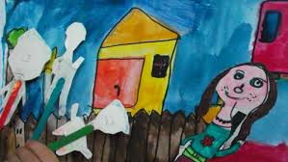

Enrolment
https://www.aberdeencity.gov.uk/sites/default/files/2020-08/Integrated%20Children%20%26%20Family%20Services%20Guide%202021%201.2_2.pdf
https://www.aberdeencity.gov.uk/services/education-and-childcare/apply-school-place

Permissions, Admission Forms and Data Protection
Upon joining the school, parental permission is requested to:
- Allow photos of your child’s work or themselves to be taken and displayed to show good practice and to celebrate achievements on school boards and on the school website.
- Allow your child to take part in local outdoor learning experiences in line with ACC Visits Policy
When your child starts school, you will be asked to provide information about them on an admission form. The admission form includes a data protection statement which is in line with local and national standards and guidelines.
More information can be found in ’A Guide to Education and Children’s Services’ at https://www.aberdeencity.gov.uk/sites/default/files/2018-01/A%20Guide%20to%20Education%20and%20Children%27s%20Services%202018-19_0.pdf
Primary and Secondary zones
All schools in Aberdeen serve a local ‘zone’. Parents are advised that they should always check the zone in which their existing or proposed address lies. This can be obtained from https://www.aberdeencity.gov.uk/services/education-and-childcare/find-school Parents should make a placing request if they wish their child to attend a school out with the zone in which they live. Placing requests are available on https://www.aberdeencity.gov.uk/services/education-and-childcare/apply-school-place
Nursery Class
Enrolment for nursery takes place annually in January and February. A child may start Nursery in the school term after his/her third birthday. The authority advert in the local newspaper will notify parents that applications will be taken throughout January although late applications are accepted. Apply online here; Apply for a School ELC/Nursery place https://www.aberdeencity.gov.uk/services/education-and-childcare/apply-school-elcnursery-place
Places are allocated in line with the authority policy and a waiting list is kept for unsuccessful applicants. Priority is given to children who live within the school’s catchment area, and then places are offered in order of age.
Primary 1
Children who have their fifth birthday on or before the last day of February may enrol for Primary 1 commencing in August. In January the Authority places an advert in the local newspaper to give notification of the enrolment week. Parents should then follow the online instructions at
https://www.aberdeencity.gov.uk/services/education-and-childcare/apply-school-place
Advice and help are available at your nearest library if needed.
Children who will reach their fifth birthday on or before the last day of February are accepted for Primary 1 in the following August. Parents should note however, that there is no obligation to enrol children until the August after their fifth birthday. Parents should enrol their children in the appropriate week in January (see local press) or any time thereafter.

All other classes
Pupils can be accepted for all other classes at any time throughout the year, whether or not they live within the catchment area of the school, provided there is a place available at that stage. Those not resident in the catchment area must complete an out-of-zone placing request. When joining Cornhill School from another school, a visit to the school can be arranged to allow parents and children to receive a short tour of the school and meet some staff members. This is usually carried out by the Head Teacher.
https://www.aberdeencity.gov.uk/services/education-and-childcare/apply-school-place
Class organisation
There are two classes at each stage, with additional composite classes at P1/2 and P3/4. Maximum pupil/teacher ratio is 1:25 in P1/composite classes, 1:30 in P2-3, and 1:33 in P4-7. The structure of classes, particularly the need to create composite classes, must be continually reviewed within current staffing guidelines.
Induction and Transition
We take great care to make the transitions from Nursery to Primary, from stage to stage in Primary and from P7 to Secondary as seamless and as positive an experience for all as possible.
Starting Nursery
Parents and children meet with nursery staff and children attend for a short visit with a parent staying and then on their own for increasing lengths of time, building up to full sessions. Parental support is valued for helping each individual to settle and enjoy the experiences on offer.
Starting P1
Parents should go to the school website for information about starting P1, details of where to buy uniform, the school lunch menu, etc. The website will have welcome videos of P1 teachers introducing themselves and reading a story to the children which it is useful to share with children in the lead up to starting P1.
Before the summer holidays, parents will have an opportunity to see round the classrooms, lunch hall etc. Also, an email will be sent giving the date for a morning induction visit for children in August before a week of half day attendance and then full-time attendance. For children not at our nurseries, an additional visit and an opportunity to sample a school dinner will be offered before the summer holidays. (Nursery 3 afternoon children can also sample a school dinner; details will be sent out.)
Primary 7 to S1
On leaving Cornhill School in Primary 7, most children transfer on to St. Machar Academy:
St. Machar Academy,
St Machar Drive,
Aberdeen, AB24 3YZ
Tel: 01224 - 492855
Email: stmacharacademy@aberdeencity.gov.uk
Website: www.st-macharacademy.aberdeen.sch.uk
Parents should note that attendance at Cornhill School does not guarantee admission to St. Machar Academy for those who do not reside in the catchment area. Out-of-zone children are required to make a placing request through https://www.aberdeencity.gov.uk/services/education-and-childcare/apply-school-place
Throughout the year, we liaise closely with St. Machar Academy staff, and they come to talk to our P7 pupils and P7 Teachers. In addition, P7 generally have a 2-day orientation visit to the Secondary school which they are moving on to along with additional half-day events through the session.
We work closely with St. Machar staff to provide enhanced transition programmes for those children requiring extra support in the move to S1. Should you have any concerns about your child moving to S1, please contact the P7 class teacher in the first instance.

Between classes at each primary stage
Prior to moving onto a new year group, Class Teachers will meet to share and pass on relevant learning, and personal and social information about each child. Records, assessments, reports and samples of work are passed on to ensure continuity in the child’s learning. At the start of the school year, there is an Open Afternoon and Evening for parents to visit their child’s new classroom and meet the new Teacher informally, prior to the parents’ evening consultations later in the session.

School Lunches
Children may bring packed lunches to school or purchase a school meal. Children in P1-5 can receive a free school meal. P6 -7 children pay for school meals using the Parent Pay system (though some P6-7 pupils may receive free meals based on income. Application forms are available online at https://www.aberdeencity.gov.uk/services/education-and-childcare/school-life/apply-free-school-meals-and-school-clothing-grant
A dinner costs £2.35 and this can be used to purchase cold or hot lunches with dessert/fruit/cheese and biscuits. A form is sent home annually to establish any food allergies experienced by your child; it is crucial that this is filled in, returned and kept updated so that the Kitchen Staff may inform their system and only offer food allowed.
Menus are available from the school office or online at http://www.aberdeencity.gov.uk/schoolmeals/
Children who go home for lunch are expected to return just at the end of the lunch break in time for lining up.

School Playground
The children are supervised during playtime and lunchtime by our team of PSAs. During lunch/break times children will be expected to play outside unless the weather is excessively wet or windy. Children should be sent to school with appropriate outerwear to suit the time of year.
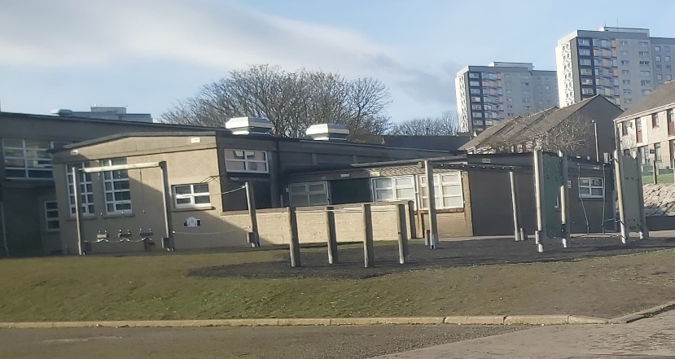
If your child has an accident in the playground, he/she will be treated by a PSA. If your child has bumped their head they will be given a head injury letter, which will inform you of the nature of the injury and the treatment given. We will attempt to notify you by telephone of any serious injuries. (Please ensure that you keep the school updated of any change in your emergency contact details/ new mobile phone number.)

Uniform
We expect pupils to be neatly dressed at all times. There is a school uniform and we actively encourage pupils to wear it. Good quality green sweatshirts, printed with the school logo, along with white polo shirts similarly printed, can be obtained at reasonable cost from https://myclothing.com/collections/cornhill-school-16684 (select our school via the search bar). The Parent Council also run a ‘swap’ system whereby old uniforms may be donated and swapped, or a uniform taken for a minimal donation/free.

We have chosen a simple uniform that is readily available at any main store, apart from items with the school badge:
Grey or black skirt, shorts, trousers (not leggings) or pinafore;
White polo shirt / shirt / blouse;
Green school sweatshirt /cardigan. We do not allow ‘hoodies’ to be worn in school other than the P7 Leavers’ Hoodies in the final term only.
An old shirt or painting smock is advised for art and craft work.
All school clothing should be clearly labelled with the child's name. In the interests of comfort and cleanliness, if your child wears boots to walk to school, they may opt to bring a pair of well-fitted gym-shoes (‘gymmies’) or an old pair of trainers to change into upon arrival.
On safety grounds, hooped or dangling ear-rings should not be worn. If jewellery of any value is worn the school cannot accept responsibility for its loss. We would also ask parents to support us in discouraging the wearing of clothing with fashion labels or distinctive logos.
Some families may be entitled to a school clothing grant.
https://www.aberdeencity.gov.uk/services/education-and-childcare/school-life/apply-school-clothing-grant

P.E. Kit
A P.E. kit is also required and should include a change of t-shirt (not a football or fashion t-shirt), either shorts or jogging/tracksuit bottoms (not fashion leggings/shorts or football strips), and appropriate footwear (trainers or gym shoes that fit well and do up securely).
P.E. kit should not include zippers, sequins or other embellishments as they are a safety hazard. Children should not wear any vest tops or crop tops, any type of football kit, jeans or denim.
Earrings and other jewellery are not permitted to be worn during P.E. In line with guidelines, it is expected that children remove their piercings independently, or simply not wear them on P.E. days.
Children should wear PE kit on gym days but must also wear their school jumper on top.
Below are some good examples of P.E. Kit.
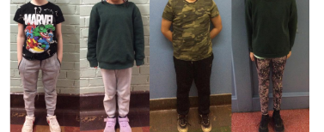

Mobile Technology and Mobile Phones
We prefer children not to bring mobile phones/devices to school as we cannot guarantee their safe keeping and accept no liability for any loss, theft or damage. If you feel your child needs to have a mobile phone in school, it must be switched off during school time and be kept in the school office or in a box by the class teacher (this includes Smart watches that can send or receive texts and/or calls, or can take, send or receive media). Please refer to our Mobile Phone Policy https://cornhill.aberdeen.sch.uk/school-policies/

Fire Drill
Fire drill notices are displayed prominently throughout the school. A fire drill is held at least once a term and a short test is carried out every Friday morning at 8.30 a.m. All visitors to the school are asked to familiarise themselves with the location of fire exits.

Breakfast Club/After School Care
The After School Club and Breakfast Club are operated within the Community Centre attached to Cornhill School. Breakfast Club is 7-9am and Afterschool Club is 3-6pm. Contact: Mandy Burnett on 07557191764 or by email MaBurnett@aberdeencity.gov.uk

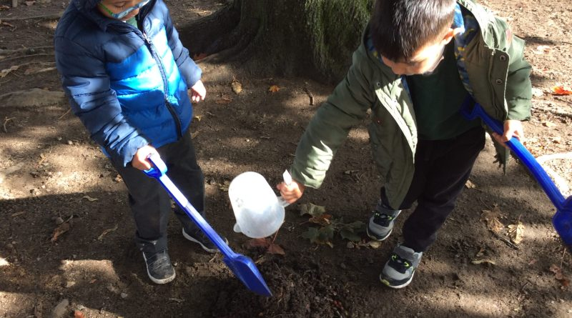

Section 2: Curriculum and Assessment

School vision, values and aims
Motto: Strive for Excellence
Vision: Cornhill is a nurturing, welcoming, positive, and inclusive learning community where everyone feels safe and listened to; where learners, staff and parents work together for the best outcome for all. High quality learning experiences, along with dedicated pastoral care is ensured to allow everyone in our learning community to reach their potential.
Values: Learners at Cornhill School are Respectful, Focused, Self-Motivated, Resilient and Inquisitive.
Aims:
- We aim to provide an inclusive, stimulating and flexible curriculum that creates opportunities for each learner to be challenged and to achieve their full potential. We encourage healthy, active lifestyle choices, promoting enjoyment, happiness and wellbeing.
- We aim to involve our learners in decision making, encouraging them to take responsibility in their learning journeys and to develop leadership skills, whilst regularly celebrating their achievements and successes.
- We aim to practise a restorative and trauma-informed approach to support learners to develop self-regulation strategies, to encourage respectful interactions throughout the school, and to celebrate positive choices and kindness.
- We aim to consistently support our staff in further learning opportunities; creating a friendly, committed team who communicate well, and evaluate and reflect upon their practice.
- We aim to work in partnership with families, the wider school community and other agencies to enrich our learners’ experiences and equip them with the skills and enthusiasm for life-long learning.
Curriculum for Excellence is Scotland’s education guidelines for all 3-18 year olds – wherever they learn. It aims to raise standards, prepare our children for a future they do not yet know and equip them for jobs of tomorrow in a fast changing world. Curriculum for Excellence enables professionals to teach subjects creatively, to work together across the school and with other schools, to share best practice and explore learning together.

Teachers share information to plan and track a child’s ‘learning journey’ from 3-18, helping their progression from Nursery to Primary, Primary to Secondary and beyond, ensuring the change is smooth. They ensure children continue to work at a pace they can cope with and with challenge they can thrive on. Curriculum for Excellence balances the importance of knowledge and skills.

The curriculum is designed to enable all young people to understand the world they are living in, reach the highest possible levels of achievement, and equip them for work and learning throughout their lives. It links knowledge in one subject area to another helping children understand the world and make connections. It develops skills so that children can think for themselves, make sound judgements, challenge, enquire and find solutions. Teachers use a range of ways to assess progress and ensure children achieve their potential.
The curriculum can be described as ‘the totality of all that is planned for children and young people throughout their education’ and it includes:
• The ethos and life of the school as a community – this includes the work of the Houses, Champions, Buddies, P7 Prefects and the Pupil Council;
• Curriculum areas and subjects – sometimes as discrete curriculum subjects, sometimes in project based activities, sometimes taught by class teacher and sometimes by a visiting specialist;
• Interdisciplinary learning – this includes project activities, Champions and House challenges, where children work in mixed stages across the school;
• Opportunities for personal achievement – how we celebrate, encourage and promote achievement for all, how we provide opportunities for personal interests, and how the pupils’ lead their learning and decision making in school.
The principles of challenge and enjoyment, breadth, progression, depth, personalisation and choice, coherence and relevance underpin Curriculum for Excellence and all learning experiences at Cornhill School. Ultimately, Curriculum for Excellence aims to improve our children’s life chances, to nurture successful learners, confident individuals, effective contributors, and responsible citizens.
Parents are kept informed and involved in the curriculum in many different ways throughout the year such as through newsletters, open days, invitations to watch performances, SeeSaw app, Google Classroom, at Parents’ Evenings, through involvement in the Parent Council, helping in school, through questionnaires and curriculum information evenings and when attending induction events.

Curriculum for Excellence/ Curricular Areas
The following paragraphs outline very briefly what we aim to do in the different areas of study. There is a particular focus on Numeracy, Literacy, Health and Wellbeing and children are taught to make connections between aspects of learning and understand how they learn and how they will use that learning. In Nursery and the early years of Primary, the children learn as much as possible through play and, throughout the school, we promote active learning and employ a range of approaches to meet the different learning styles of our pupils. Our Curriculum Rationale is available on request. Should you like further information about the Curriculum for Excellence, please see; https://education.gov.scot/curriculum-for-excellence/curriculum-areas/

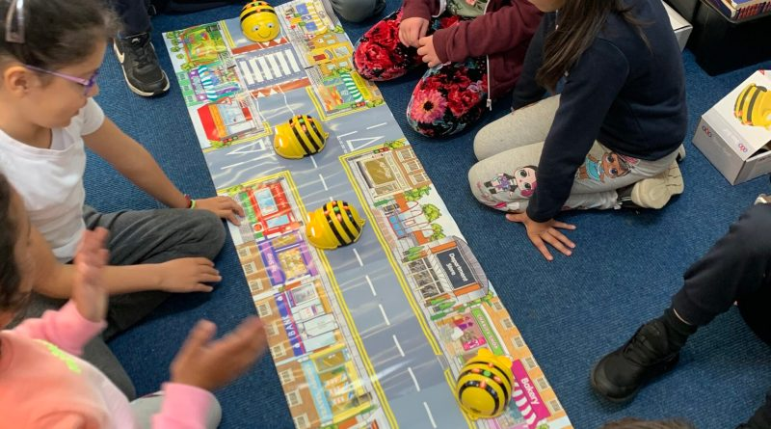

Literacy
Literacy consists of Reading, Writing, Talking and Listening and these are very closely linked in the learning process. Children are encouraged to listen carefully and effectively, talk confidently and fluently, read with understanding and enthusiasm and write with expression and accuracy. Literacy is promoted across all areas of the curriculum.

Modern Languages in the Primary School
Through the 1 + 2 initiative, all stages learn French. The Scots/Doric language is valued in school.

Numeracy and Mathematics
Numeracy and Mathematics comprises:
- Information Handling - gathering, organising, displaying and interpreting data
- Number, Money and Measurement - learning to add, subtract, multiply and divide, as well as to work with money, time, length, weight, area and volume
- Shape, Position and Movement - learning about the properties of two and three dimensional shapes, and to comprehend position and movement
In each of these aspects, children will develop problem solving and enquiry skills. We place a strong focus on the development of mental maths skills from Nursery to P7 and, as such, use a range of practical resources.

Health and Wellbeing
We are a Health Promoting School and the health and wellbeing of everyone in our school community underpins everything we do.
Health is an integral part of the curriculum and children are encouraged to develop healthy lifestyles. The Health programme focuses on:
• mental, emotional, social and physical wellbeing;
• planning for choices and change;
• physical education, physical activity and sport;
• food and health;
• substance misuse;
• relationships, sexual health and parenthood.
Health and Wellbeing is essentially concerned with the development of life skills. All aspects of a child’s experience at home, in school and out with school and home, contribute to his/her personal and social development. The children are taught from Nursery that healthy eating, exercise, attitude and environment all influence health. We are fortunate to have many visitors from the community who contribute to, and enhance, our Health programme. We aim to provide two hours of Physical Education each week and use both inside and outside play areas for this. A biennial Health Term takes place which involves our wider community, along with a range of partners and agencies.
Children learn about relationships, sexual health and parenthood through themes taught across many areas of the curriculum from Nursery through to P7. Through these themes, we work together with parents, helping the children learn to develop caring, respectful and loving relationships, understand consent, and to keep themselves safe. The programme of learning is carried out in accordance with national and local advice. Parents will be informed when some aspects of the programme of work will be covered and are welcome to speak to school staff and see materials used prior to the teaching. https://rshp.scot/

Science, Social Studies and Technologies
These subjects are explored through project-based activities and also as individual lessons. Learning links are developed across many curricular areas. We aim to provide children with experiences through which they can acquire and develop skills, increase their knowledge and understanding and develop positive attitudes, through open-ended and enquiry-based learning. ICT permeates the curriculum. We have Chromebooks, Laptops, IWBs and iPads, which are used across Nursery and school to integrate ICT throughout the whole curriculum.

Expressive Arts
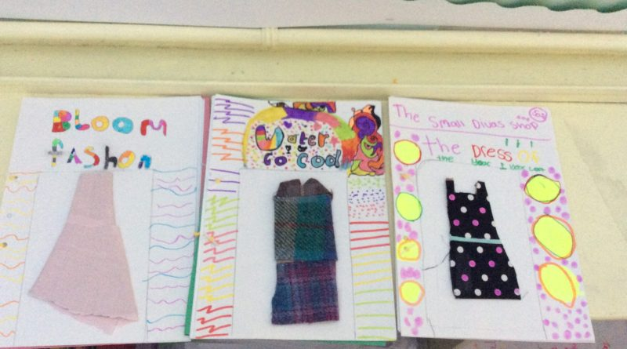
We aim to provide opportunities to enable all children to appreciate different forms of expression and to be confident and capable of self-expression through all areas of creativity. In addition to class lessons in Music, Art & Design, Dance and Drama we try to ensure that every pupil has the opportunity to perform for their peers and parents every year in assemblies and shows. Pupils from P3 – P7 have the opportunity to learn to play an instrument through visiting tutors.
Religious and Moral Education
Education is about the development of the whole person. Religious and Moral Education deals with the development of the person in relation to self-awareness, relationships with others, beliefs, values, attitudes and practices which for some are characterised by religion.
The three components of Religious and Moral Education are:
- Christianity
- Other World Religions
- Development of Values and Beliefs
Throughout the school, there are opportunities for pupils to learn about aspects of Christianity, Other World Faiths and to reflect upon their own moral standpoint in relation to world issues, and to develop empathy. During weekly school assemblies led by the staff and pupils, we encourage awareness of matters of a cultural, social and moral nature through planned themes with links to local and global events. We aim to develop in our pupils an ethos of tolerance, understanding and respect for the beliefs and customs of others. The school minister, Mr Ian Aitken, visits school to support Teachers in class and to talk in assembly every term. Should you wish to discuss any of the lesson topics, please contact the class teacher in the first instance.

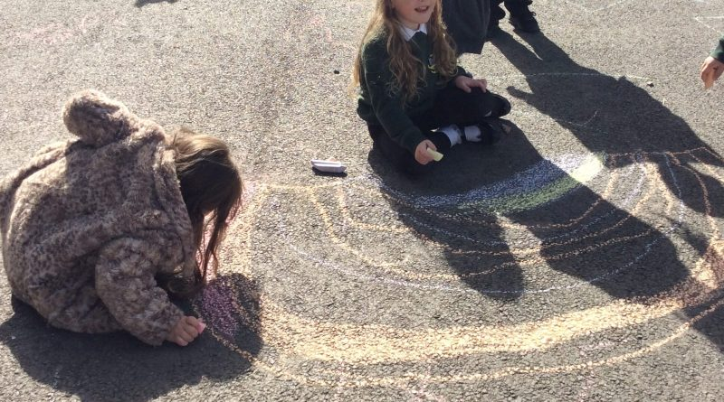

Equal Opportunities and Multi-Cultural Education
In school we strive to promote and reflect good relations between persons of different cultural groups. We respect and value our own and other cultures and show appreciation of their contribution to our daily lives. The school is committed to ensuring equality of opportunity in relation to race, disability, gender, sexual orientation, age, religion or belief and this permeates through all aspects of school life and is taught through our RME, Health & Wellbeing and Social Studies programmes.
Education for Global Citizenship and Social Enterprise
At Cornhill School we promote lifelong learning and encourage everyone in our school community to be active and effective citizens. Our pupils have opportunities to be involved in a variety of activities which help them to develop skills which will enable them to: communicate well with others, work as part of a team, listen well, organise ideas, make decisions, take responsibility, follow instructions, solve problems, stick to a task, cooperate with others, plan things out, resolve conflict, speak confidently and have fun. Activities help children to apply skills learned through the curriculum into real life situations. These are the skills for learning, life and work. The school supports a number of different charities throughout the year as it is important to encourage the children to develop their knowledge and understanding of other countries and local and global issues. The annual Christmas Fair led by the Parent Council, allows all children to participate in enterprise activities.

Eco School
We continue to develop the school’s Eco activities and initiatives in themes such as recycling, litter, health and wellbeing, school travel, school grounds, water and energy. This is done at class level, through Pupil Council or via Assemblies. We continue to develop our garden area to provide a learning area for all to enjoy.

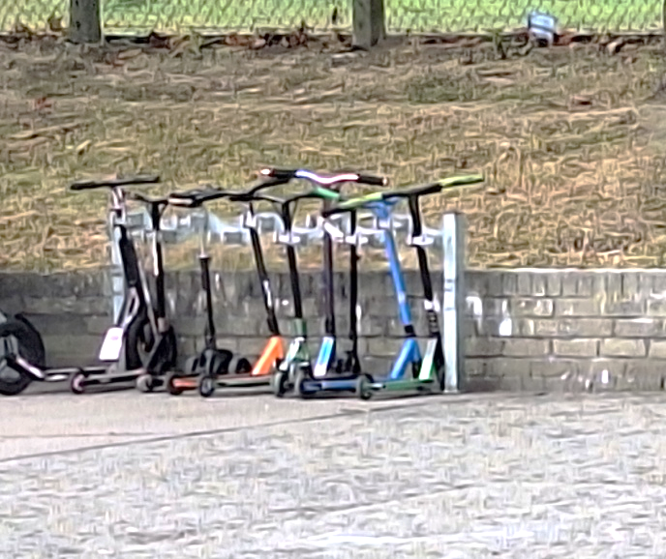
Health Promoting School
•We encourage the children to bring healthy snacks to school. Fizzy drinks and Energy drinks are not permitted. Children are encouraged to bring a water bottle to school and to refill it throughout the day.
•Everyone is encouraged to try to walk or travel actively (cycle or scooter) at least part of the way to school every day. We have both scooter and cycle storage areas for P1-7 children – a chain and padlock are required. All children cycling to school should wear a well-fitted safety helmet.
•It is our policy not to give out rewards of sweets, birthday cakes etc. because, in addition to our promotion of healthy eating, we have many children with food allergies.
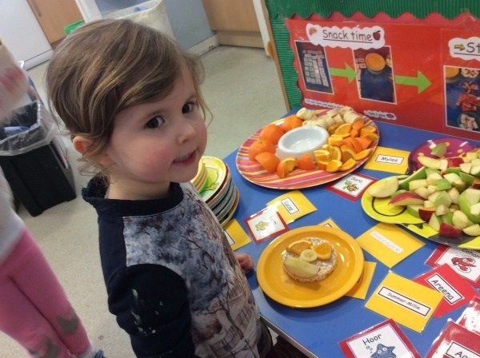
We carry out a biennial Health Term during which we highlight and promote all aspects of health including physical, mental/emotional and sexual health, and spanning areas including healthy eating, exercise, road safety, tobacco/alcohol and drug use, first aid, dental hygiene, handwashing, mindfulness and stress management. Toothbrushing is carried out daily for P1-4.
We work in partnership with the Russell Anderson Development School (RADS) and Active Schools to promote fitness and healthy choices.

Homework
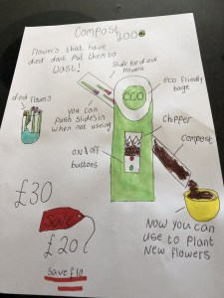
All pupils will have some work to be done at home every week and we appreciate parents’ support in this. It is helpful if parents encourage good work habits by providing a suitable situation for the child to carry out the work.
All homework is set with a purpose and no child will be expected to do at home, work which has not been explained previously. Work will generally consist of a literacy-based activity, a numeracy activity, a Home-Reader book, and tasks based on other areas of the curriculum or life-skills.
Homework instructions are available in your child’s Seesaw/Google Classroom, though paper copies are available on request.
Children are rewarded for bringing in completed Homework and their achievements recognised and celebrated. Parents will be contacted if their child misses homework often.

Pupil Voice and Leadership
We encourage our pupils to be involved in school decision-making and pastoral care through several well-established initiatives. Pupils take responsibility for running Champion groups with support from staff. They report back to assemblies after their meetings to share what they have been taking forward. There are display boards around school on which the Champions also share information.
Each child is also in a House and these Houses meet twice-termly to learn about the United Nations Convention on the Rights of the Child (UNCRC). Houses are led by P6/7 Captains who work with teachers to offer learning across the stages, and they feedback to others at assemblies. Our Houses are Ashgrove, Beechwood, Cairncry, Hilton, Rosehill and Stockethill, and children can earn House Points for positive behaviour around school, which are shared regularly at Celebration assemblies.
Our Pupil Council consists of Reps elected by each class and the pupils meet monthly to explore SHANARRI with the view to making positive changes within their school experience.
Our P6s and 7s help to encourage happy, safe playtimes for the children as they each take a role as a Buddy or Door Monitor. Additionally, our P7 Prefects help monitor children at lunchtime and wet play times. P5 can opt in as Litter Bugs if they choose.
RADS Young Leaders are given leadership training by RADS so they may lead learning with younger pupils during fitness sessions; a skill which they can take on in S1.

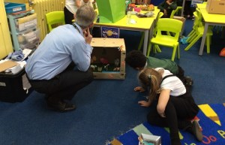

Extra-Curricular Activities
Pupils have the opportunity out with school hours to participate in a variety of activities such as hockey, tennis, netball, football, rugby and SAMS club. The selection of activities depends on the goodwill and availability of staff and parents willing to lead and supervise these sessions. We are always keen to support parents who wish to organise, or help with, any appropriate activities. Active Schools support and organise a wide range of activities for the children from all year groups to enjoy throughout the year.
For more information contact: www.sportaberdeen.co.uk/activeschools
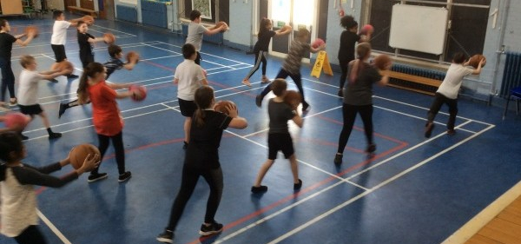

Outdoor Learning and Educational Visits
These are an important part of our school curriculum. Learning happens throughout the school, school grounds and also in the local community. Information about any visit will always be sent to parents and permission gathered where necessary. In order for these trips to go ahead, we require Parent Helpers to support our adult-to-pupil ratios; if too few parent helpers volunteer to accompany the class, unfortunately, the trip will be cancelled.

Instrument Tuition
Provision of instrument instruction is extra to the curriculum and involves release from normal class. Pupils are selected by the tutors involved and the number selected depends not only on aptitude, but also on the availability of tutors and instruments. Fees are paid directly to Aberdeen City Music Centre.

School Policies
School and authority policies are reviewed and updated in line with Curriculum for Excellence, Care Inspectorate and national guidance and requirements. Some policies are found on the school website https://cornhill.aberdeen.sch.uk/school-policies/ such as Child Protection & Safeguarding; Mobile Phone; and Anti-Bullying/Respect policies whilst others are available on request. Please contact the school office if you would like more information about current school or authority policies.

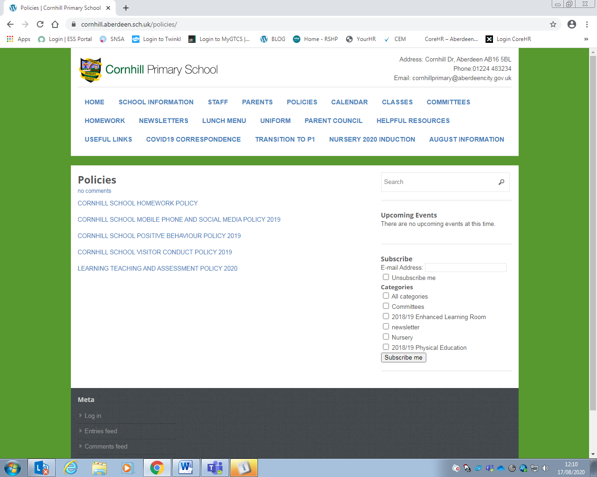

Attainment, Assessment and Reporting
Children work within Curriculum for Excellence levels aiming for breadth and depth in learning. The expectations about progression through the levels are shown in the table below. Teachers meet regularly with their stage partners, the Head Teacher and Depute Head Teachers to plan learning experiences and track children’s progress through these levels;
Early Level: Pre-school year and P1, or later for some;
First Level: To the end of P4, or earlier or later for some;
Second Level: To the end of P7, or earlier or later for some;
Third Level S1 – S3, but earlier for some.

Assessment and Progress Reports
Assessment is an integral part of learning and teaching involving both teacher and pupil in recognising successful learning, identifying next steps in learning and setting targets to work on. Assessment occurs through observation, discussion, questions, and oral/written tasks.
Formative Assessment includes:
• Sharing learning intentions, success criteria/Steps to Success, ideas and expectations;
• Promoting creative thinking skills by using quality questioning techniques;
• Giving constructive feedback to pupils, focusing on improvement;
• Assessing what children make, say, write and do, and planning teaching activities to support future learning.

Children are also encouraged to self and peer assess and to recognise their own strengths and learning needs. Once learning needs are identified, children are involved in planning their own future learning. In addition to this, Teachers set realistically challenging targets for their pupils, helping to ensure that the pace of children’s learning is appropriate.

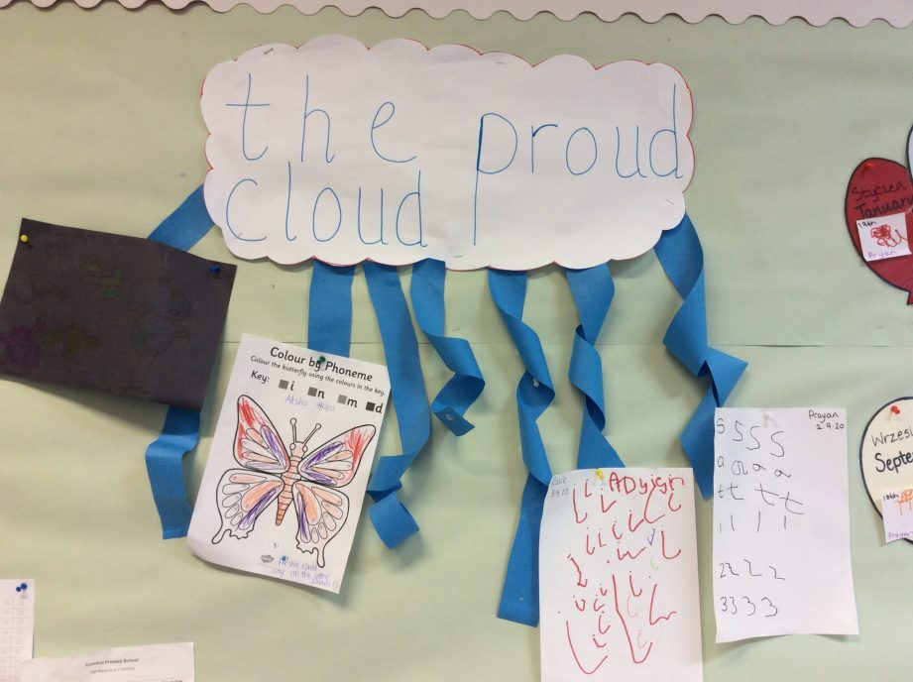
More formal assessments are also carried out to support Teachers’ professional judgement about learning. This may include summative assessment, diagnostic assessment and the use of national assessment resources. The pupils progress through the Curriculum for Excellence levels of Early, First, Second and for some Third, throughout their Primary school career. During this time the children are also signposted as making progress through the levels. All assessments feed back into the learning planned as next steps.
There are two sets of parent consultations; one around October time and one around February. Parents are welcome to make an appointment to speak with a teacher at any time – please phone the School Office or speak to member of the Management Team to arrange an appointment time. All pupils receive a written progress report annually (along with an additional interim report). This report will give parents specific information relating to the levels of attainment and achievement in curricular areas as outlined in the National Guidelines. The report will be based on the ongoing Assessing and Reporting procedures that are presently being utilised within school.
Teacher assessments of P7 learners are shared with the Secondary school each learner attends to ensure effective handover and continuity of learning.

For further information: https://education.gov.scot/media/bwxg5wma/btc5-framework.pdf

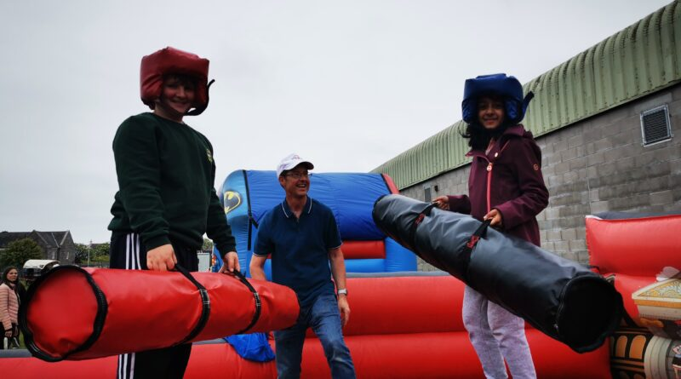

Section 3: Pupil Welfare and Support

Promoting Positive Behaviour
Adults and children at Cornhill School aim to follow the Golden Rules which span across all areas of the school community. Classes also create their own individual class charters. Our Positive Behaviour & Relationship Policy is available on the school website. https://cornhill.aberdeen.sch.uk/policies-2/school-policies/
The Golden Rules
1. Do be gentle, don’t hurt anybody. This means that you keep your hands, feet and other objects to yourself. We keep you safe at school, and so we keep everybody safe.
2. Do be kind and helpful, don’t hurt people’s feelings. This means that you are kind towards other people’s feelings. You don’t like feeling sad, so don’t try to make other people feel sad. Be fair.
3. Do be honest, don’t cover up the truth. This means that you do not lie or tell half-truths. It is important for us to know the whole story, even if you have done something that you regret.
4. Do work hard, don’t waste time. This means that, since you are here to learn, you do your best so that you can be proud that you’re reaching your potential.
5. Do look after property, don’t waste or damage things. This means that you take special care of things that don’t belong to you. Everything in school costs money and we need to share what we have with all the pupils.
6. Do listen, don’t interrupt. This means that you must follow instructions from all adults in the school. You might not agree with an adult’s instruction, but you must follow it until such times that it can be discussed calmly, later.
Discipline is a joint responsibility between home and school. We hope for your cooperation in maintaining the high standard of behaviour we expect. We take a positive approach to promoting responsible behaviour. We recognise and praise good behaviour, effort and application using stickers, Yellow Slips, certificates, Celebration Assemblies, Wider-World Achievements, etc. Evidence of good work is displayed in class and around school. Through the school ‘House’ system, pupils are awarded points in a variety of ways for example for special achievements, good manners or acts of kindness.
Our pupils are expected to have a respectful and considerate attitude towards adults and other pupils. The older pupils are expected to set examples of appropriate behaviour and all are encouraged to care for the school and its environment. The senior pupils model positive behaviour through their role as a House captain, Buddy, Monitor or Prefect.
The way in which pupils and staff relate to each other is vital for the environment we aim to create, and we hope the mutual respect will be obvious to visitors to the school. We expect pupils to go to and from school in a sensible way and be punctual for all activities. Pupils are expected to give careful concentration to the work assigned to the class, whether oral, written or practical, and have the appropriate equipment, materials or clothing for the work being undertaken.
The emphasis is always on positive behaviour management, and we practice a trauma-informed approach to supporting learners with their emotions, using restorative conversations, and a solutions-approach to help pupils to move forward.
Although it is necessary to look carefully at every incident involving unacceptable or unsafe behaviour and to react appropriately to each set of circumstances, the following are some of the consequences to reinforce the message about boundaries of acceptable behaviour in school that are available for use by the class teachers and promoted members of staff:
• Loss of reward time
• An exercise / letter of apology to be completed at home or in school
• Green Slip home/phone call/email to inform parents/carers
• Reflection time during break periods
• Positioned in an individual seating area within the classroom
• Withdrawal from the classroom
• Exclusion from outings
• Exclusion from school teams
• Discipline letter
• Temporary exclusion from school
Most of these consequences are used infrequently and as a last resort. Parents are involved in discussions regarding their child’s behaviour issues at an early stage so that we can then work together to support their child. Where a pupil repeatedly displays behaviours which are unsafe i.e. failing to follow instruction or showing aggressive actions, and where other forms of support and sanctions have proved unsuccessful, the authority exclusion policy will apply.
Anti-Bullying
We have an Anti-Bullying/Respect Policy https://cornhill.aberdeen.sch.uk/school-policies/ which is put into practice by all staff and pupils. It is important that our pupils feel secure and happy at school and so we aim to create an ethos in which everyone understands what bullying is, actively disapproves of it, and takes action to stop it. PSAs, Buddies, Monitors and Prefects are available at playtimes to support pupils and encourage cooperative play. Children are helped to become aware of what bullying is, and to increase their understanding of all the related issues through drama, assemblies and Circle Time discussions.
Our new partnership with Cybersafe promotes discussion between home and school about online bullying, racism, misogyny, sexism and use of sexualised or offensive language. This is supported in class through lessons on Internet safety and conduct.
Parental support and involvement is vital in making our school a happy and secure environment. Please contact a member of the Senior Management Team if you have any concerns.

Additional Support Needs
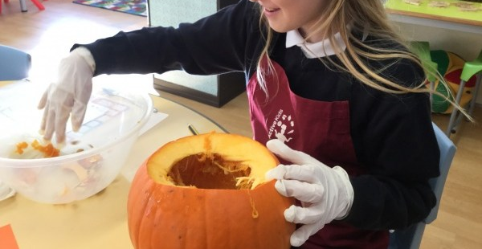
The school’s policy, in line with the Authority’s policy of a presumption of mainstream, is to support pupils with additional support needs alongside their peer group, in their classroom setting. Individually targeted work at a level accessible to the child and designed to support the learning progress is provided by the Class Teacher. Where deemed necessary, the children may be supported individually or in small groups away from the classroom in a quiet setting within the school. They may have support from a PSA, another Teacher and/or other agencies such as English as an Additional Language (EAL). The authority is committed to inclusion and the presumption of mainstreaming, as set out in the Standards in Scotland Schools Act. Education and Children’s services will consider how best to utilise expertise and support from existing services to most effectively support learners over session 2025/26

Many children will face barriers to their learning at some time in their school career. These may be short or longer term and for a variety of different reasons – social, emotional or learning needs. Some children may benefit from having some sort of support plan or Individual Education Plan (IEP) to develop their social, emotional or learning skills. Pupils, parents and staff are involved in developing these plans, helping to identify specific needs and what might be done to help overcome areas of difficulty. If parents have any questions about their child’s progress or wellbeing at school, they should discuss these first with the Class Teacher or Senior Management Team.
The Depute Head Teachers work cooperatively with Class Teachers to support learning. They also advise class teachers and provide suitable materials for use with children of all ranges of ability. PSAs work closely with the Class Teacher to support learning in each class and to support and supervise pupils’ wellbeing during breaks.
We work collegiately with many professionals such as English as an Additional Language staff (EAL), Educational Psychologist (EP), Speech and Language Therapist (SALT), Autism Outreach (AOR), Occupational Therapist (OT), Social Work and the School Nurse and Doctor to meet the developmental and learning needs of our children. The EP offers advice, support and training to staff, pupils and parents. Pupils with educational, emotional or behavioural difficulties may be referred to this service after consultation with parents. We work together to Get It Right for Every Child (GIRFEC) by ensuring a common, co-ordinated approach across all agencies that support the delivery of appropriate, proportionate and timely help to all children as they need it.

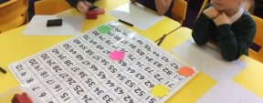

The school’s EP works in partnership with school staff and parents to help children and young people reach their full potential. During planned visits to the school, the EP meets with staff to discuss whole school and class issues and how best to meet the needs of the children and young people. These informal consultations aim to develop strategies the Class Teacher can use to bring about positive change. The EP may also spend time observing in the classroom or playground to support teachers in assessing how different teaching approaches affect learning and behaviour. When concerns persist, the school and EP may feel that a more formal meeting may be helpful. If the concern is about a child, the school will ask the parent’s permission to hold a consultation meeting. This is a problem-solving meeting led by the EP, with parents, school staff and sometimes others who can usefully contribute. The child or young person can also be supported to attend or contribute to the meeting in another way if it is thought appropriate. The aim is to develop a plan of action to bring about positive changes for the child or young person.
There are a range of services to support children with additional support needs (ASN).
Information on Getting it Right for Every Child: http://www.scotland.gov.uk/Topics/People/Young-People/gettingitright

Child Protection and Safeguarding
At Cornhill School, Child Protection is of paramount importance and the safety and wellbeing of our pupils is taken very seriously by all staff. Schools are required to report where it is thought a child has come to harm as a consequence of possible abuse. Each school has a named senior member of staff appointed to be responsible for Child Protection matters. In our school that person is Mark Evans, Head Teacher.
Should you wish to talk further about Child Protection and the safety of children, please feel able to contact us. As a school, we have positive working relationships with medical officers, Social Workers and the Police – any of whom may become involved if abuse is suspected. We will always ensure that you are informed and participate in any action which we may initiate regarding your child. However, where there is a possibility that a child could be at risk, the school is required to refer the child to the Joint Child Protection Unit, Social Work, the Police or the Children’s Reporter, and under these circumstances, the parent may not always be contacted first.
If you hold a concern about a young person’s wellbeing, you can contact the school to talk to a member of the senior leadership team. However, if your concern is out of hours, you can call Social Work on 0800 731 5520, or the Police on 101. If your concern regards the immediate danger of a young person, please call 999 and ask for the Police.
Health Care
Our PSAs are trained First Aiders. Should a child become unwell in school or have an accident, minor first aid will be provided. A parent or emergency contact will be informed as soon as possible should a child need to be taken home or need medical attention. If your child has a head injury, a note will be sent home with your child to notify you of this. If your child uses an asthma inhaler, please give us written confirmation of this with clear instructions as to how and when your child will need to use it; this should match the dose label provided by the GP and printed on the box by the Pharmacist. We recommend that any medication be given before and after school but, should your child require to take medication during school time, you will be asked to complete a form giving detailed instructions of this at the School Office; all medications handed in must be in their original boxes complete with pharmacy labels. Parents are responsible for ensuring dates on medication kept in school are checked regularly.

Free Period Products
Sanitary towels are available in school free of charge for those who require them. They can be taken for weekends and holidays when needed. There are provisions also available at the front foyer and nursery entrance. Aberdeen City Council statement of provision ACC FPP Statement explains how free period products are provided across the city including in our school.

Communicable/Infectious Diseases
In line with advice from NHS Grampian, pupils who are off school because of sickness or diarrhoea should not be sent back to school until 48 hours after symptoms have passed. Pupils must be kept off school for a period of time where they have an infectious or contagious disease.
Please see National Guidance regarding COVID 19.

Medical Examinations
The NHS Grampian School Health Team includes a School Nurse and the School Doctor. They are NOT based in school. They work in close liaison with Teachers and other health professionals such as ChildSmile and Children and Family Mental Health Team to identify any conditions which may have not been previously noted and which may affect a child’s ability to benefit fully in his/her education. Parental consent is sought before health assessments/screening. The programme includes;
- Selective health care review with parent and child (not all children receive this as they are screened for need and seen on that basis);
- Vision screening in pre-school nursery;
- Growth screening by the school nurse in primary 1;
- Dental checks and fluoride applications at various stages.
Insurance
Parents should note that no insurance cover is held by the Aberdeen City Council to provide automatic compensation to pupils for personal accident, whether an accident occurs within or out with the boundary of the school. Insurance of this nature, e.g. personal insurance, life, private medical, is seen as a parental responsibility. It is the parents’ responsibility to insure their child for personal accident or death if they feel it is appropriate.
Aberdeen City Council does hold Public Liability Insurance, which covers the council for any legal liability in respect of claims from third parties e.g. parents on behalf of pupils who have suffered injury, loss or damage arising from the negligence of the council or its employees. However, if there is no negligence, a claim would not be accepted by the council or the insurers.
Safety in the Playground/ Security
PSAs are employed to oversee activities at interval and lunchtime. Parents should be aware that no staff members are available to supervise children before 9.00am or after 3.00pm.
Bicycles (except during cycling proficiency training), skateboards, scooters and roller blades should not be used in the playground during the school day.
A secure door system operates in every Aberdeen school. Any parent or visitor to the school should enter via the main entrance and report to the school office.
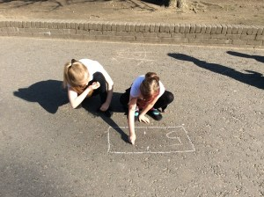

Section 4: Parental Engagement

The Scottish Schools (Parental Involvement) Act 2006 recognises the vital role that parents play in supporting their children’s learning through supporting learning at home, home/school partnerships and parental representation. The role of parents/carers supporting children at home with their learning is crucial and is highly valued at Cornhill School.
At Cornhill School, home/school partnership is developed in many different ways such as through helping with homework, informal contact with Class Teachers, helping in school on a one off or more regular basis, replying to questionnaires or surveys, attending open days, Parents’ Evenings and class assemblies, whole school concerts and productions and curriculum information and induction events. We have many active home /school partnerships but we always very keen to involve all our parents in the life of the school and are always open to new ideas and approaches.
Parents are encouraged to use children’s homework jotters to communicate with staff and are always welcome to make an appointment to speak to a member of staff to express their views.
One of the ways parents/carers are able to express their views is through the Parent Council. Throughout the year, parents will be kept informed of school activities through newsletters, GroupCall, email, Seesaw and Google Classroom.
http://cornhill.aberdeen.sch.uk/

The Parent Council
The Parent Council is a group of parents who volunteer to represent all the parents of children at the school. They meet at least once a term to discuss a range of topics. Parent Councils are very flexible groups and we are always keen to welcome parents to the meetings or to join. Our Parent Council:
- Supports the work of the school;
- Gathers and represents parents’/carers’ views to the Head Teacher, education authority and HMIE;
- Promote contact between the school, parents, children and the local community;
- Is involved in the appointment of senior school staff:
- Set up and run fundraising events.
Parent Councils are recognised in law from August 2007. As a statutory body, the Parent Council has the right to information and advice on matters which affect children’s education. The Parent Council is also entitled to support from the education authority in fulfilling its role. Generally, members of the Parent Council must be parents of children who attend the school, and the chairperson must have a child in the school. However, the Parent Council can decide to co-opt other members from Teachers and the community who will have knowledge and skills to help them.
Any parent interested in joining Cornhill’s Parent Council should contact the Head Teacher or email cornhillparentcouncil@yahoo.com

Parent Helpers
Parents can offer help to the school in a wide variety of ways, from helping organise resource materials to accompanying groups on outings. Whatever expertise you have to offer – we welcome it! Some of our parents volunteer to help in school by accompanying classes on visits, Paired Reading/Maths Support or running extra-curricular activities. If you feel you could assist in an out of school activity or would like to join our rota of daytime helpers, please contact the Head Teacher or your child’s Class Teacher.

On the Family Information Service directory at www.aberdeencity.gov.uk/fis you will find further information on family support, additional support needs, children (pre-birth to 12) and young people (12+).

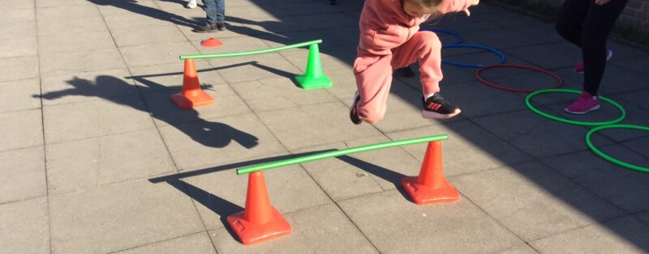

Section 5 – School Improvement
Quality Assurance and Improvement Planning
All schools in Scotland are required to report on Standards and Quality and Improvement Planning on an annual basis; this is shared with parents via the Parent Council and is available on request. The Standards and Quality Report measures school performance against a set of national quality indicators and include information about the main achievements of the school. The report also evaluates progress on the school’s previous year’s improvement plan. School gathers feedback from all parents through a variety of processes such as questionnaires, feedback after events such as a Curriculum Evening, informal feedback, pupil responses and feedback in classes or from pupil groups and from staff throughout the school year as well as through more formal audit processes.
For further information:
https://cornhill.aberdeen.sch.uk/standards-and-quality-report-school-improvement-plan-squip/
https://education.gov.scot/inspection-and-review/find-an-inspection-report/find-an-inspection-report/details?id=2144

Cornhill School Priorities 2025/26
The school prepares an annual School Improvement Plan following consultation with the Parent Council, pupils and staff. These are submitted annually to the authority. National and Local Authority initiatives and developments also inform the School Improvement Plan. The school improvement priorities are available to parents if requested and is available on our website. The six key areas identified in our current Improvement Plan are;
- Literacy
- Numeracy
- Health & Wellbeing/Metaskills
- Digital
- Play-based Learning
- Visible Learning

All teaching and SMT staff members are part of groups who work directly with each of the areas of focus.

Section 6: Additional Information

Cornhill School Staff 2025/26

Senior Management Team:
Head Teacher: Mr Mark Evans
Depute Head Teachers: Mrs Beki Bennett, Mrs Kerry Lawrinson
Principal Teacher: Miss Gillian Devlin
Class Teachers:
Ms Aniqah Begum, Miss Sarah Buckley, Mrs Alison Clementson, Miss Jennifer Cowe, Miss Louise Drever, Miss Sophie Dunbar, Mrs Caitlyn Duthie, Mrs Sarah Fraser, Mrs Jill Garlick, Miss Michelle Grove, Ms Lauren Knox, Mrs Monika Krakowska, Mrs Emma Meen, Miss Eilidh Meyjes, Mrs Gemma Mowat, Miss Jade Rennie, Miss Maggie Thom, Mrs Helen Young
The Hive / The Den (ASN/Support for Learning):
Mrs Cara Eadie, Mrs Catriona Goodbrand, Miss Emma Nairne, Miss Susan Steel
PE Specialist:
Mrs Kat Paul-Bird
Nursery Staff:
Senior Early Years Practitioners: Miss Karolina Kujel, Miss Leona McCook, Miss Rachel Seivwright
Early Years Practitioners: Mrs Hilary Burrows, Mrs Joanne Fraser, Mrs Amanda Henderson, Miss Stacey Laing, Ms Stephanie Norval, Miss. Julie Stevenson
Support Workers: Ms Teresa Allen, Miss Emma Shirley, Ms Tiffany Young
Modern Apprentices: Miss Caitlin Taylor, Miss Catherine Wotherspoon
Russell Anderson Development School (RADS)
Mr Lee McAllister, Mr Craig _________

Instrument Tuition:
Drums – Mr Sandy Nicol, Guitar – Mr Mark McMillan
EAL:
Ms Lorna Raby
PSAs:
Mrs Nargis Bibi, Ms Michelle Bruce, Mrs Gillian Chalmers, Mrs Amy Christie, Mrs Cara Coleman, Mrs Jackie Emslie, Mrs Tasrina Hasan, Ms Angela Maghinay, Mrs Sheila Mitchell, Miss Kim Paterson, Mrs Pupleen Rahman, Ms Snow Roberston, Mrs Alison Smith, Mrs Claire Taylor.
Barnardo’s (Northern Star):
Mr Nick Labiche
School Chaplain:
Rev. Ian Aitken
Office Personnel:
School Administrator – Mrs Jayne Addison
School Support Assistant – Mrs Coilia Virdee
Janitor:
Mr Stewart Ritchie
Kitchen Staff:
Cook in Charge: Mrs Kim Stewart
Cook: Mrs Deborah Keith
Catering Assistants: Mrs Sailaja Bodepudi, Ms Gail Clark, Miss Loren Greig, Ms Sian Pirie, Mrs Jill Reid, Miss Skye Wilson
Cleaning Team:
Ms Aneta Chojnacka, Ms Linda Grant, Miss Sharon Law, Mrs Margaret MacMillan, Ms Wioletta Warisas

We understand that parents may have concerns about their child/ren from time to time and we are accustomed to supporting parental concerns regarding issues such as friendships, eating habits, behaviour, health issues, homework, learning difficulties etc. Please contact the Class Teacher, Depute Head Teacher or Head Teacher either by telephone or in writing to arrange a time to discuss the concern.

Complaints Procedure
Aberdeen City Council recognises the vital role that parents play in supporting their children’s learning and is committed to fostering positive relationships with parents. No matter how strong partnerships are, or how good our policies are sometimes things can still go wrong and there may be occasions when parents wish to express unhappiness or dissatisfaction with Council services, policies or staff behaviour.

Please give us the opportunity to put things right first by contacting the Head Teacher or any member of the senior leadership team by telephone, email or in person.

If you are not satisfied that your issue has been resolved, you can then make a complaint using our online form:
https://www.aberdeencity.gov.uk/services/have-your-say/make-complaint

You can also make a complaint in person at any council office or by contacting our Customer Feedback team by telephone or in writing:

Customer Feedback team
Business Hub 6
First Floor South
Marischal College
Broad Street
Aberdeen
AB10 1AB
Tel: 01224 523058

Our Customer Feedback Team follows a complaint handling procedure to make sure that every complaint is dealt with consistently and as quickly as possible.

National Contacts

Care Inspectorate (Social Care and Social Work Improvement Scotland)  Johnstone House  Rose Street  Aberdeen AB10 1UD | Tel: 0345 600 9527  enquiries@careinspectorate.com  www.careinspectorate.com
ChildLine | Tel: 0800 1111  www.childline.org.uk
Children in Scotland  ‘Children in Scotland’ is the national agency for voluntary, statutory and professional organisations and individuals working together with children and their families in Scotland. | Tel: 0131 313 2322  info@childreninscotland.org.uk  www.childreninscotland.org.uk
Enquire  The Scottish Advice Service for Additional Support for Learning | Tel: 0345 123 2303  info@enquire.org.uk  www.enquire.org.uk
Education Scotland  Denholm House  Almondvale Business Park  Almondvale Way  Livingstone EH54 6GA | Tel: 0141 282 5000  enquiries@educationscotland.gov.uk  https://education.gov.scot/  Education Scotland is an Executive Agency of the Scottish Government, tasked with improving the quality of the country's education system.
Grampian Racial Equality Council (GREC)  41 Union Street  Aberdeen AB11 5BN | Tel: 01224 595505  info@grec.co.uk  www.grec.co.uk
Parent line Scotland | Tel: 0800 028 2233  www.parentlinescotland.org.uk
Connect Scotland (formerly Scottish Parent Teacher Council) work with parents and educators. They provide information, advice and training, all focused on parental engagement in children's learning. | https://connect.scot  Tel: 0131 4746199
The National Parent Forum of Scotland  Gives parent councils and parents an opportunity to discuss and raise educational issues or mutual interest or concern at a national level. The provide Nutshells to ensure parents understand changes at government level | https://www.npfs.org.uk/  office@npfs.org.uk  Rosebery House, 9 Haymarket Terrace, Edinburgh, EH12 5EZ Tel 0131 313 8842
The Parent Zone  Find out how you can support your child’s education; information for parents and carers. | https://education.gov.scot/parentzone
Respect Me | https://respectme.org.uk/
Cybersafe | https://www.cybersafescotland.org/
sensationALL | https://www.sensationall.org.uk/

