**CORNHILL PRIMARY SCHOOL TRAVEL PLAN 2024**

Cornhill Primary School is situated within a residential area and is surrounded by four main roads; Foresterhill Road, Ashgrove Road West, Westburn Drive, and Cairncry Road.

There is a traffic light crossing on Foresthill Road and Westburn Drive, and there has been a Patrol Crossing situated at the crossing on Cairncry. Road.

The section of Cornhill Drive that runs parallel to the school playground is pedestrianised, though it is accessible to bikes and motorbikes.

The school car park is for school staff only with the section near the entrance for use by the staff linked to the attached community centre. Parents and carers must not use the car park to drop off or collect their children, and children should not walk through the car park. Instead, they use one of the three gate entrances to the playground. Dogs are not permitted in the playground.

It is prohibited to stop vehicles on the yellow zig zag lines adjacent to the school. Drivers are asked to be mindful that children are crossing roads around the school and, of course, must follow speed limits.

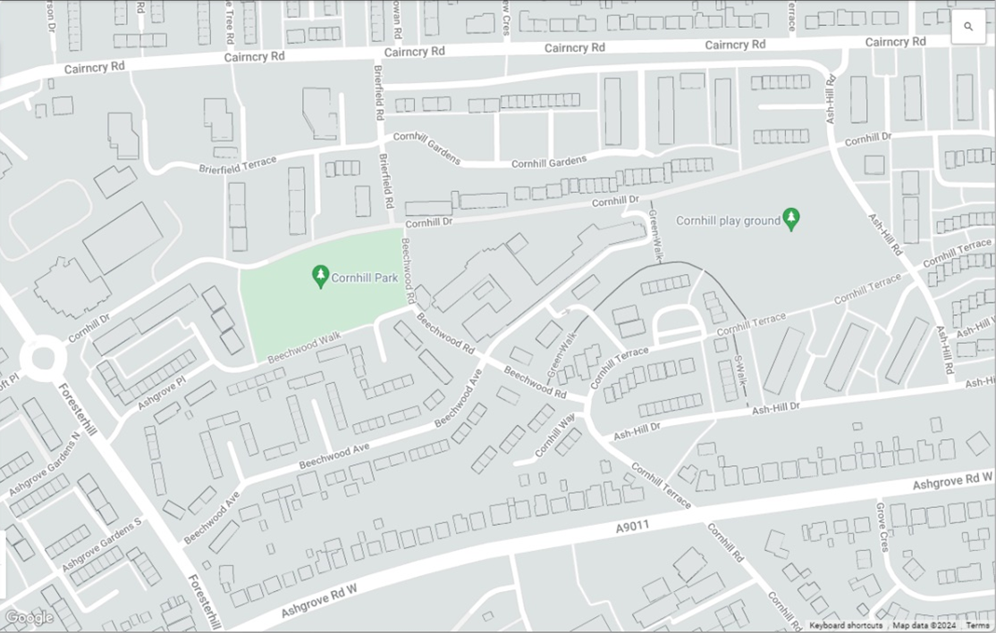

**Cornhill**

**Primary School**

**Action Plan 2024/25:**

Based on the data gathered, it is important that Cornhill School make a plan to further continue the encouragement of sustainable, healthy travel to and from school. School will continue to engage with the annual Hands Up Survey and will keep the Travel Plan updated.

|  |  |  |  |
| --- | --- | --- | --- |
| **Question** | **Action** | **Next steps** | **Progress update/impact** |
| Following a site/school offer audit, is there sufficient infrastructure/ initiatives to support scooter/cycling to school? | Scooter racks and bike racks have been installed and are well used, daily. | Continued offer of Bikeabilty (currently offered annually to set stage groups via Adventure Aberdeen as organised by the PE Specialist) and continued offer of bike maintenance via the Bike Doctor (also organised by PE Specialist). |  |
| Is there a way to tackle the barriers to walking to school as identified by the pupil focus groups? | Parent Council have emailed local councillors to invite them to the next meeting on 11th Sept. 2024 6-7pm to meet with some pupils to talk about solutions. | TBC at Parent Council Meeting. Potential actions may be to link with the dog warden. |  |
| Does school communicate frequently with parents to promote sustainable travel? | Regular newsletters are sent to all parents reminding them to refrain from entering the car park to drop off/pick up, and to refrain from parking on the yellow zig zag lines. | Pupil group to be established to meet termly and to focus on travel to school; this is with the view to them creating and sending extra communications, posters etc. to parents and pupils. |  |

Learners at Cornhill are Respectful, Focused, Resilient, Self-Motivated and Inquisitive

***Strive for Excellence***