CORNHILL PRIMARY SCHOOL Child Protection and Safeguarding Policy

Introduction

Cornhill School is committed to ensuring that all children and young people get the best start in life and are safe from harm. In order to achieve this we create an ethos where wellbeing and safeguarding is prioritised by making adaptions to universal and targeted supports in school and by working with multi-agency partners in keeping with the GIRFEC Operational Guidance. In addition we have well known processes to take action if a risk of significant harm is suspected.
There are several ways Cornhill School proactively supports pupil wellbeing and discharges safeguarding and child protection responsibilities including:
- regularly refreshing the universal curriculum to ensure it empowers pupils to keep themselves safe, based on available data
- empowering children to understand and claim their rights including the right to have a say in decisions which directly or indirectly impact on them
- establishing a positive ethos which is inclusive and builds on strengths and resilience as well as addressing risk and vulnerabilities
- being alert to wellbeing, safeguarding and child protection concerns
- taking decisive action according to established procedures to address wellbeing, safeguarding and child protection concerns
- being alert to and proactive in addressing signs of compromised wellbeing in the adults who care for children
- working in partnership with Community Planning Partners by seeking a shared understanding.
The highest standards of professional conduct are expected from all school staff and staff and volunteers in Cornhill School are registered with the Protecting Vulnerable Groups Scheme. School staff are registered with the appropriate professional body and comply with the professional standards expected of them. All staff working in Education have responsibilities with regards to Positions of Trust as stated in the Sexual Offences (Scotland) Act 2009. Staff confirm their understanding of the need to report any concerns regarding breaches of professional conduct to their Line Manager without delay on a yearly basis as this policy is refreshed. All allegations of misconduct against school staff are fully investigated and appropriate action taken.

What is Child Protection and Safeguarding?
Child Protection is a term used to describe the actions of certain organisations in their efforts to make sure children are safe from abuse and neglect. Abuse or neglect may involve inflicting harm or failing to act to prevent harm. Safeguarding is a much wider concept than child protection and refers to promoting the welfare and wellbeing of children and young people. It encompasses protecting children from maltreatment, preventing impairment of children’s health or development, ensuring that children are growing up in circumstances consistent with the provision of safe and effective care; and taking action to enable all children and young people to have the best possible outcomes to prevent involvement with statutory social work services wherever possible given the wealth and research outlining the negative impact on outcomes for children and young people who find themselves in the care system as outlined in The Promise.

Cornhill School recognises the important role we play is limiting the escalation of risk that would require statutory measures through the careful design of the curriculum, the strength of universal and targeted supports in school and our proactive approach to working with multi-agency partners.

Child Protection processes are reactive and are followed when there is a suspicion that harm has already occurred or may occur. When there are concerns that a child may have experienced or may experience significant harm, and these concerns relate to the possibility of abuse or neglect, then police or social work must be notified. Along with other relevant services they will form a view as to whether the harm is or is likely to be significant. Professionals must also consider what harm might come to a child from failing to share relevant information, within the terms of their respective duties.

Child Protection is the collective responsibility of all services, professional bodies and agencies. Cornhill School has an allocated Child Protection Coordinator and Deputised Child Protection Co-ordinator/s who oversees and actively supports the implementation of it.

Key policies that help us safeguard and protect children and young people.

The National Guidance for Child Protection in Scotland (2021) National Guidance for Child Protection in Scotland 2021 (www.gov.scot) has been agreed as our local guidance and a link to Aberdeen City Council’s education guidance is available here Child Protection & Safeguarding Guidance - Education.pdf. Both documents outline the collective responsibility of all services, professional bodies and agencies that provide child and/or adult services’ to identify and actively consider potential risks to all children and young people. The updated guidance sets out a rights based approach and focusses on ‘early support’, referred to as ‘whole family support’, to prevent needs from escalating and requiring compulsory measures. Practitioners are asked to have a strong focus on:
- listening to children and giving their views due consideration
- building on strengths and resilience as well as addressing risk and vulnerabilities
- having a more collaborative approach between professionals, carers and family members
- a need to fully appreciate and address the impacts of poverty on families and communities
- appreciating the risks of our digital age
- working in partnership by listening and seeking shared understanding
- leading services by constantly reviewing data to secure further improvement.

All relevant documents can be found on the ACC Child Protection & Safeguarding Thinglink. https://www.thinglink.com/scene/1519680652994150402

The Children and Young People (Scotland) Act 2014 places a specific duty on services to safeguard, support and promote the wellbeing of children and young people. It builds upon the principles set out in the Children (Scotland) Act 1995 which places a specific duty on Local Authorities to investigate if it believes that a child is or is likely to suffer significant harm. The Act is discharged locally through the Aberdeen City GIRFEC Operational Guidance 2019. GIRFEC Operational Guidance 2019.pdf (sharepoint.com)

The Aberdeen City Council Child Protection, Corporate Policy and Procedure (2017) sets out the expectations of all staff employed by the Local Authority and emphasises the responsibility of all services, both individually and collectively to work in partnership to effectively protect children and young people. As such it helps guide our working practices with Community Planning Partners.

The Equality Act (2010) places a duty on schools and Local Authorities to not discriminate against children and young people based on protected characteristics, this statutory requirement is integral to the entirety of this policy. All individuals, inclusive of children and young people, practitioners and students, will be supported to reach their full potential regardless of race, ethnicity, religion, age, gender, sexual orientation and identity, physical disability, socio-economic background or intellectual ability. A commitment to anti-discriminatory practice is fundamental to application of this Policy and development of a supportive and empowering school ethos.

The How Good Is Our School quality framework sets clear expectations of schools and school staff should use the document to support self-evaluation. “In our school age, disability, gender reassignment, marriage and civil partnership, pregnancy, race, religion or belief, sex and sexual orientation are not barriers to participation and achievement (3.1).” HIGIOS 4

The aim of this policy

Our aim is to ensure that all of our children and young people are safe - reducing and preventing risk where possible - with a strong focus on primary prevention through a strong universal offer and early intervention through well designed targeted supports delivery both in school and across the Community Planning Partnership.

To realise this aim there is a need to ensure that all staff, students and volunteers within our school/service:
- contribute to a positive ethos where discrimination is challenged and diversity celebrated
- ensure children are aware of their rights within UNCRC including the key principles of the right to be protected from being hurt or badly treated (Article 19) and the right to be heard (Article 12)
- support children to develop an understanding of the 8 Wellbeing Indicators, outlined in the GIRFEC National Practice Model, appropriate to their age and stage of development, allowing them to set a positive benchmark of wellbeing and recognise deviations from this
- ensure children are aware that information may be shared to keep them safe
- enable children to have experience of appropriate life and social skills to support them in seeking the assistance of adults/services who can help them and learn to identify potential risks to their safety and wellbeing through our delivery of the health and wellbeing curriculum
- understand and carry out their responsibilities to protect our children and young people from all forms of neglect, abuse and discrimination
- recognise a situation that presents a risk to children and young people linked to:
- physical abuse
- emotional abuse
- sexual abuse
- criminal abuse
- child trafficking
- neglect
- female genital mutilation
- forced marriage
- Recognise indicators of risk as defined in the National Guidance for Child Protection in Scotland (2021) section 4 as:
- poverty
- non-engaging families
- disabled children and parents with learning disabilities
- children impacted by poor health, including mental health
▪ poor parental health
▪ children and young people experiencing mental health problems
- suicide and self-harm
- neglect and emotional abuse
- domestic abuse
- parental alcohol and drugs use
- physical abuse, equal protection and restraint
- severe obesity
- child sexual abuse and exploitation
- internet enabled sexual offending
- harmful sexual behaviour or under-age sexual activity
- Looked After Children
- missing, separated or unaccompanied children
- trafficking and child criminal exploitation
- bullying
- hate crime
- female genital mutilation
- honour-based abuse and forced marriage
- fabricated or induced illness
- children with premature caring responsibilities
- sudden unexpected death in infants and children
- understand and implement procedures related to the reporting and recording of concerns
- ensure that all record keeping, including Child Protection concern forms and chronologies, are kept in accordance with the Data Protection Act (2018)
- ensure that Child Protection incidents are carefully considered and contribute to the Child’s
Assessment and Plan and maintain routine reviews of the impact of Plans
- review data routinely to help reshape the curricular offer available in their school.

We will achieve these aims by:
- reviewing this policy annually to ensure it remains in line with most recent advice and guidance
- issuing all members of staff, students and volunteers with this Child Protection & Safeguarding Policy upon their arrival to ensure that all staff, students and volunteers are aware of their responsibilities and of how to take action
- ensuring all partners / visitors to school, including supply staff, are aware of the school’s procedure for reporting child protection and safeguarding concerns by issuing them with guidelines and the name and photograph of the Child Protection Co-ordinator and Deputised Senior Manager
- ensuring that all members of staff, students and volunteers know where to access the Child
Protection, Corporate Policy and Procedure, Aberdeen City Council (2017), National Guidance for Child Protection in Scotland (2021) and GIRFEC Operational Guidance, Aberdeen City Council (2019).
- ensuring that all members of staff make effective use of the GIRFEC National Practice Model as an effective means to identify vulnerabilities and risk factors at the earliest possible time
- ensuring that all new staff, volunteers and students complete the mandatory corporate ACC Learn modules ‘Essential Child Protection, For All Staff Members’ and ‘Introduction to GIRFEC’ within 1 week of their appointment. Full education specific service training should be undertaken within 12 weeks of appointment and thereafter refreshed on a yearly basis
- monitoring the impact of these procedures to inform working practices
- ensuring that data is routinely reviewed to help shape impactful practices to reduce the risk of harm at school level
- conveying how we keep our children safe through school/service handbooks
- raising awareness of the holistic safeguarding agenda and how it complements already well established arrangements for keeping children safe.

Roles and responsibilities of all staff

Education services are an essential part of inter-agency planning and support with children and their
parents, whether through the provision of a strong universal offer focussed on wellbeing, through the provision of targeted supports at school level or though co-ordinated planning within a GIRFEC approach or child protection processes. On a yearly basis all staff will confirm their understanding of the their responsibilities and their duties with regard to;
- GIRFEC
- child protection procedures
- Corporate Parenting responsibilities (Looked After Children – LAC)
- Anti-bullying Policy with particular vigilance paid to protected characteristics which may result in increased vulnerability
- Anti-weapon and Knife Crime Policy
- PREVENT – Action to counter terrorism
- digital technology and safety online
- substance misuse
- school attendance
- positive relationships and behaviours
- incidents and near miss reporting.

Staff will inform the Named Person of any changes in behaviours or disposition which might indicate compromised wellbeing in a pupil. The Named Person will help to coordinate full consideration of the wellbeing needs of the child by making use of the tools available within the GIRFEC Operational Guidance, the voice of the child is critical to this process and should be captured and recorded. If the Named Person is not immediately available the concern should be logged in writing and discussed as soon as reasonably possible. The concern will generally be logged in pastoral notes along with details of the action taken to address the wellbeing concern. At times, the concern may be considered a child protection concern and require escalating to the Child Protection Coordinator.

Staff, students and volunteers are supported to recognise a situation that presents a risk of significant harm to children and young people and feel confident to respond in a way that will help protect the child to ensure that the correct route is followed as quickly as possible. Children and young people may not necessarily disclose abuse and therefore it is important for schools to nurture a climate of positive relationships in which children feel safe and are able to express concerns.

Signs of a child protection concern may be physical, emotional, behavioural, educational or relational. Some concerns are visible. However, there are neglected children who are abnormally quiet and compliant and become invisible. As a result there is a need to look out for signs which might suggest that a child is:
- being physically, sexually or emotionally harmed, or put at risk of harm, abuse of exploitation
- having their basic needs neglected or being cared for in ways that are not appropriate to their age and stage of development
- being denied the sustained support and care necessary for them to thrive and develop normally
- being denied access to appropriate medical care and treatment
- being exposed to demands and expectations which are inappropriate to their age and stage.

Cornhill School recognises that the better we know our young people, the better we understand if they are presenting differently and place significant focus on building positive relationships. There may be one single reason why a member of staff escalates a concern to the Named Person. The Named Person may be aware of several smaller concerns which, on their own, seem not to be of significant concern but present a concerning picture when brought together and would trigger a child protection response. Examples that require to be escalated include;
- unexplained bruising or injuries in an unusual place
- young person appears afraid, quiet or withdrawn or scared to go home
- young person appears hungry, tired, unkempt or have poor hygiene
- young person is left unattended or unsupervised or are out too late
- young person seems to have too much responsibility for their age
- young person is speaking or acting in a sexually inappropriate way
- young person is misusing drugs or alcohol
- young person is abnormally quiet and unresponsive, infants with signs of developmental delay
- young person shows abnormally frequent and persistent aggression and frustration
- young person is avoidant of parents or carers
- young person is indiscriminate in their affections with strangers
- young person shows an abnormally poor attention span
- young person lacks confidence and self-esteem
- young person shows unusual impulsivity and sharp mood swings
- young person shows an abnormal lack of concentration, confidence and/or social skills
- young person lacks trust in others
- young person is self-isolating or has difficulty sustaining friendships
- young person is stealing items
- young person is bullying others
- young person runs away
- young person shows signs of eating disorders
- young person shows signs of self-harm or depression.

In addition, we all have a duty to raise concerns about a child or young person if the behaviour of an
adult who has responsibility to care for the child or young person causes concern. The adult may:
- act in a violent way to other adults, within or out with the household
- act violently or sexually toward the child or young person, or appear to be grooming them for sex
- misuse drugs or alcohol chaotically
- be physically or verbally abusive towards the child or young person
- appear to be neglecting the child’s basic needs or not taking them for medical treatment
- be exposing the child to inappropriate images, particularly on-line
- struggle to manage mental health problems.

The role of all staff at Cornhill School is to identify and report concerns timeously. The best means of addressing the concern will be determined by either the Named Person (if a wellbeing concern) or the Child Protection Coordinator (if there is a suspicion of significant harm).

The role of the Named Person
The Getting it Right for Every Child (GIRFEC) approach underpins both preventative and child protection processes. This includes an identified point of contact to provide early support, advice and access to services, a shared approach to assessment and consideration of wellbeing, and a shared response to identified needs, including planning for children across services where needed.

The Named Person is responsible for overseeing the wellbeing needs of all children they hold responsibility for and for ensuring that the best practice within the GIRFEC Operational Guidance is followed. They also have a responsibility for overseeing record keeping within pastoral notes and the Wellbeing App.

The Named Person will:
- listen carefully to children and young people and ensure they have a say in decisions which impact them either directly or indirectly
- receive and log wellbeing concerns in keeping with data protection legislation
- support the assessment of wellbeing in keeping with the tools in the GIRFEC Operational Guidance to determine how best to respond
- be a single point of contact for children and families
- provide advice and guidance and help children and families access services to prevent an escalation of risk
- monitor data to help quality assure the effectiveness of the schools approach to safeguarding children and young people and flag any emerging issues
- raise potential Child Protection concerns immediately with the Child Protection Co-ordinator.

The Named Person, or indeed any member of schools staff, has no role in investigating child protection concerns, this role sits with the Police and Children’s Social Work.

The role of the Child Protection Coordinator
Child Protection Co-ordinators in schools lead the work of the school to keep children safe. The Child Protection Coordinator will:
- ensure that all staff within the school are competent and confident in carrying out their responsibilities for safeguarding and promoting children’s wellbeing
- engage with appropriate training and development to ensure they can respond effectively to child protection concerns and support staff
- oversee the timely delivery of Child Protection training and keep records of attendance
- evaluate the confidence of school staff in delivering this policy to inform the professional learning offer
- oversee and quality assure record keeping in keeping with data protection legislation
- ensure that Child’s Plans are uploaded on the Wellbeing App and that staff have access to the information they require to deliver on the agreed Plan
- retain a file of open Child Protection cases (see appendix 5). When next steps have been decided with Police/Social Work, Child Protection Coordinator should then upload the concern form, or transfer pertinent information, on to SEEMIS Wellbeing App. (Only CP Coordinator and SLT should have access to these records.)
- keep a list of pupils with current or previously opened files
- oversee child protection data to inform self-evaluation for improvement
- ensure that Social Work contact details and the name and photograph of the Child Protection Co-ordinator and Deputy Child Protection Co-ordinator/s are displayed in the ELC, classrooms, reception area and throughout the school.

The role of Senior Leadership Team
Senior Leaders play a significant role in our safeguarding arrangements. These include:
- creating an environment which gives all children and young people a sense of belonging and acceptance
- a responsibility to oversee and quality assure the many policies and procedures that support safeguarding
- displaying transparent relationships encouraging early reporting of concerns to enable swift action to be taken to support individual children
- using available data to inform both school and ASG improvement planning
- auditing the confidence of staff and provision of professional learning to ensure that the team are aware of any emerging risks or new agendas to enable staff to take appropriate and proportionate action at least on an annual basis or more frequently if required
- keeping records of training delivered
- routinely updating this policy to complement professional learning with an early review when new risks are identified.

The role of the Lead Professional
‘A Lead Professional will be responsible for ensuring the production and review of an agreed multi-agency child’s plan. This should integrate information from previous plans by individual agencies as appropriate. Reports for a child’s planning meeting or for a CPPM should be circulated to everyone involved, especially the child and family. Reports should be available and presented so that they are accessible to all. This includes, for example, children or parents/carers with learning disabilities.

In child protection cases, the role of a lead professional will typically be taken by the local authority social worker. Where a child is believed to be at risk of significant harm, a Child Protection Plan should be incorporated into the child’s plan for as long as the risk of significant harm is deemed to last. The multi- agency group working with the child and their family will be known as the Core Group.

A Lead Professional will:
- ensure the child’s voice and experience is heard and his/her views recorded
- work with the child and family, ensuring shared understanding about the plan and about
how it is working from the perspective of the child and family
- track and respond to changes in circumstances that may affect the plan
- be a point of contact for all practitioners who are delivering services to the child
- make sure that the help provided is consistent with the plan
- be a bridge to engagement with and support from other agencies
- offer to link the and family with specialist advocacy when appropriate
- monitor how well the child’s plan is working
- co-ordinate the provision of other help or specialist assessments as needed.

A lead professional will make sure the child is supported through significant points of transition. They will ensure a planned transfer of responsibility when another practitioner becomes the lead professional, for example if the child’s needs change or the family moves away.’
National Guidance for Child Protection in Scotland (2021)

Taking action
As outlined previously, wellbeing concerns should be raised with the Named Person. Concerns which suggest a risk of significant harm are immediately passed to the Child Protection Coordinator. Examples include:
- a disclosure of abuse
- suspected abuse
- expression of a concern made by a third party
- a staff member witnesses an abusive situation involving another person or staff member.

Look and listen to the child or young person
Do not interrogate the child/young person or enter into detailed investigations. Be particularly mindful of not asking leading questions. Observe carefully the behaviour of the child or young person.

You should respond to the child or young person without showing signs of anxiety, alarm or shock. You should enquire casually about how the injury was sustained or why the child/young person appears distressed. Do not promise confidentiality, this is misleading, instead be open and transparent about the need to share information. Do not ask the child or young person leading questions which could compromise any potential investigation. (See Appendix 4)

Record it
Make a note of concerns by recording:
- what you have seen
- what the child/young person has disclosed (in the child/young person’s words if possible)
- what concerns this has raised.

Record the context, time, date and actions taken. Use non emotive, clear, plain English which is understandable to all. Provide as much information about your concerns and use the Child Protection Concern Form available in Appendix 5 wherever possible.

Staff, students and volunteers must not:
- carry out any sort of investigation into the allegations
- make promises to the child/young person about what may or may not happen.

At times you may have cause to be concerned about a child or young person through an incident or information you have received. If this is not an immediate child protection concern, then the Senior Leadership Team ask that you indicate this within SEEMiS pastoral notes and flag to a senior manager. Any further actions required will also be stated here. This will give an accurate record of incident and/or concerns which can be fed into the pupil’s chronology on the Wellbeing section.

Pastoral notes will be checked regularly by member of SLT, however, as is stated above if this is an immediate concern please seek out the Child Protection Co-ordinator or a Child Protection Officer.

Any Child Protection related updates will be uploaded onto Wellbeing App using the Child Protection Concern Form below or directly into the information upload section.

Report it
If you have a concern about a child or young person, speak to a Child Protection Coordinator/Officer/Deputised Senior Manager immediately. You should never assume that someone else has already reported a concern.

The Child Protection Coordinator/Officer will listen carefully to your concern and use the Child Protection Concern Form to determine next steps.

If a Child Protection Coordinator/Officer or more senior member of staff is not available, the responsibility for taking the following steps rests with the individual with the concern. In this unlikely event the individual should contact the Joint Child Protection Team or Emergency Out of Hours Social Work for advice and support.

In the likely event the Child Protection Coordinator/Officer is present they will take appropriate action. If abuse is suspected, staff may refer the concerns onto police or social work without first notifying parents. Discussion with a Child Protection Coordinator/Officer may lead to a series of actions to be taken. Consideration will be given to how parents are to be engaged if appropriate, how the outcome of any investigation will be relayed to you and how the Named Person will be informed (if the Named Person is not one of the Child Protection Co-ordinator/Officers). At this point further actions may include contacting the Joint Child Protection Team (01224 306877), Emergency Out of Hours Social Work Service (08007315520) or any agency who may have information about the child/young person or their family.

The Child Protection Coordinator/Officer should adhere to the principles of information sharing set out in the Data Protection Act 1998 and only share information which is relevant, necessary and proportionate to the Child Protection concern raised but they should not seek consent to share if they consider the child to be at risk. This could include checking the Child Protection Register.

If there are significant and immediate concerns about the safety of a child staff, students and volunteers should call 999 or 101 immediately.

All discussions and actions should be noted on the Record of Account form with times and
dates noted. This should be securely retained with a summary of relevant and proportionate information and transferred into the child’s chronology within the Wellbeing section of SEEMiS.

Deciding not to take action
Following collaboration with the Joint Child Protection Team, Out of Hours Social Work or Police Scotland, any decision not to take further action and the reasons for this should be recorded in the child’s chronology. It is important that this entry is completed with times and dates noted.

What Happens Next
Reported information will be considered by the Police and Children’s Social Work. This may result in a joint investigation. Colleagues in Children’s Social Work and Police Scotland will advise of any support they require from the Child Protection Coordinators.

Confidentiality
It is essential to maintain strict confidentiality in all child protection matters. All staff, students and volunteers have a duty to pass on their concerns to the Child Protection Co-ordinator but should not discuss the concerns with anyone who is not relevant to the enquiry. Breach of confidentiality is a serious disciplinary matter and will be handled following the Council’s Disciplinary Procedures. All staff, students and volunteers should be aware of their role in any child protection matter and also of the principles set out in the Data Protection Act (1998) and GDPR (General Data Protection Regulation) through undertaking regular training. Sharing relevant information is an essential aspect of protecting children from harm.

Where there is a child protection concern, relevant information will be shared with police and/or social work without delay, provided it is necessary, proportionate, and lawful to do so. Practitioners with child protection concerns may share relevant information to:
- clarify if there is risk of harm to a child
- clarify the level of risk of harm to a child
- safeguard a child at risk of harm
- clarify if the child is being harmed
- clarify the level of harm the child is experiencing
- protect a child who is being harmed.

Sharing without consent
Where there may be a child protection concern, information may be lawfully shared without the need for consent to be obtained from the individual(s) to whom the information relates. The following considerations will be helpful to support relevant, proportionate, timely, safe and effective information sharing:
- if there is evidence that a child is at risk of significant harm, relevant information can be shared with a statutory agency without delay. Consent is not required or appropriate because the information must be shared in order to protect the child. Consent should only be sought when the individual has a real choice over the matter. However, where appropriate, agreement and understanding about the sharing of information may be helpful in engaging individuals in the process
- the needs, feelings, views and wishes of the child should be taken into account and documented. They may also need additional support to understand and communicate
- information sharing decisions must be based not only upon considerations about the safety and wellbeing of the individual, but also the safety of others
- information can be shared without consent if, for example, a practitioner is unable to gain consent from the individual in time to prevent risk of harm, or if gaining consent could place a child at risk
- relevant personal information can be shared lawfully if, for example, it is to keep a child or individual at risk safe from neglect or physical, emotional or psychological harm. This must be done in a way that complies with the relevant areas of law such as data protection, human rights and confidentiality
- in all circumstances, it is important to be transparent with children and families so that they know what information is to be shared or has been shared and in what circumstances. In certain exceptional circumstances, it may not be appropriate to advise the individual that information is to be shared
- children and their families should also be aware that they can challenge whether sharing information is proportionate
- a record should be made of the reasons and considerations that informed the decision to share the information.

If, where there is a possible child protection concern, a decision is made not to share information,
consider:
- What are the reasons for deciding not to share information?
- What harm could result if this information is not shared?
- What are the possible risks for the child or young person or for others if information is not shared and how serious could those risks be?
- Reasons for not sharing should be recorded.

Record keeping
Professionals should ensure language used in child protection processes is non-stigmatising and understood by children and families. All records, including pastoral notes and child protection files, should have a central focus on the child’s voice and perspective. Cornhill School follow the ACC ‘Guidance for Practitioners – Pastoral Notes’. Recording Pastoral Notes - Guidance (20.08.2021).pdf

The Child Protection Register

Children and young people are registered on the Child Protection Register in order to alert workers to the fact that there is sufficient professional concern about a child or young to warrant a Multi-Agency Child Protection Plan.

The Child Protection Coordinator/Officer can phone to check if a child’s name has been recorded on the Child Protection Register.

The Child Protection Register is held jointly on behalf of Aberdeen City, Aberdeenshire and Moray. Child Protection Committees can be contacted on 01224 523232 or by e-mail ask@childprotectionpartnership.org.uk

Review of this policy

Cornhill School does not view the Safeguarding agenda as complete upon delivery of this policy but rather as an area to be continually improved over time to ensure that it meets the needs of children and young people. This policy is based on the premise that every wellbeing and child protection incident provides a learning opportunity. Patterns of incidents will be analysed to identify actions to be taken to improve safeguarding arrangements. Consideration of Safeguarding cannot be isolated from other school policies. On-going review of safeguarding arrangements may trigger a need to review associated school policies or feed into a review of Local Authority Policy.

Monitoring

This Policy will be reviewed annually and each Leadership team has a responsibility to ensure that all staff, students and volunteers understand what they have to do if they have a concern about a child.

Lisa Williams is the Officer with the Child Protection Lead for Education Services (Tel:07970068859) and can be contacted for advice and guidance.
Appendix 1 - Links to associated legislation, policies and guidance
Looked after Children
Schools have a legal duty to consider if every Looked After Child requires a Co-ordinated Support Plan (CSP). The need to consider is most easily undertaken during a multi-agency meeting. If a full assessment of wellbeing shows that a child does not need additional support to benefit from school education the decision to not put a CSP in place will be recorded and the provision of a Childs Plan will suffice. In order to meet the criteria for a CSP, a child or young person must meet all of the following criteria:
  - The education authority is responsible for the school education of the child or young person;
  - The child or young person has additional support needs arising from one or more complex factors or multiple factors;
  - Those needs are likely to continue for more than a year;
  - Those needs require significant additional support to be provided by one or more appropriate agencies as well as by the education authority.

Based on the criteria above Cornhill School will evidence that robust multi-agency discussions have taken place about whether or not a Looked After Child meets the criteria for a CSP and that there is a clear process in place for review.

Physical intervention and restraint
Children and young people who experience distress are proactively supported at Cornhill School, through the application of effective de-escalation strategies. Physical intervention and restraint would only be deployed by staff who are trained in approved techniques.

In keeping with the school Anti Bullying Policy all incidents of a bullying nature will be logged with support afforded to both parties. A bullying incident is defined by the perception of the victim, not the potential perpetrator(s) or practitioner’s perception. In situations where a victim of bullying does not want to report it due to fear of potential consequence, the responsibility lies with practitioners to do so, whilst also reducing anxieties of the victim. Any emerging trends will inform a review of the school Anti-Bullying Policy and help inform approaches to safeguarding. Preventative and reactive response to all incidents of bullying will be in full alignment with Cornhill School’s Anti-bullying Policy and Aberdeen City Council’s Anti Bullying Policy. Particular vigilance will be paid to protected characteristics which may result in increased vulnerability such as:
● Asylum Seekers
● Transgender
● Homophobic bullying
● Belief Sectarianism
● Refugees
● LAC
● Race and Ethnicity
● Religion
● Body Image
● Sexism and Gender
● Social and Economic Prejudice
● Disablist Bullying
● Young Carers

Cyberbullying, or online bullying, can be defined as the use of technologies by an individual or by a group of people deliberately and repeatedly upsetting someone else. Online harassment is a crime. The production and distribution of ‘sexting images’ involving anyone under the age of 18 is illegal and will often result in child protection arrangements being followed including a referral to Police Scotland. Advice on dealing with activities which may be considered as Sexually Harmful Behaviour can be found at: Brook Traffic Light Tool.

Hate crime is defined as any crime which is perceived by the victim or any other person as being motivated by malice or ill will towards a social group. Perpetrators of hate crime focus upon demonstrating malice or ill will towards individuals on the basis of their actual or presumed, sexual orientation, transgender identity, disability, race or religion. All incidents of Hate Crime are reported be reported to Police Scotland in person or though the Hate Crime Reporting Form. https://www.scotland.police.uk/secureforms/hate-crime/

Cornhill School fully embraces the Anti-Weapon/knife pledge. There are key messages to safeguard children from the potential dangers of weapons embedded in the curriculum and in keeping with the Aberdeen City Anti-Weapons Policy. Focus is given to weapon facts, law relating to weapon/knife crime, consequences of knife crime, personal safety and strategies to manage risky situations with curriculum delivery regularly reviewed to inform improvement.

All staff in Cornhill School are fully committed to the National Prevent Strategy and are aware of the Single Point of Contact who has responsibility for dealing with all Prevent concerns relating to the potential radicalisation of vulnerable children, young people and their families. In addition, Cornhill School staff should report any school incidents to SLT. All staff in Cornhill School have an appropriate awareness of signs of potential radicalisation enabling them to keep an effective watch upon children and young people to keep them safe.

Cornhill School takes its responsibility to safeguard children and young people from potentially harmful and inappropriate online material to empower learners to stay safe online. Our IT Acceptable Use Policy establishes expected on-line behaviour and is understood by children, young people, parents and staff. Any breach of policy triggers a review of the school’s policy and changes made as appropriate. Staff have access to professional learning to support them to understand this increasingly complex risk. Cornhill School is vigilant in receiving online safety updates from Central Officers and acting upon these appropriately.

All staff in Cornhill School meet their responsibilities in relation to substance misuse through fully adhering to Aberdeen City Council’s ‘Policy and Procedure for Managing Substance Misuse Incidents Involving Children and Young People in Schools’. All incidents are recorded and reported informing safeguarding arrangements and policy review. This allows for appropriate, timely and proportionate support for children involved in a substance misuse incident, in full alignment with Local Authority procedure.

Children who are Missing from Education (CME) are a particularly vulnerable group and Cornhill School adheres to Aberdeen City Policy on Children Missing from Education. Analysis of cases will inform local safeguarding arrangements and Local Authority Policy revision.

The Aberdeen City Attendance Policy promotes good school attendance. Careful monitoring of attendance enables Cornhill School to identify and address any truancy before a pattern becomes established. We recognise that children and young people are at greater risk when not in school and have arrangements in place to monitor attendance, lateness or children and young people who do not remain on school premises after initial registration.

Class Teachers will monitor attendance of all children throughout the course of the school day, in the morning, after break and after lunch time to enable an early alert to be created for a child whose status changes from present to absent during these busy periods of transition. Violent incidents and near misses are logged on the corporate system. The number of incidents will be carefully tracked to inform a review of how effectively the school supports vulnerable children and young people.

Cornhill School’s Positive Relationships Policy sets out how the school promotes positive behaviour. Scrutiny of the effectiveness of the policy will support on-going monitoring of our safeguarding arrangements.

Monitoring the frequency and impact of Person Centred Risk Assessments will enable the school to review how best to support vulnerable learners in keeping with the Local Authority continuum of provision and Staged Intervention Framework.

Any incidents of exclusion are managed in keeping with the Aberdeen City Minimising Exclusion Policy and Guidance. Attendance and exclusion are carefully monitored so that any emerging trends can be addressed through either a review of internal systems or refinement of the universal or targeted offer to support and promote wellbeing.

The School Complaints Log will be monitored to review the current complaints, concerns or allegations which could inform a review of the school safeguarding arrangements. Consideration of how to quality assure first aid and administration of medicines procedures will be established with learning informing school safeguarding arrangements. All arrangements are in keeping with the Aberdeen City Administration of Medicines Policy.

Incidents of self-harm can be an indicator of a wellbeing need. All incidents are managed in accordance with Local NHS Guidance with advice sought from the School Nursing Team where necessary.

Cornhill School keeps a watching brief and acts upon all guidance and resources disseminated by Central Education Officers in relation to water safety, road safety and other safety initiatives to minimise risk to children when in school, at home and in the community and maximise learning opportunities. Aberdeen City Council is supported by partners such as Police Scotland, RNLI, RLSS, Scottish Fire and Rescue Service and Absafe in delivering safety inputs to schools and raising awareness of key safety messages.

Appendix 2 - Child Protection & Safeguarding Checklist
Data around child protection and safeguarding will be reviewed collectively to see how effectively safeguarding arrangements are reducing the number of incidents requiring an immediate and reactive child protection response. SLT/Child Protection Lead will ensure the following is considered/planned:

RAG Rate Termly | To be considered/planned. | Notes
 | Annual ACC training completed by all staff (August In-Service Day).
 | Child Protection & Safeguarding CLPL sessions are completed with new staff when required throughout the academic year.
 | Ensure all signage and school handbook reflects updates & lead responsibilities.
 | Child Protection & Safeguarding Guidance Materials are collated, well organised and accessible to all (where appropriate).
 | Latest Pastoral Notes Guidance is followed when uploading information onto SEEMIS. (Sample 5 pupil records termly).
 | Records are appropriately stored. (Sample 5 pupil records termly).
 | Evaluation processes used to ensure all staff understand the definition of safeguarding and their role in keeping children safe.
 | Evaluation processes used to ensure the curriculum is regularly reviewed through a safeguarding lens to ensure it reflects current best practice to empower children and minimise risk.
 | Evaluation processes used to ensure children in the school know how to report concerns and identify a trusted adult.
Ensure trends are being tracked. (See monitoring example visual aid below).
Plan CLPL accordingly.
 | Ensure clear systems are in place to monitor and track care experienced learners.
 | Ensure school are proactive in developing links with partner agencies in order to support and safeguard all children.
 | Clear systems are in place to monitor absence and lateness. Evaluation processes used to ensure staff are aware that this can be an indicator of a wellbeing concern or risk of harm or significant harm.
 | PRD sessions are used as an opportunity to reflect upon practitioner understanding of safeguarding and child protection process and take action accordingly.
Next Steps:

Appendix 3 Example: Child Protection Disclosure/Concerns - Tracking & Monitoring
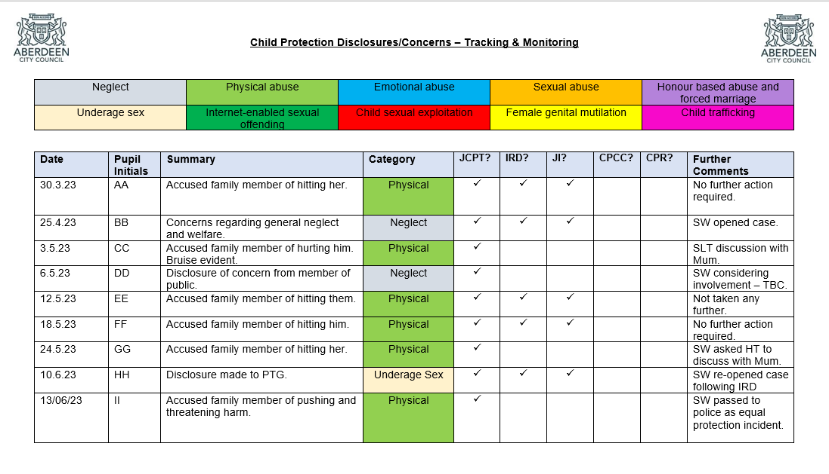
Appendix 4 – What is Child Abuse?

Abuse and neglect are forms of maltreatment. Abuse or neglect may involve inflicting harm or failing to act to prevent harm. Children may be maltreated at home; within a family or peer network; in care placements; institutions or community settings; and in the online and digital environment. Those responsible may be previously unknown or familiar, or in positions of trust. They may be family members. Children may be harmed pre-birth, for instance by domestic abuse of a mother or through parental alcohol and drug use.

Physical abuse

Physical abuse is the causing of physical harm to a child or young person. Physical abuse may involve hitting, shaking, throwing, poisoning, burning or scalding, drowning or suffocating. Physical harm may also be caused when a parent or carer feigns the symptoms of, or deliberately causes, ill health to a child they are looking after. There may be some variation in family, community or cultural attitudes to parenting, for example, in relation to reasonable discipline. Cultural sensitivity must not deflect practitioners from a focus on a child’s essential needs for care and protection from harm, or a focus on the need of a family for support to reduce stress and associated risk.

Emotional abuse

Emotional abuse is persistent emotional ill treatment that has severe and persistent adverse effects on a child’s emotional development. ‘Persistent’ means there is a continuous or intermittent pattern which has caused, or is likely to cause, significant harm. Emotional abuse is present to some extent in all types of ill treatment of a child, but it can also occur independently of other forms of abuse.

It may involve:

• conveying to a child that they are worthless or unloved, inadequate or valued only in so far as they meet the needs of another person

• exploitation or corruption of a child, or imposition of demands inappropriate for their age or stage of development

• repeated silencing, ridiculing or intimidation

• demands that so exceed a child’s capability that they may be harmful

• extreme overprotection, such that a child is harmed by prevention of learning, exploration and social development

• seeing or hearing the abuse of another (in accordance with the Domestic Abuse (Scotland) Act 2018). National Guidance for Child Protection in Scotland 2021

Sexual abuse

Child sexual abuse (CSA) is an act that involves a child under 16 years of age in any activity for the sexual gratification of another person, whether or not it is claimed that the child either consented or assented. Sexual abuse involves forcing or enticing a child to take part in sexual activities, whether or not the child is aware of what is happening.

For those who may be victims of sexual offences aged 16-17, child protection procedures should be considered. These procedures must be applied when there is concern about the sexual exploitation or trafficking of a child.

The activities may involve physical contact, including penetrative or non-penetrative acts. They may include non-contact activities, such as involving children in looking at or in the production of indecent images, in watching sexual activities, using sexual language towards a child, or encouraging children to behave in sexually inappropriate ways.

Child sexual exploitation (CSE) is a form of child sexual abuse. It occurs where an individual or group takes advantage of an imbalance of power to coerce, manipulate or deceive a person under 18 into sexual activity in exchange for something the victim needs or wants, and/or for the financial advantage or increased status of the perpetrator or facilitator. The victim may have been sexually exploited even if the sexual activity appears consensual. Child sexual exploitation does not always involve physical contact. It can also occur through the use of technology. Children who are trafficked across borders or within the UK may be at particular risk of sexual abuse.

Criminal exploitation

Criminal exploitation refers to the action of an individual or group using an imbalance of power to coerce, control, manipulate or deceive a child or young person under the age of 18 into any criminal activity in exchange for something the victim needs or wants, or for the financial or other advantage of the perpetrator or facilitator. Violence or the threat of violence may feature. The victim may have been criminally exploited, even if the activity appears consensual. Child criminal exploitation may involve physical contact and may also occur through the use of technology. It may involve gangs and organised criminal networks. Sale of illegal drugs may be a feature. Children and vulnerable adults may be exploited to move and store drugs and money. Coercion, intimidation, violence (including sexual violence) and weapons may be involved.

Child trafficking

Child trafficking involves the recruitment, transportation, transfer, harbouring or receipt, exchange or transfer of control of a child under the age of 18 years for the purposes of exploitation. Transfer or movement can be within an area and does not have to be across borders. Examples of and reasons for trafficking can include sexual, criminal and financial exploitation, forced labour, removal of organs, illegal adoption, and forced or illegal marriage.

Neglect

Neglect consists in persistent failure to meet a child’s basic physical and/or psychological needs, which is likely to result in the serious impairment of the child’s health or development. There can also be single instances of neglectful behaviour that cause significant harm. Neglect can arise in the context of systemic stresses such as poverty and is an indicator of both support and protection needs.

‘Persistent’ means there is a pattern which may be continuous or intermittent which has caused or is likely to cause significant harm. However, single instances of neglectful behaviour by a person in a position of responsibility can be significantly harmful. Early signs of neglect indicate the need for support to prevent harm.

The GIRFEC SHANARRI indicators set out the essential wellbeing needs. Neglect of any or all of these can impact on healthy development. Once a child is born, neglect may involve a parent or carer failing to provide adequate food, clothing and shelter (including exclusion from home or abandonment); to protect a child from physical and emotional harm or danger; to ensure adequate supervision (including the use of inadequate caregivers); to seek consistent access to appropriate medical care or treatment; to ensure the child receives education; or to respond to a child’s essential emotional needs.

Faltering growth refers to an inability to reach normal weight and growth or development milestones in the absence of medically discernible physical and genetic reasons. This condition requires further assessment and may be associated with chronic neglect. Malnutrition, lack of nurturing and lack of stimulation can lead to serious long-term effects such as greater susceptibility to serious childhood illnesses and reduction in potential stature. For very young children the impact could quickly become life-threatening. Chronic physical and emotional neglect may also have a significant impact on teenagers.

Female genital mutilation

This extreme form of physical, sexual and emotional assault upon girls and women involves partial or total removal of the external female genitalia, or other injury to the female genital organs for non-medical reasons. Such procedures are usually conducted on children and are a criminal offence in Scotland. FGM can be fatal and is associated with long-term physical and emotional harm.

Forced marriage
A forced marriage is a marriage conducted without the full and free consent of both parties and where duress is a factor. Duress can include physical, psychological, financial, sexual, and emotional abuse. Forced marriage is both a child protection and adult protection matter. Child protection processes will be considered up to the age of 18. Forced marriage may be a risk alongside other forms of so called ‘honour-based’ abuse (HBA). HBA includes practice used to control behaviour within families, communities, or other social groups, to protect perceived cultural and religious beliefs and/or ‘honour’.

Appendix 5 - Listening to the Child

The first steps when listening to a child are crucial. They often feel frightened, confused and vulnerable.

- Be receptive.

- Take it seriously – there is a reason for the child imparting such information.

- Reassure the child they are right to tell, listen carefully, and avoid showing any kind of shock reaction.

- Tell the child you need to seek help. Do not promise to keep secrets.

- Make a careful record of what was said – use the child’s words not your own.

- Do not record or report opinion, only factual information.

- Don’t jump to conclusions, speculate or accuse anyone.

- Don’t use leading questions; this is not your role and may cause serious legal implications regarding potential prosecution.

- Inform the Child Protection Co-ordinator without delay.

Appendix 6 - Cause for Concern/Incident

CHILD PROTECTION CONCERN FORM – PART 1
PART 1: To be completed by the person who has the concern.
- If a member of staff knows or suspects that a child/young person has been, is being or is at risk of being harmed, this form must be completed and the concern must be passed onto the Child Protection Co-ordinator as soon as possible and on the same working day.
- This form should be either handwritten or completed electronically.
- It should be kept in a secure place, separate from other Educational records.

1. Child/Young Person’s Details
Name | Date of Birth | Year group / Class

2. Person recording the concern
Name | Role
3. Details of concern. (The member of staff must record the facts as accurately as possible. If suspicions arise because of something a child has said, the member of staff should record the facts using the child’s own words.)

CHILD PROTECTION CONCERN FORM – PART 2
PART 2: To be completed by the Child Protection Co-ordinator

Name of Child Protection Co-ordinator:
Date and Time Concern Form Received:

Remember if this leads to a new child protection referral to open up a separate child protection file and chronology. Note this concern in the child's chronology as well as details of the action taken. If the child/young person already has a Child's Plan this should be updated to include details of the Child Protection Concern.
1. Have there been previous concerns involving any of the risk factors?
Yes □ No □
If yes, give details:

2. Is the child currently on the Child Protection Register?
Yes □ No □
If yes, the concern should be referred on the day to the allocated social worker or their senior.

Name of social worker: Date & Time contacted:

3. Was this concern shared with the child/young person?
Yes □ No □
(If Yes what is the child/young person saying about the concern? Note the date when the concern was shared. If No, please explain why not.)

4. Was this concern shared with the child/young person's parents/carers?
Yes □ No □
(If yes, what was the Parents' response? Note the date when the concern was shared. If no, please explain why not.)
5. Did the child/young person express a view on this matter?
Yes □ No □
(If Yes, what was it?)

6. What action is being taken in relation to this concern(s)? Please tick the appropriate box.
□ Initiate child protection procedures (see below)
□ Treat as a wellbeing concern, initiate a Child's Planning meeting and continue to monitor
□ Other – please give details ________________________________________________________

7. If child protection procedures are initiated, record details of the discussion with social work services.
Date: Time: Name of social worker:
Details of discussion:

*Upload this document in Wellbeing App.

Appendix 7
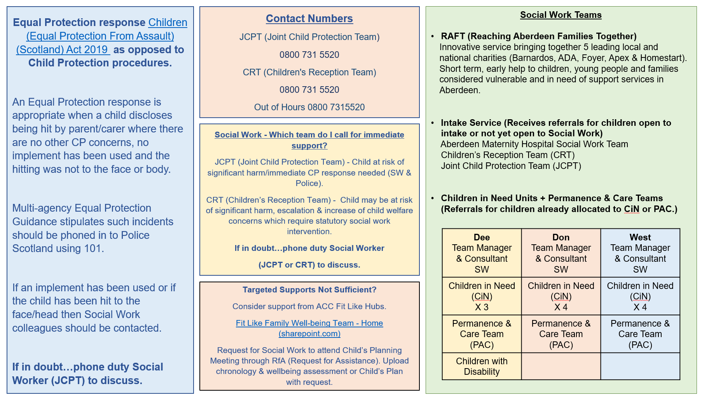

Appendix 8

Legislative Framework
Child Protection is not entirely governed within a legislative framework, and this list is not exhaustive.

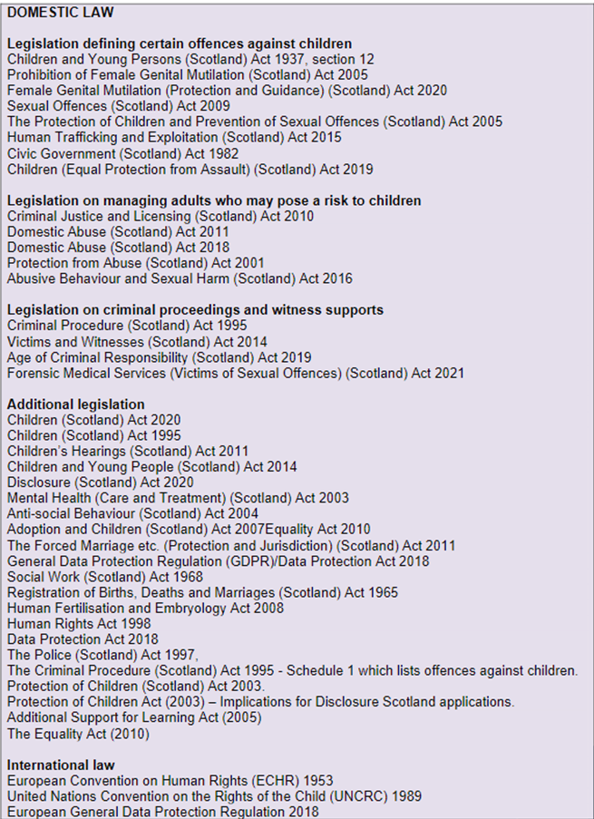

Appendix 9
We ensure that this poster is on display in all communal areas of the school.
Link for poster - CP & Safeguarding Coordinator Poster.pdf

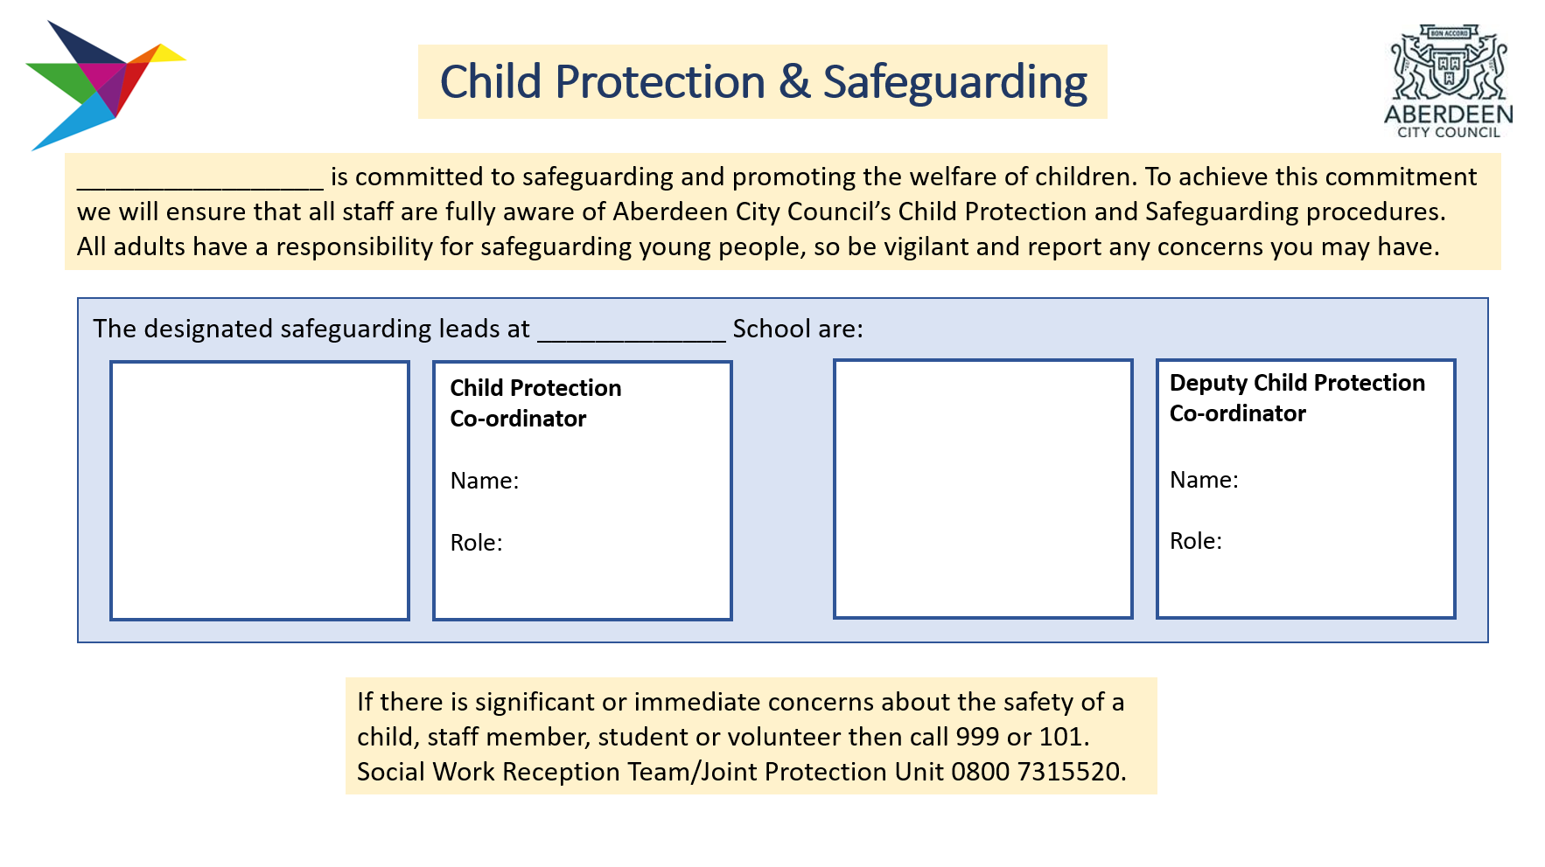

Appendix 10

