Motto:
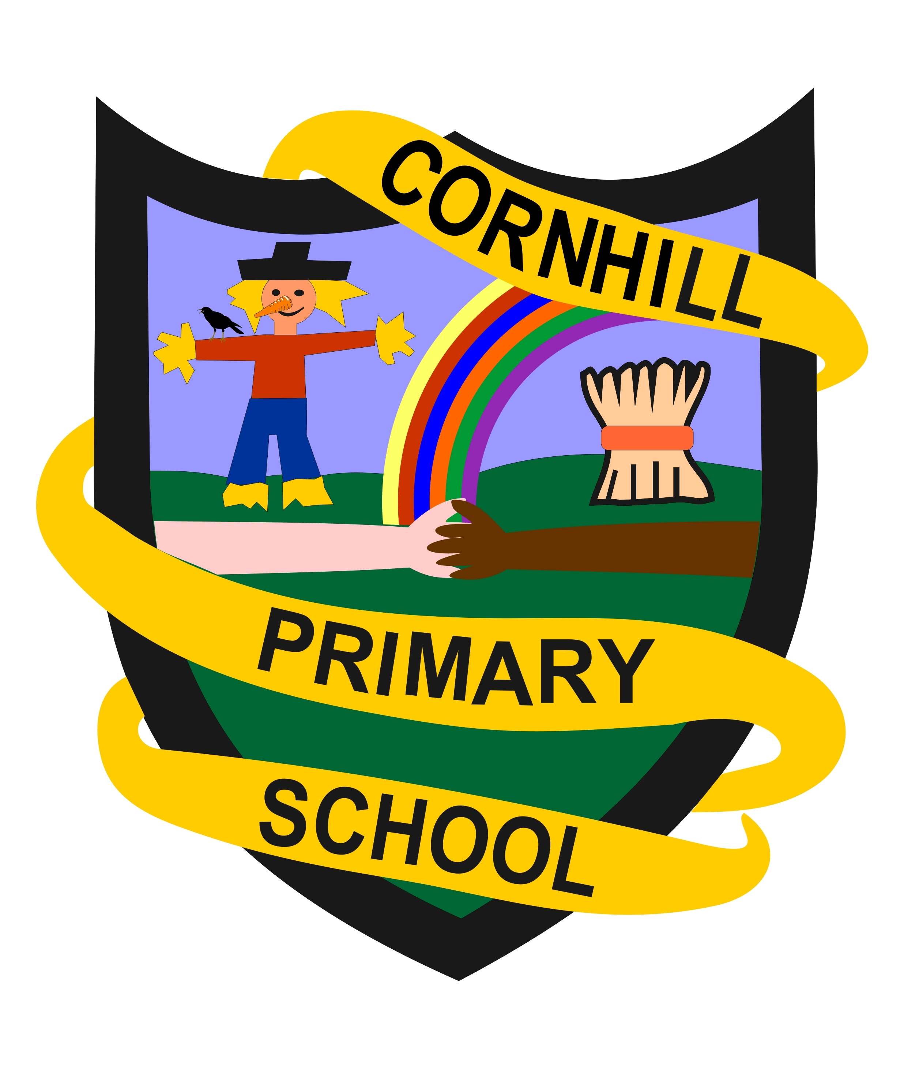
Strive for Excellence
Vision:
Cornhill is a nurturing, positive, and inclusive learning community where everyone feels safe and listened to; where learners, staff and parents work together for the best outcome for all. High quality learning experiences, along with dedicated pastoral care is ensured to allow everyone in our learning community to reach their potential.
Values:
Learners at Cornhill School are Respectful, Focused, Self-Motivated, Resilient and Inquisitive.
Aims:
- We aim to provide an inclusive, stimulating and flexible curriculum that creates opportunities for each learner to be challenged and to achieve their full potential. We encourage healthy, active lifestyle choices, promoting enjoyment, happiness and wellbeing.
- We aim to involve our learners in decision making, encouraging them to take responsibility in their learning journeys and to develop leadership skills, whilst regularly celebrating their achievements and successes.
- We aim to practise a restorative and trauma-informed approach to support learners to develop self-regulation strategies, to encourage respectful interactions throughout the school, and to celebrate positive choices and kindness.
- We aim to consistently support our staff in further learning opportunities; creating a friendly, committed team who communicate well, and evaluate and reflect upon their practice.
- We aim to work in partnership with families, the wider school community and other agencies to enrich our learners’ experiences and equip them with the skills and enthusiasm for life-long learning.

