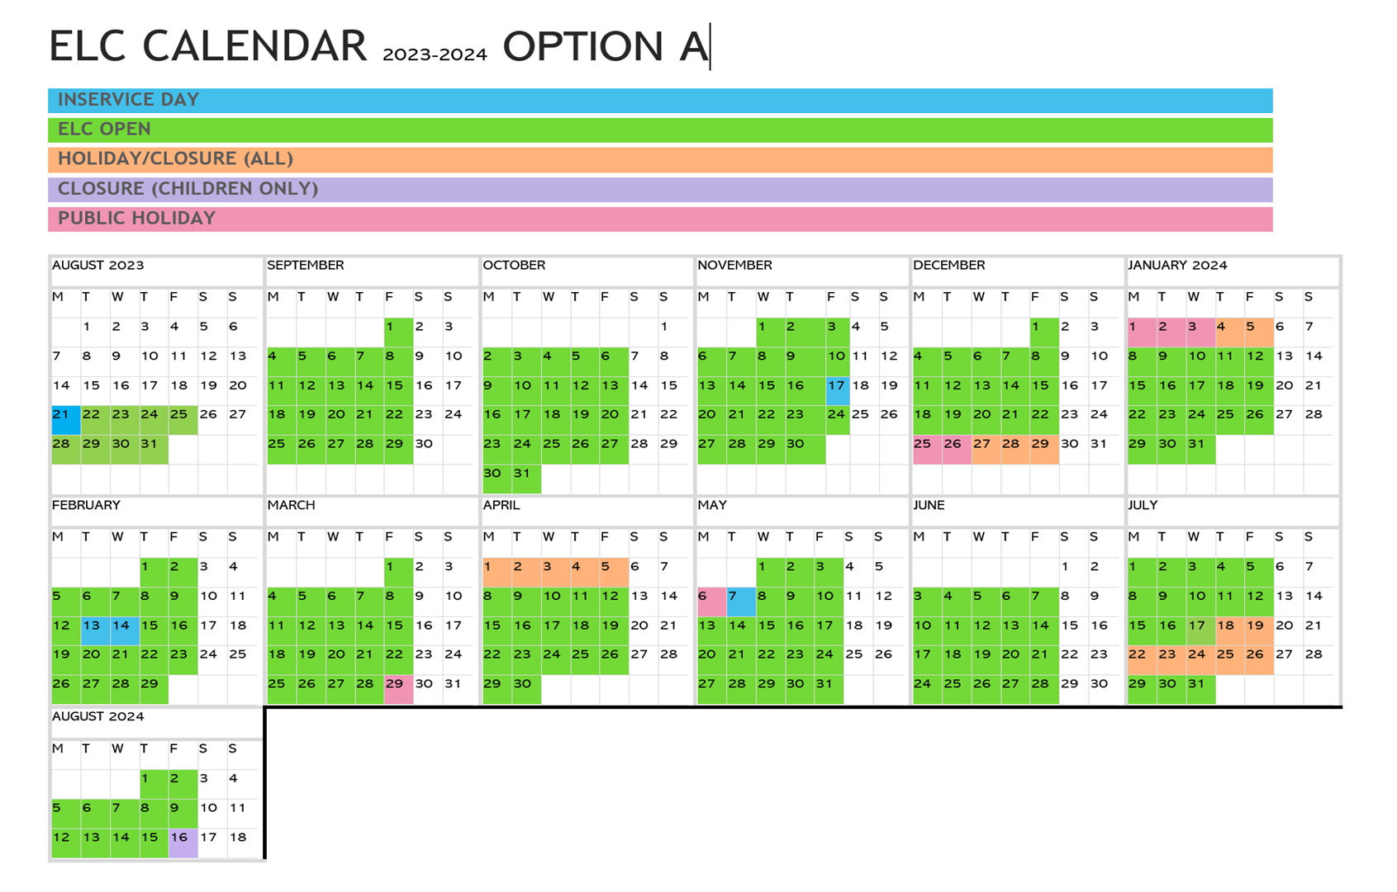



Nursery 3 Calendar 2023-24