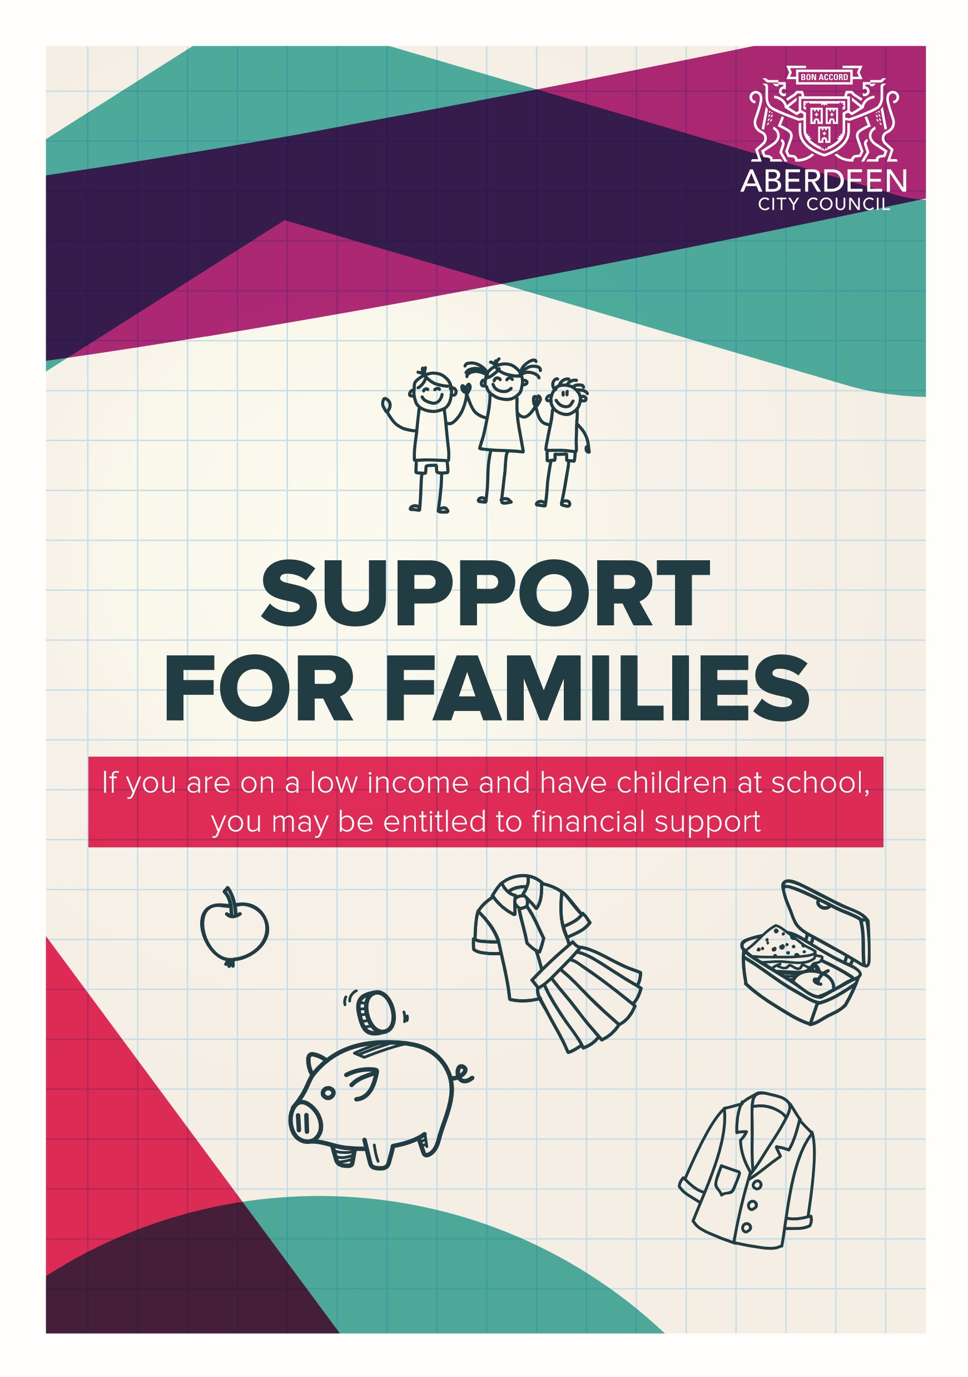

BEST START GRANT

WHAT
The Best Start Grant School Age Payment is £252.50 for each child to help with the costs of children starting school. It is up to you what you spend it on, and you don’t need to show receipts

WHEN
If your child’s date of birth is between 1 March 2016 and 28 February 2017, then you can apply between the 1 June 2021 and 28 February 2022.
If your child’s date of birth is between 1 March 2017 and 28 February 2018 then you can apply between 1 June 2022 and 28 February 2023
You cannot apply out with these dates.

WHO
You can claim this payment if you are responsible for a school age child (see previous information on application dates) and you or your partner are entitled to one or more of the following benefits listed below: • Universal Credit
- Child Tax Credit or Working Tax Credit
- Income Support
- Income-Based Job Seekers Allowance
- Income-Related Employment and Support Allowance
- Housing Benefit
- Pension Credit
You can apply anytime within the 9-month application window. If you have become responsible for a child, for instance as a kinship carer, you might qualify for a payment even if a payment has already been made to someone else – as long as you were not that person’s partner when they received the grant, and the child is not living with that person.
Apply online or download a claim form at www.mygov.scot/best-start-grantbest-start-foods/how-to-apply or call 0800 182 2222 to apply by phone or request a form.
FREE SCHOOL MEALS

WHAT
The School Meals Catering Service provides meals for all schools in the city. The service aims to provide nutritious, well presented meal choices daily, promote the healthier options and actively encourage their uptake and provide a service that meets the highest health and safety standards.
Currently Primary school meals cost £2.20. If you qualify for free school meals, you can save approximately £431 per year.

WHEN
From January 2022, all primary school pupils from P1 to P5 presently receive a free school meal.
If a child is in P1 to P5 and the parent/ carer meets the eligibility criteria due to low income, the parent/carer should apply for Free School Meals in order to receive vouchers during the holidays or periods of home learning. Access is also given to the Scottish Government Scottish Child Bridging Payments.

WHO
Pupils are eligible for free school meals if their parents or carers receive one of the following benefits: • Income Support
- Guaranteed Pension Credits
- Income-based Job Seeker’s Allowance
- Any income related element of
Employment and Support Allowance
- Child Tax Credit, but not Working Tax Credit, with an income of less than £16,105
- Both Child Tax Credit and Working
Tax Credit with an income of up to £7,500
- Support under Part VI of the
Immigration and Asylum Act 1999
- Universal Credit with a monthly earned income from your employer of not more than £625
- Universal Credit, with a single parent/carer working less than 16 hours per week with an annual earned income from employment of less than £16,105
- Universal Credit, with both parents/ carers working less than 24 hours per week with an annual earned income from employment of less than £16,105
Apply online:
www.aberdeencity.gov.uk/ freeschoolmeals

