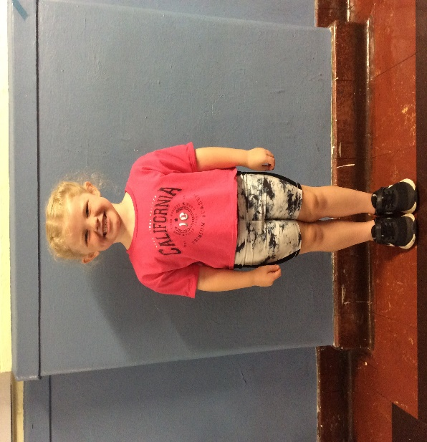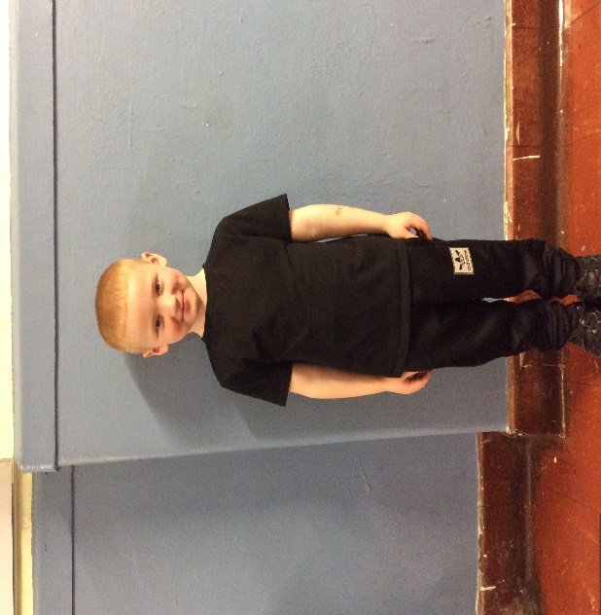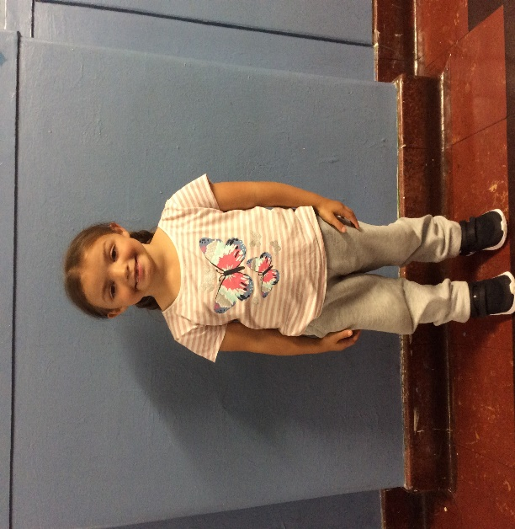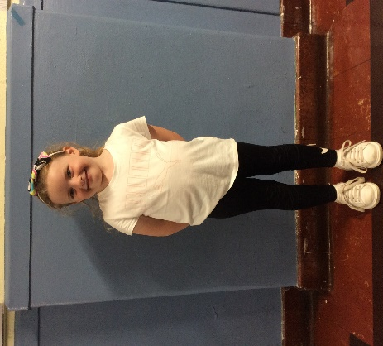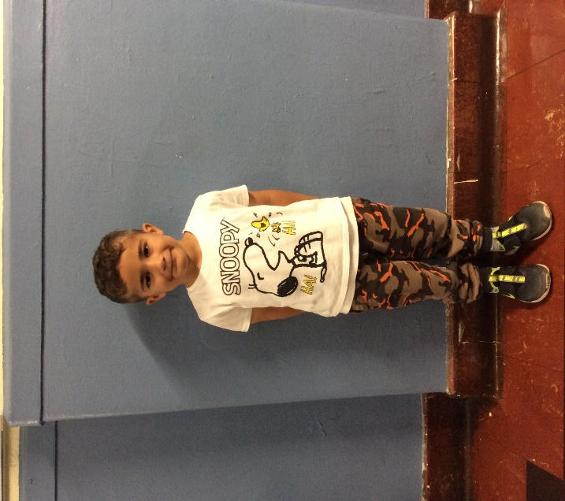

**For PE, Children should:**

**Children are not allowed:**

* Wear a t shirt and either shorts, leggings or tracksuit bottoms.
* Bring a jumper or hoodie in case of colder weather.
* Wear comfortable gym shoes or trainers that they can put on, take off and fasten themselves.
* Have any long hair tied back out of their face.
* Any vest tops or crop tops.
* Any football kits.
* **Any jewellery**. If children have their ears pierced, then they must either take their earrings out themselves before PE or remove them before they come to school that day.