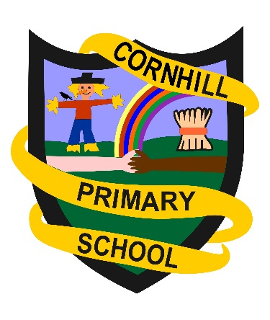Transition from Nursery to Primary 1.

We look forward to welcoming your child to Primary 1 at Cornhill. Here are a few ideas for some activities your child could do at home before they start school.

Practise putting on your own clothes and shoes – in Primary 1 you will get yourself ready for PE! | Design and make a friendship card for a new friend you will make in Primary 1. | Draw a map of how you will get to school. You could even draw the roads and pavements and talk to an adult about how you will keep safe.
Try making a snack you could have at school. Maybe a delicious fruit kebab or a decorated biscuit! | Make a sign for your door with your name on. Practise recognising and writing your own name. Remember to only use a capital letter at the start of your name. | Draw a picture of what you liked doing best at Nursery. Maybe you will do some of these things in Primary 1!
Practise opening your own snacks and lunchbox. See how quickly you can do it by yourself! | Be a number detective! What numbers can you see in your home or outside on a walk. Which numbers do you recognise? Can you write any of them? | Play I Spy with someone at home. Can you do it with sounds e.g I spy with my little eye, something beginning with a.

