My new school

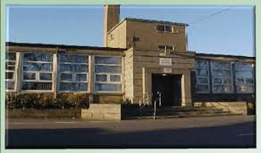

Cornhill Primary

I will be going to a new school after the summer holidays called Cornhill Primary school.

This is the school badge. It will be on my new school jumper.
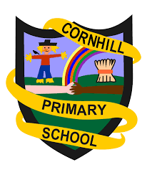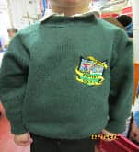

When the bell rings I will line up at these doors in the morning and wait for my teacher.
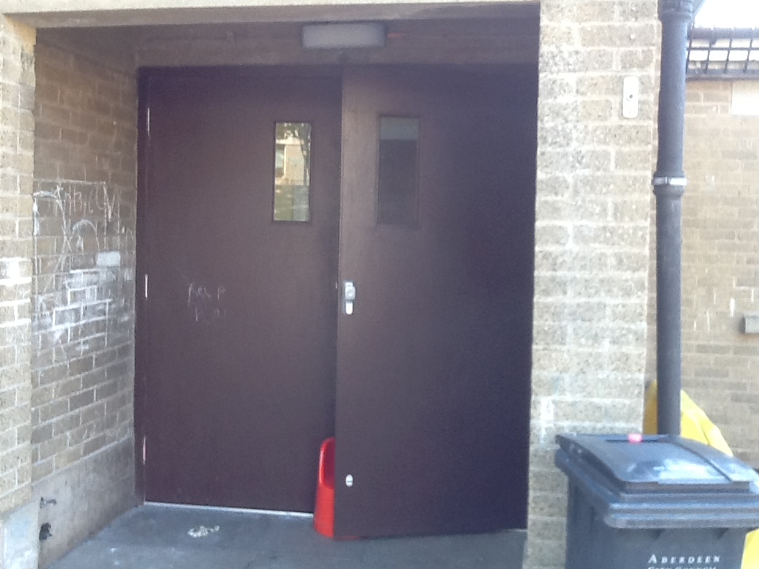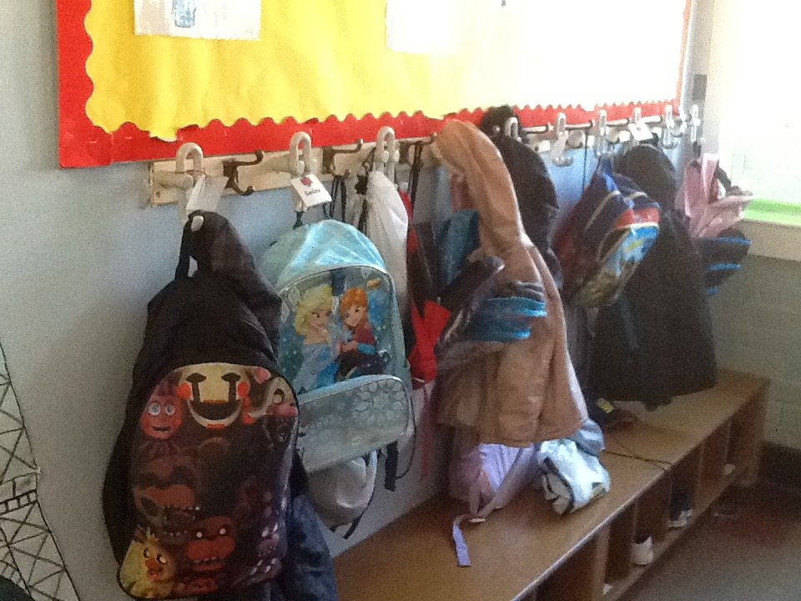

I will hang up my coat and take out my snack and water bottle, ready to line up for class.

My new teacher will look after me in my classroom. I will play and learn and have fun.
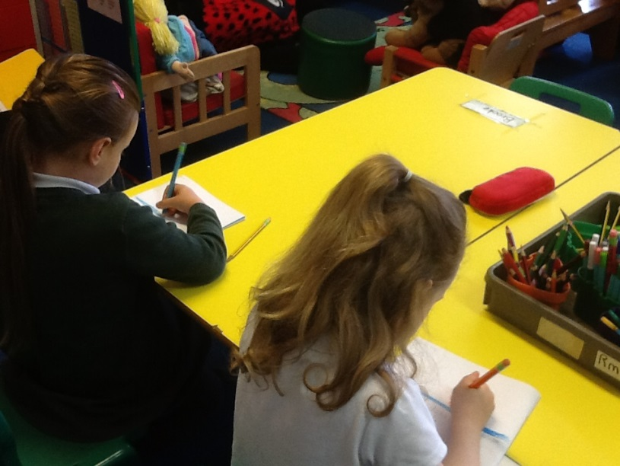

There are other places I might go to in school:
The Yellow Room
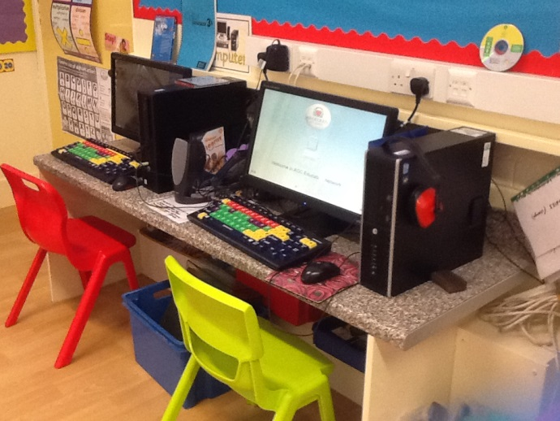

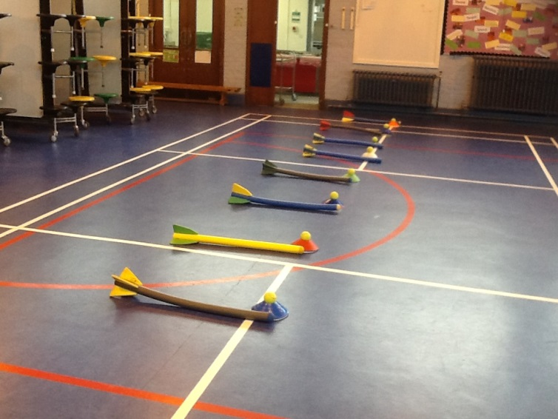

The gym hall

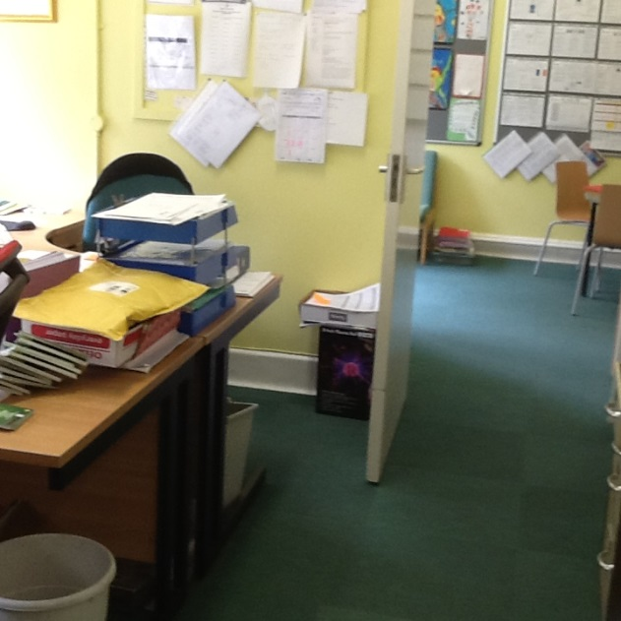

The office

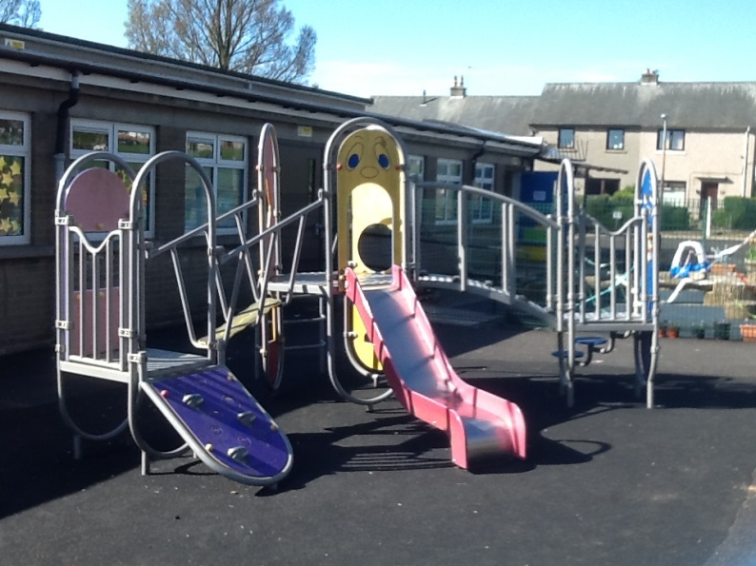
At break time and after lunch I will go outside and play in the playground.

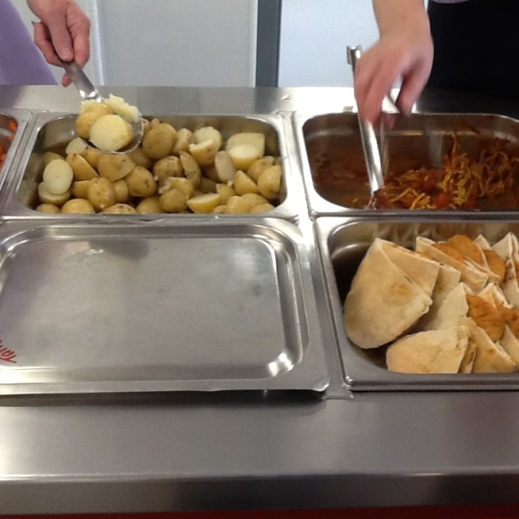
At lunchtime everyone will have their food in the lunch hall. I might have a school lunch.

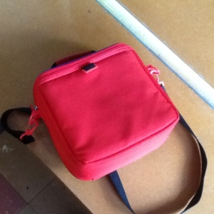
Or I might have a healthy packed lunch.

I will make lots of new friends at Cornhill Primary School and enjoy learning and playing.
