Term 1 Newsletter – Primary 2 (Room 5)
Welcome to Primary 2!  We hope you had an enjoyable summer break and are excited for the year ahead!  Here are some of the things we will be learning about through play…  This term we will be learning across the curriculum through books by Quentin Blake. We have already had fun with the story “Cockatoos” and we will be sharing our ideas with further stories including “Mr Magnolia” and “Angelica Sprocket’s Pockets.” | Numeracy  In numeracy we will continue to review number recognition and ordering numbers to 20 and beyond, going on to consolidate and build on our addition and subtraction skills. Our maths focus this term will be to explore pattern and symmetry in our environment through creating and recognising symmetrical patterns and shapes. | Literacy  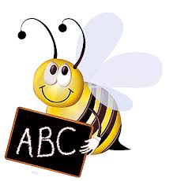  In literacy, we will consolidate prior learning of phonics and high frequency words, ensuring we have a solid foundation on which to tackle new and more challenging areas. These will include building our vocabulary, learning about the correct usage of punctuation and introducing conjunctions into our texts. We will be focusing on rhyming words through stories and creating our own stories.
Health and Well-being  Through our play we are going to be developing our understanding of emotions and our confidence to talk about them, knowing who to talk to when we need support. This will build on our resilience in new and challenging situations. We will continue to place a great focus on our own safety and hygiene in the current climate. | PE  PE will be on Thursdays. Please come to school dressed ready for PE outdoors, with lots of cosy and waterproof layers! Suitable footwear is also needed. All jewellery must be removed before you come to school on a PE day otherwise you won’t be able to take part. This includes earrings. Please ensure any long hair is tied back too. | A Learner at Cornhill is…  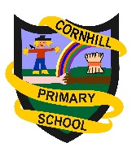  Respectful  Resilient  Self-Motivated  Focused  Inquisitive  We will be promoting these whole school learner qualities through daily yellow slips.
Other Information  - Please ensure that all clothing has your child’s name clearly labelled, including jackets, gym kits, indoor shoes, packed lunches, etc. Unfortunately teachers and PSA’s cannot be responsible for looking for lost items during or after school.  - The children will require a small snack for break time - it is only 15 minutes and the children need to play and eat within this time. Try to keep practising opening packets of crisps, tangerines etc. to help your child become more independent.  - Please provide a names water bottle for your child. This is the only way your child will be able to have a drink in school time, due to current guidance.  - We would appreciate if every child could donate a box of tissues to get us through the constant sniffles! |  | Key Covid-19 Measures  - 2 metre distancing between adults  - Each class is their own ‘bubble’  - Regular hand-washing/sanitizing routine in place  - No parents in the playground  - Careful selection and cleaning of resources
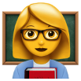
We look forward to having a great year with lots of fun learning opportunities. Thank you for your continued support.
Mrs Clementson

