Primary 4 Term 1 Newsletter- August 2020
Respectful – Self-motivated – Focused – Resilient - Inquisitive

Dear Parents/Carers,
Welcome to Primary 4! We hope you had a lovely summer break, taking into consideration the current situation. We am looking forward to working alongside you this year. Below you will find an overview of our learning for this term.
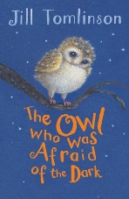  Topic  Our topic this term is a book study of ‘The Owl Who Was Afraid Of The Dark’ by Jill Tomlinson We will focus on the author’s style of writing, adjectives, adverbs, speech marks, acting out characters from the story, owl facts, nocturnal animals and safety at night. | Maths  We will be consolidating and further developing our core number skills, including addition, subtraction, multiplication and division. Please continue to practise this at home as well.  We will also continue to revise and extend our knowledge of symmetry in 2D shapes, angles and coordinates on a grid.
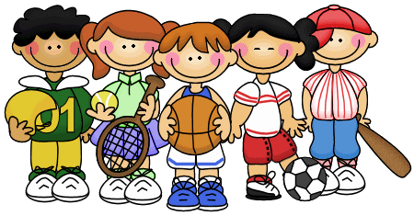  PE  This term Mrs Paul-Bird will be taking PE with our class on a Tuesday and Friday. Please ensure your child has a suitable OUTDOOR gym kit- layers of clothing and a waterproof jacket. Also, as a reminder that Aberdeen Council policy remains that there should be no jewellery (including earrings) worn on the day of PE. Your child should arrive at school wearing their kit. This term, Mrs Paul-Bird will focus on athletics. | Literacy  Due to Covid 19, reading books are not going to be sent home, however, reading skills will still be taught in class on a regular basis. Please encourage your child to read books at home. Soon, we will be introducing new phonemes and teaching grammar skills through writing and reading activities. We will be investigating different genre of writing based on our book study.
Golden Time  This year, Golden Time will continue to be structured with set activates agreed by the children. This does mean that your child will not be allowed to take a toy into school. | Reminders  Please ensure your child’s school jumpers, cardigans, PE kit, packed lunch boxes and jackets are clearly labelled with their name on it.  Due to water fountains not operating, each child requires to have a water bottle in class. Please try to avoid juice and fizzy drinks.  Due to Covid 19, please keep your child’s green bag at home for now.
As always, should you wish to discuss anything please do not hesitate to contact the school if you have any questions. As you will appreciate you cannot approach us in the playground due to social distancing.
Thanks for your continued support.
Mrs Garlick and Mrs Krakowska

