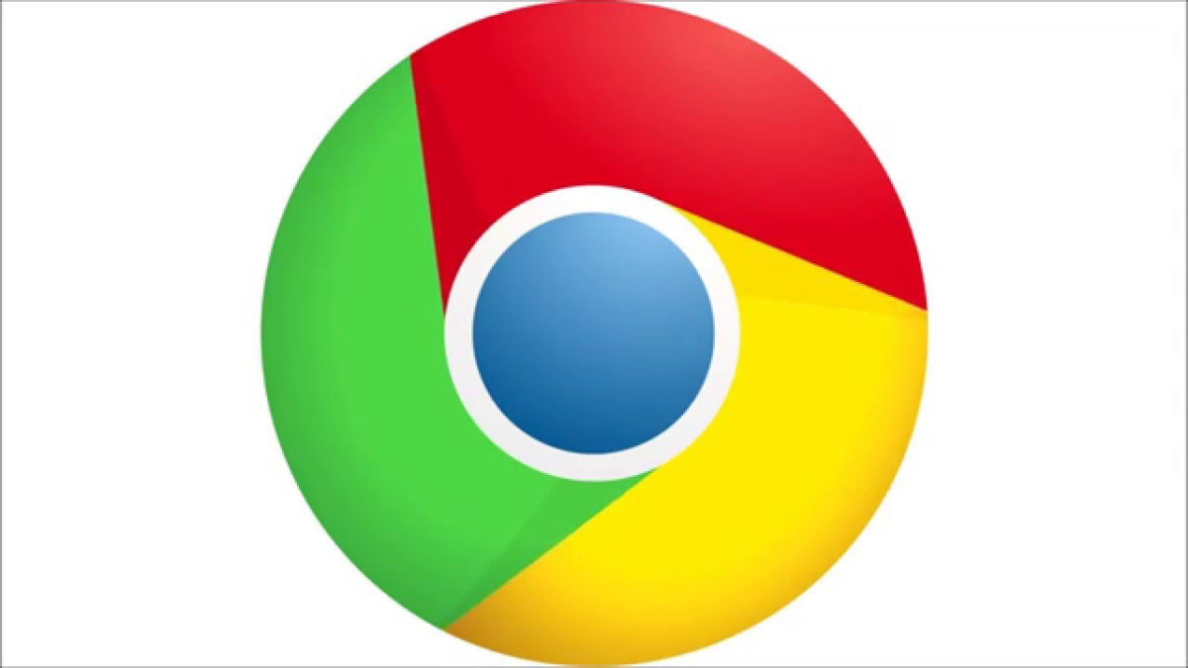
Handbook for Parents/Carers
Accessing Google at home
For laptops (if you have a Chrome device, log into device and go straight to Google homepage):
- Open a new Google homepage using Google Chrome (you may need to download the Google Chrome app)

- Click on sign in (top right corner) and enter email address then password

- Then click on the initial that will appear beside the address toolbar

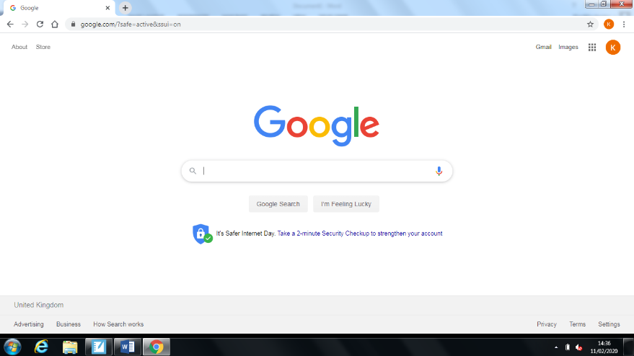

- Then click on the blue ‘Turn on sync’ button
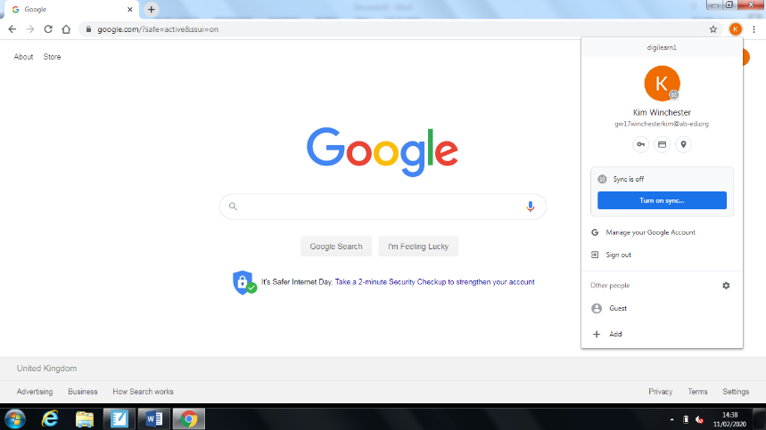

- Then a pop up message will appear, click on ‘LINK DATA’
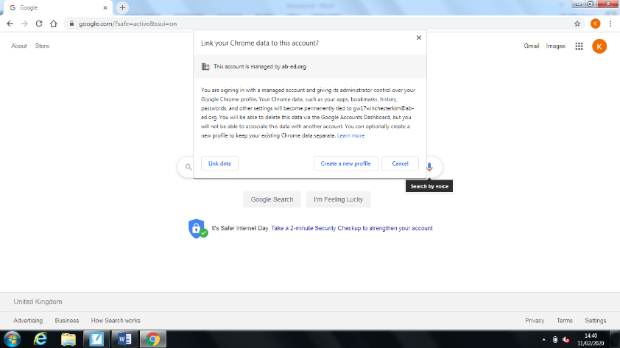

- Some messages may appear after – click on the yes I’m in/allow/blue buttons.

- Once fully logged in and the sync has been turned on, click on the waffle to access Gmail/Classroom/Docs or any other educational apps.

NOTE: if you are accessing this from an iPad or Android device, you will need to download the Google for Education apps which are as follows (if you put these names into the search of the App/Android store they should come up):

- Google (for App users use this rather than Safari)
- Google Classroom
- Google Drive
- Google Docs
- Google Slides
- Gmail
- Google Earth

Accessing Gmail
- To access Gmail when using a laptop, login/sign in to Google as usual
- Go a Google homepage.
- Click on the waffle.
- Click on the Gmail icon.
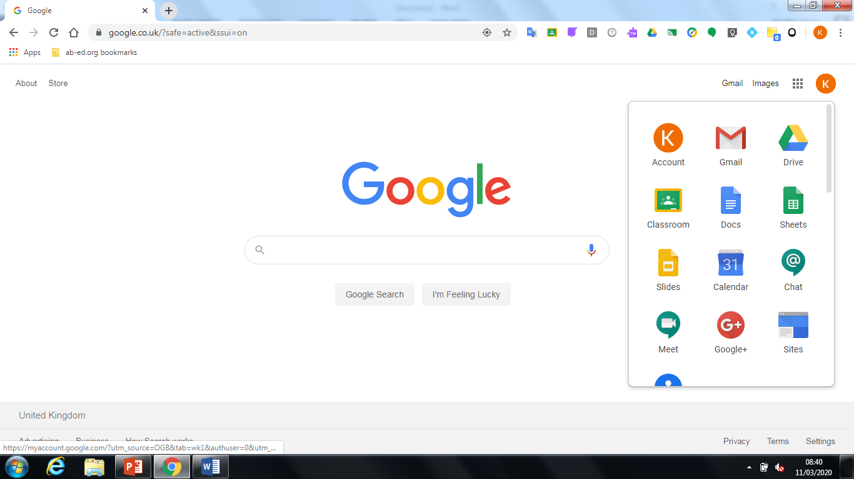

- This will open up your inbox which should look like this. Here you will see emails showing notifications of assignments being sent/invites to classrooms:
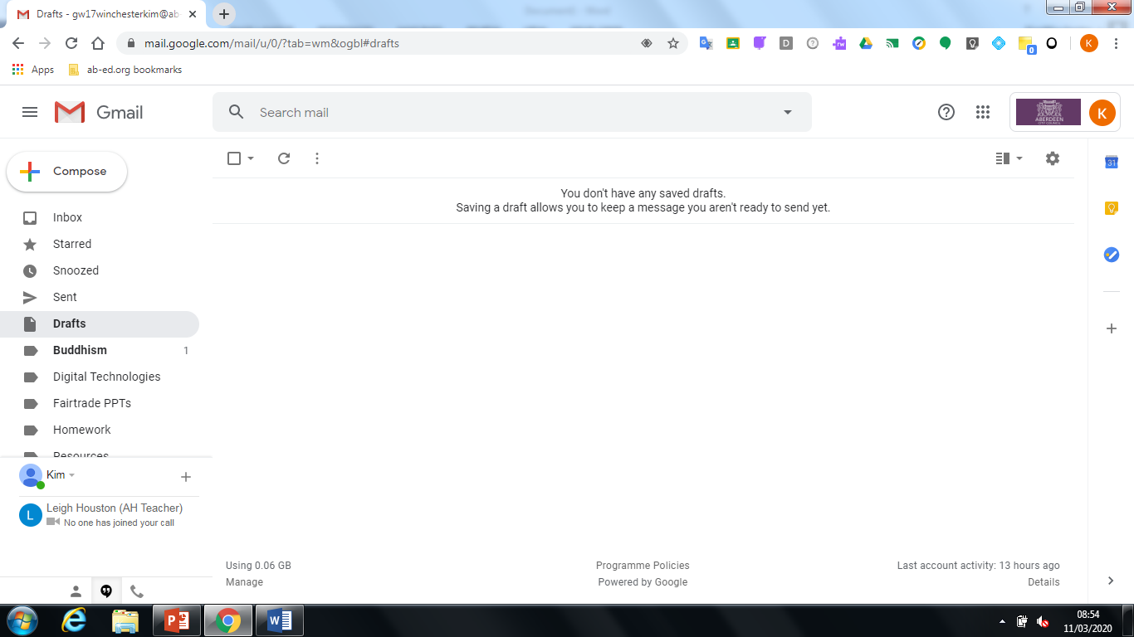

- You may want to set up folders so that work can be filed by subject, in order to keep your emails organised and keep track of what has been sent daily. To add a new folder, select the email(s) you wish to move by ticking the check box to the left of the email. Then click on the folder icon as shown:
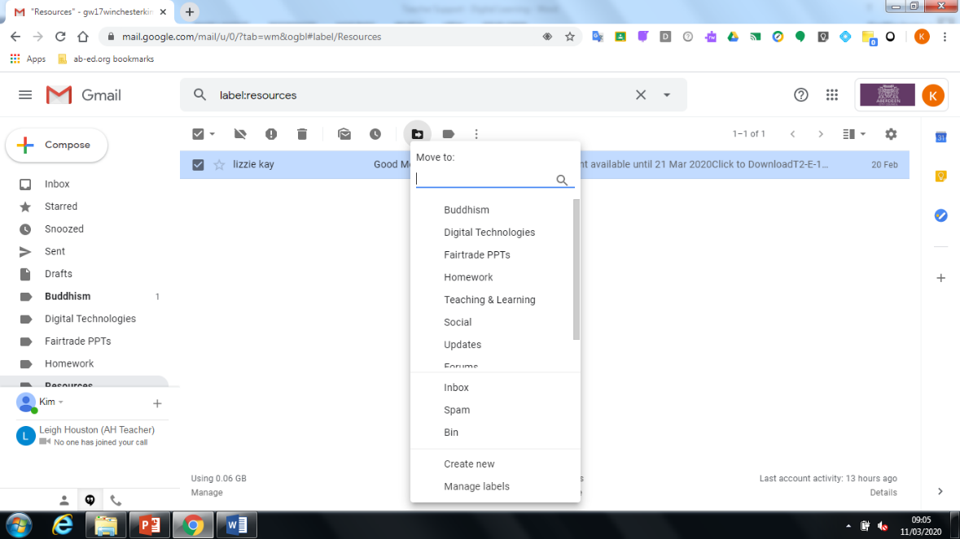
- Then click on ‘Create New’ near the bottom of the drop down menu.
- Then name the folder as you wish and click ‘Create’
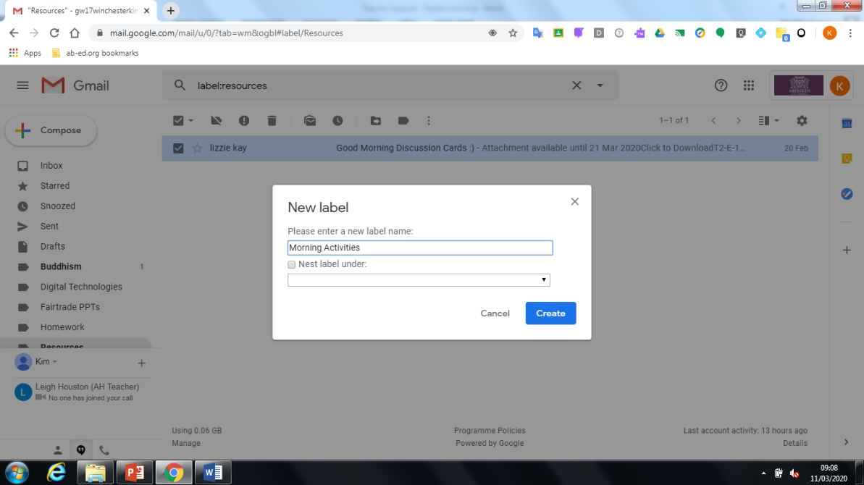

- The selected emails will then automatically move to new folder.
- To move emails to folders which have already been created, follow the above process but instead of selecting ‘Create New’, select the folder name which you wish to move the emails to.
Accessing Gmail from an iPad:
- Launch the Gmail app.
- Your inbox should appear listing any assignments you have been sent.
- Click on an email to read.
- If you wish to file emails into folders, select the circle next to the sender’s name (usually shows initials or a profile photo).
- Go to the three dots (meatballs as Google like to call them) and click on ‘Move To’ then decide which folder to file under.
- If you wish to add a new folder, go to the + sign in the top right corner and label a new folder.

Accessing Google Classroom
There are two ways that you could be asked to join a class room. Via email (through Gmail) or via a class code (via Classroom).

To access via Gmail:

- You will be sent invites to join Google Classroom via your Gmail.
- Go to a Google homepage and sign in as normal
- Click on the waffle on the top right of the Google homepage.
- Click on the Gmail icon.

- In your inbox you should see invites to join the different classrooms for different subjects. Click each email to open. Click ‘Join’
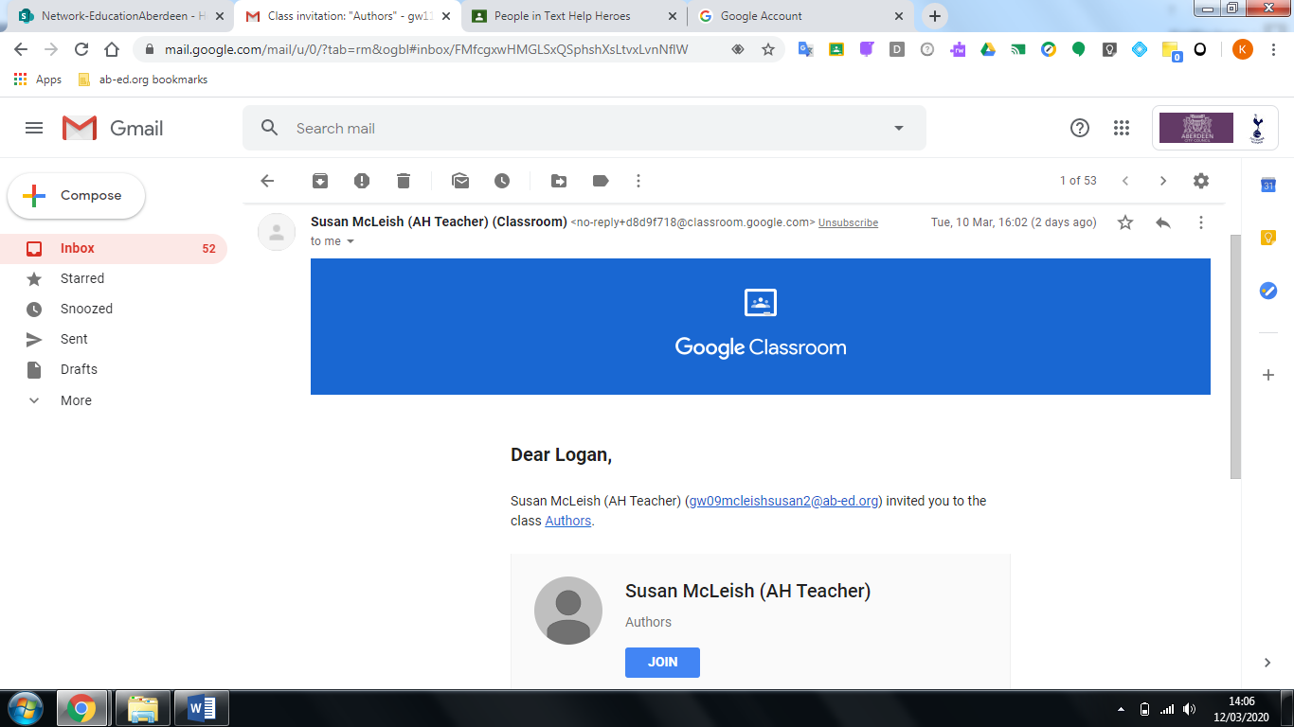
- After, you have clicked join, you should automatically be taken to the homepage of that classroom (which looks like below).
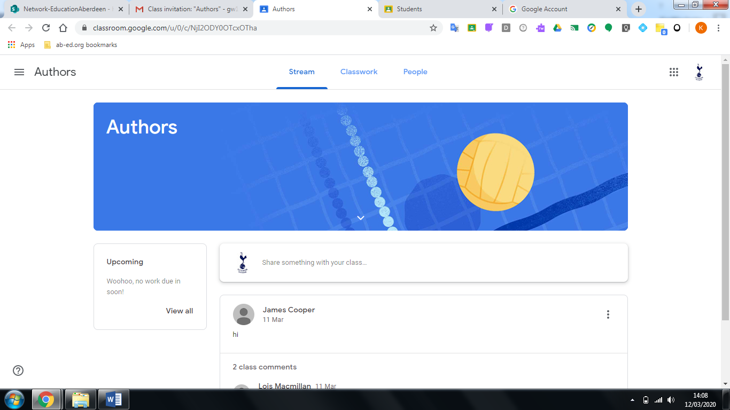

- For each classroom, your homepage will look like the above image. This is where you will access the work given to you by teachers.

To access via Classroom code:

- Go to Google homepage and click on the waffle.
- Click on Google Classroom icon.

- Once you see this screen, click on the ‘+’ sign in the top right corner of webpage. Then ‘Join class’
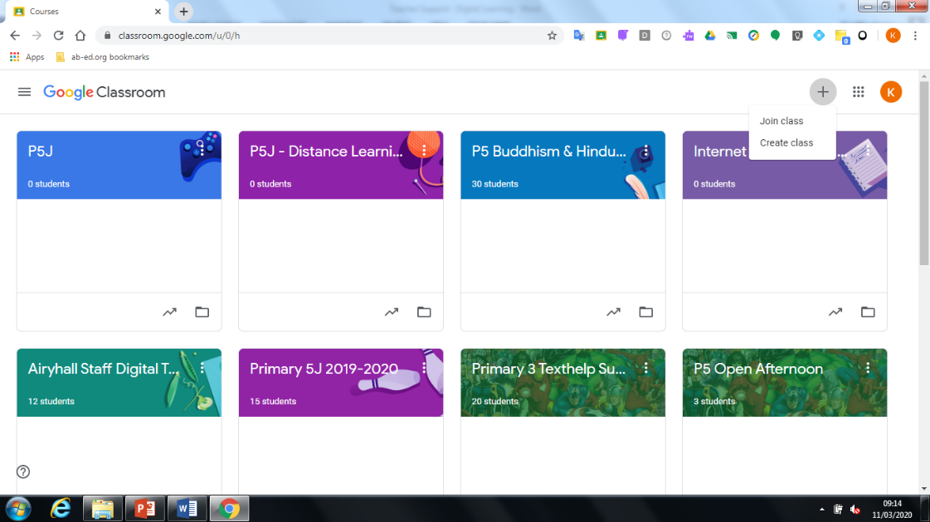

- Enter the class code you have been given and then click on join.

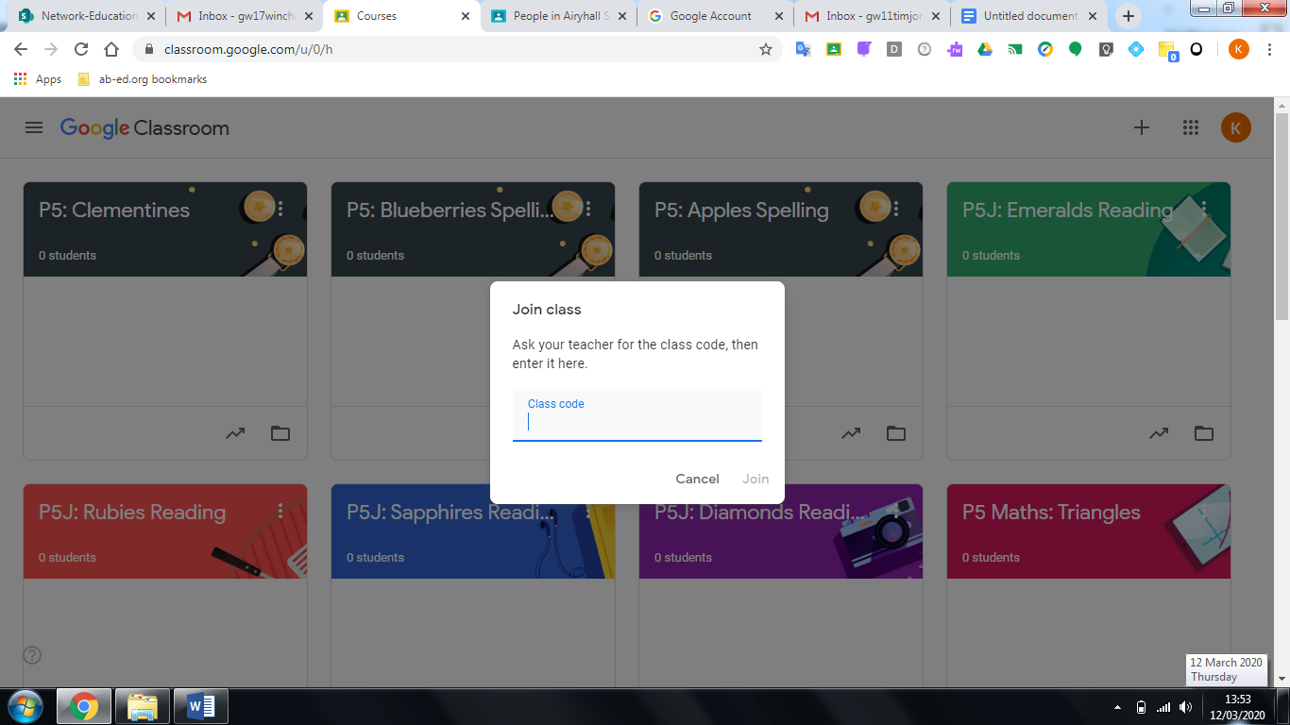

- The new Classroom should then appear. The ‘Stream’ is your class’ homepage which you can use to see what work has been assigned:

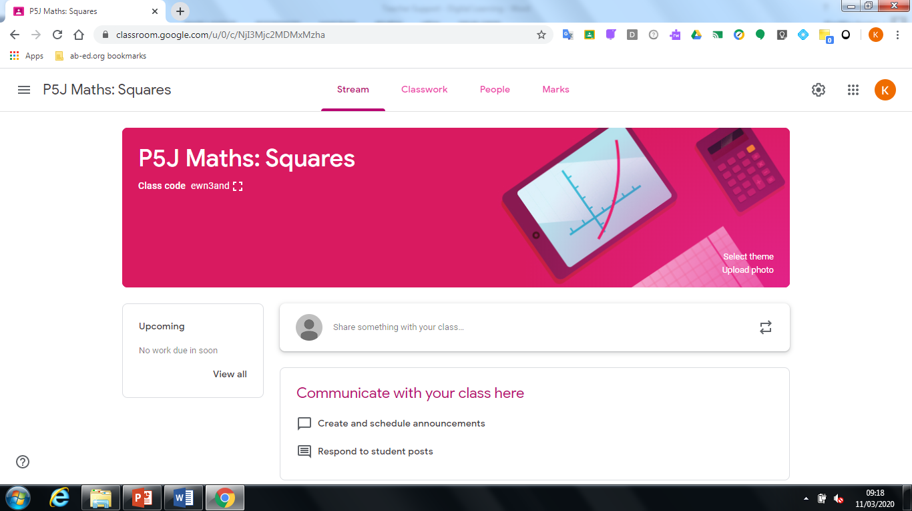

NOTE: if you are accessing Google Classroom from a mobile device, the tabs for Stream, Classwork and People might appear in a different place. You should be able to access all the classes that your child has been added to, within the homescreen of the app. To navigate to different classrooms and to get to the homescreen, use the three line menu (known at the Hamburger by Google) at the top left.

Accessing Google Assignments
- Go into the Google Classroom using the waffle.
- Click on the Classroom that you will be completing the assignment for.
- When the Classroom homepage/Stream appears, you can check the stream for your assignments or alternatively click on the ‘Classwork’ tab along the top.
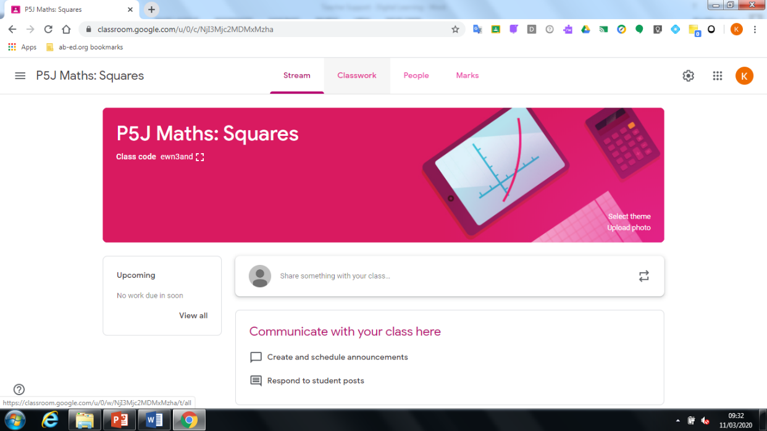

- Then you will see assignments that have been posted. Click on ‘View assignment’ of the one you will be working on.
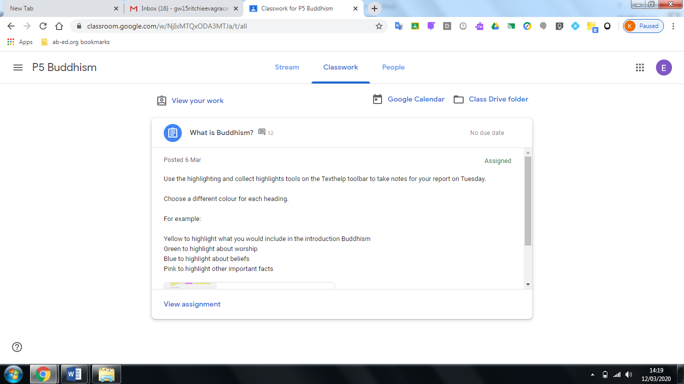

- Then you will see this screen, which shows the full details/instructions of the assignment. Click on the document which has been assigned as shown by the arrow and it should open in a new window ready for you to work on.
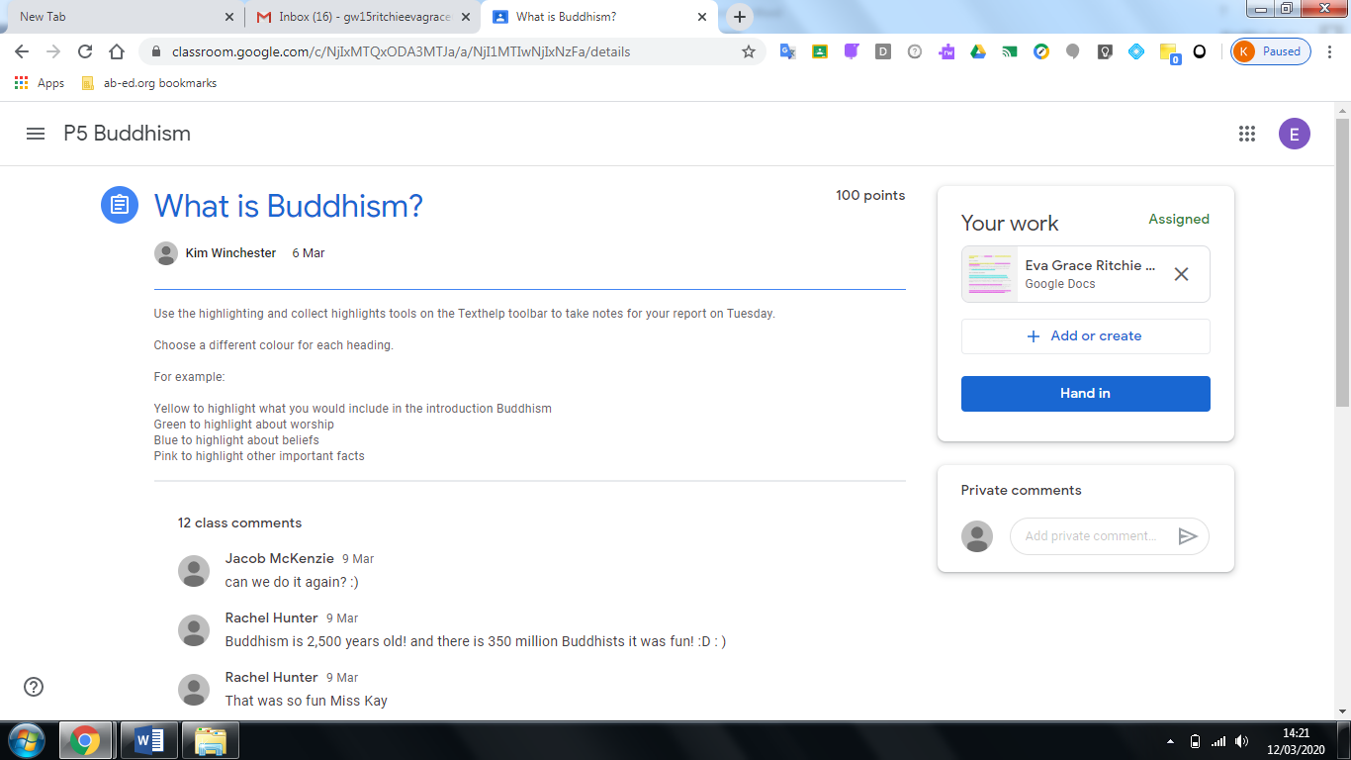

- Once you have completed, you can close the tab using the cross (you do not need to save each document as it will automatically be saved in your drive)
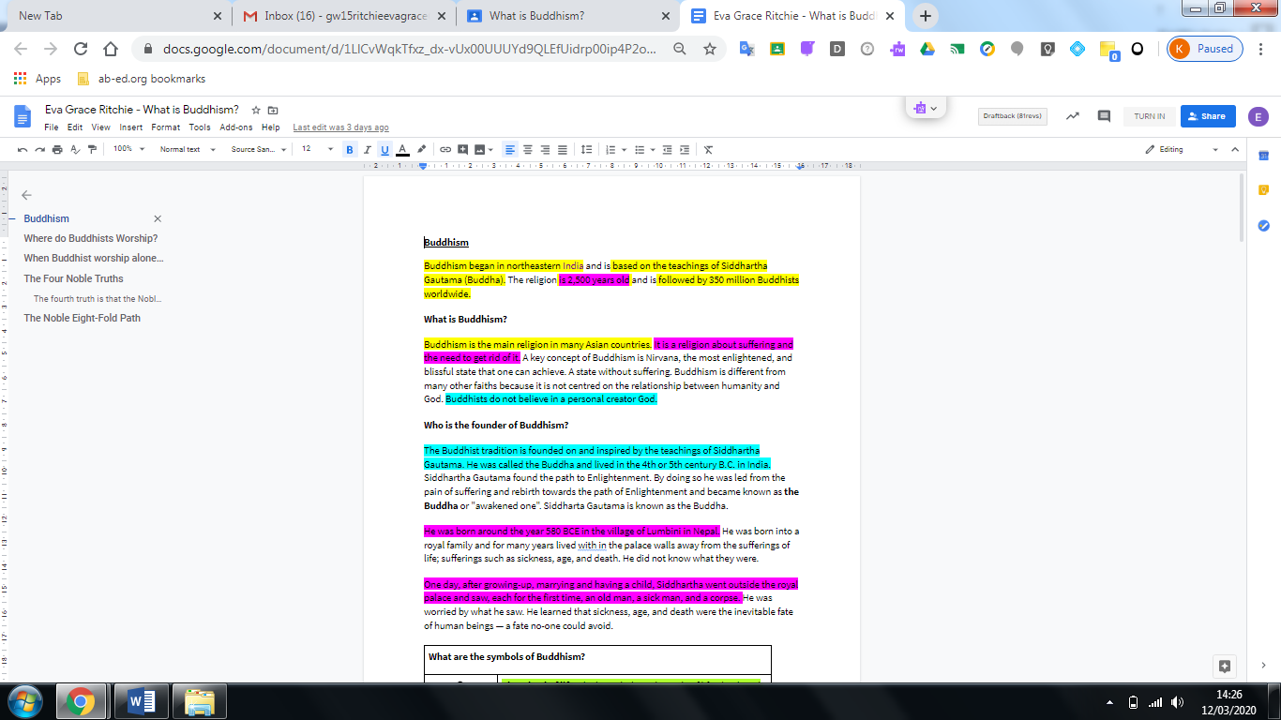

- You will be taken back to the page shown below then click on the ‘Hand in’ button to send to your teacher.

- Most of your main assignments will be given in this format.
- Please make sure you check the ‘Stream’ of your classrooms daily too as teachers may post links for websites to use in research tasks or links to games that can be played.

NOTE: if you are accessing Google Classroom from a mobile device:
- You will be able to access assignments by clicking on the ‘Classwork’ tab. Here you will see what work has been set and the instructions given.
- To find your task to complete, slide up in direction of the arrow ‘Your Work’ then click on the document.
- Click on the box with the arrow (top right) this will take you to the appropriate application to edit the document.
- Click on the tick in the top left once completed.
- Exit the document using the cross in top left corner (do not worry about saving as it is done automatically).
- Click on ‘Hand In’ within the classroom.

Uploading Docs, Photos & Videos
If you wish to know how to upload a document directly to Google Drive, follow the instructions below.
- Access Google drive by going to a Google homepage, click on waffle and then click on the ‘Drive’ icon.

- To upload a new document, click on ‘New’.
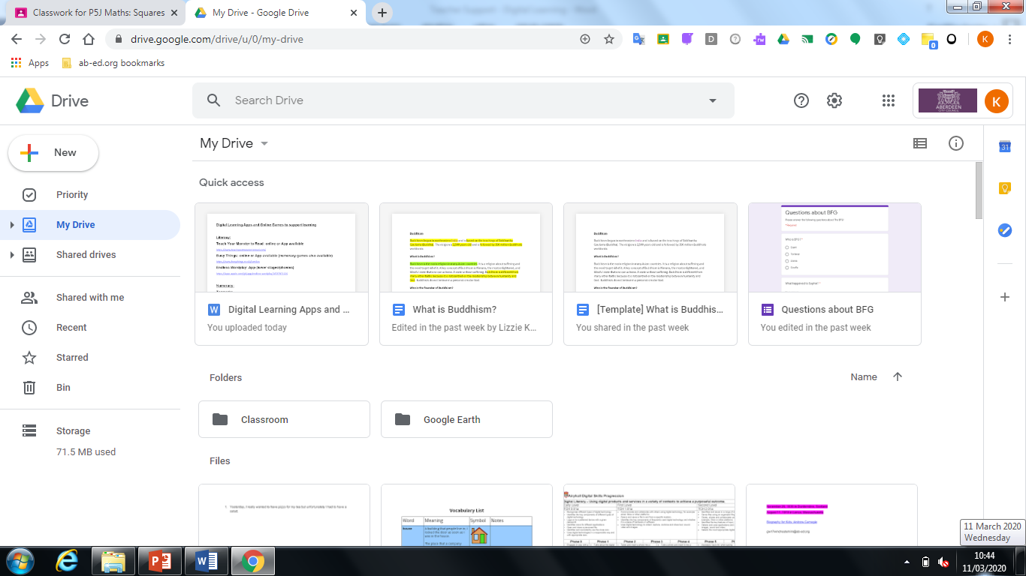

- Then click, on ‘File Upload’.
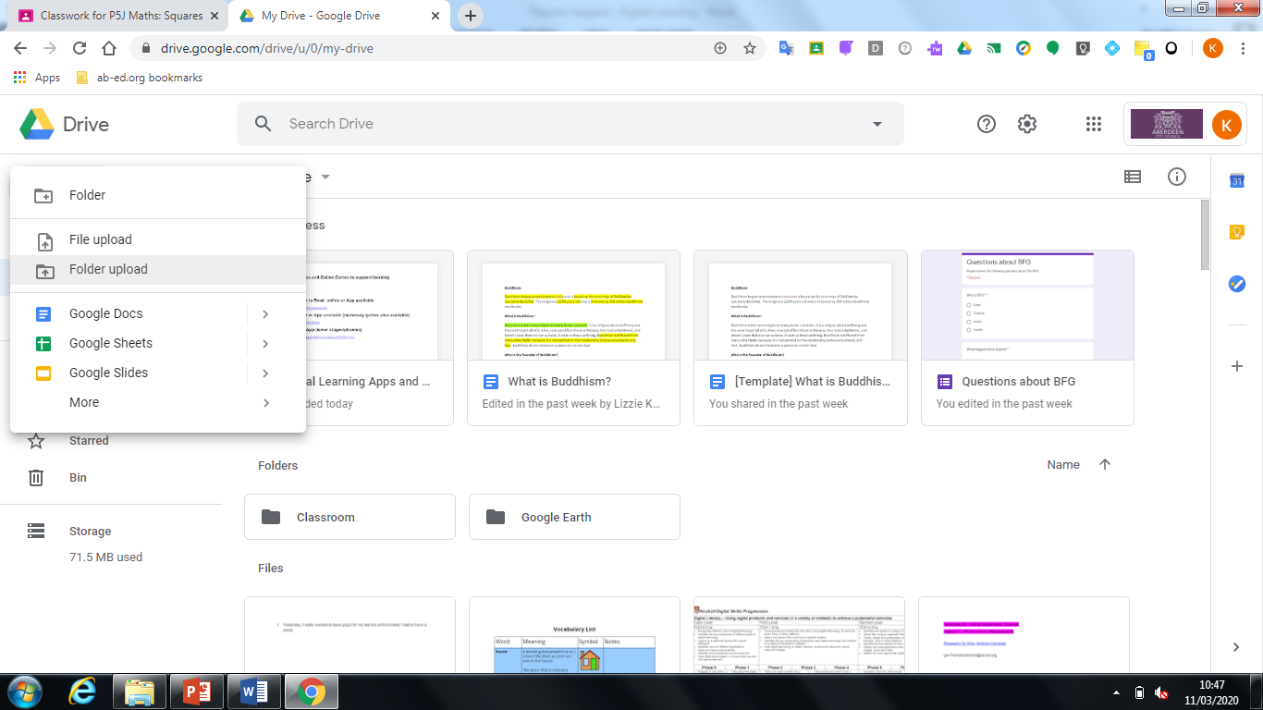

- Then choose document from your computer. Click on ‘Open’ then it will automatically be uploaded to your drive.

- You can then attach this to an email using Gmail if you wish to share with your teacher. Use the search option to find your teacher’s email.

NOTE: if you are accessing Google Drive from a mobile device:
- Access Google Drive app.
- Click on the + sign (bottom right).
- Then within the ‘Create New’ section, look for the relevant document you wish to upload. E.g. a Google Doc, photo.
- Once in Google Drive, you will be able to share by clicking on the three dots beside the title of the document you wish to share(meatballs).
- Click share and then search for teacher’s name.
- Click on the paper aeroplane to send.

Creating a Google Doc
- Once you have signed in to Google click on the waffle to access Gmail/Classroom/Docs or any other educational app:
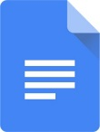
- Then go to Google Docs:

- Then create a new document.

- When the new document is created, rename it here with the date and your name (just click on the box to edit):

- Then click on the white page and begin typing to create your sentences. Click on the purple puzzle piece for the Texthelp toolbar.

- To share the document with me, click on the blue ‘SHARE’ button.

- Then type in your teacher’s email address in the people section then click on the blue ‘SEND’ button (see list of teachers emails). Add a message if you wish.
NOTE: if you are accessing Google Docs from a mobile device:
- Open the Google Docs app.
- Click on the + (bottom right).
- Choose the ‘New Document’ option.
- Give your Doc a name (it would be helpful to include your name, subject and date in this).
- Then you can begin typing.

Creating Google Slides
- Once you have signed in to Google click on the waffle to access Gmail/Classroom/Docs or any other educational app:
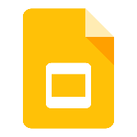
- Then go to Google Slides:

- Then create a new presentation.

- When the new presentation is created, rename it here with the date, title and name (just click on the box to edit):
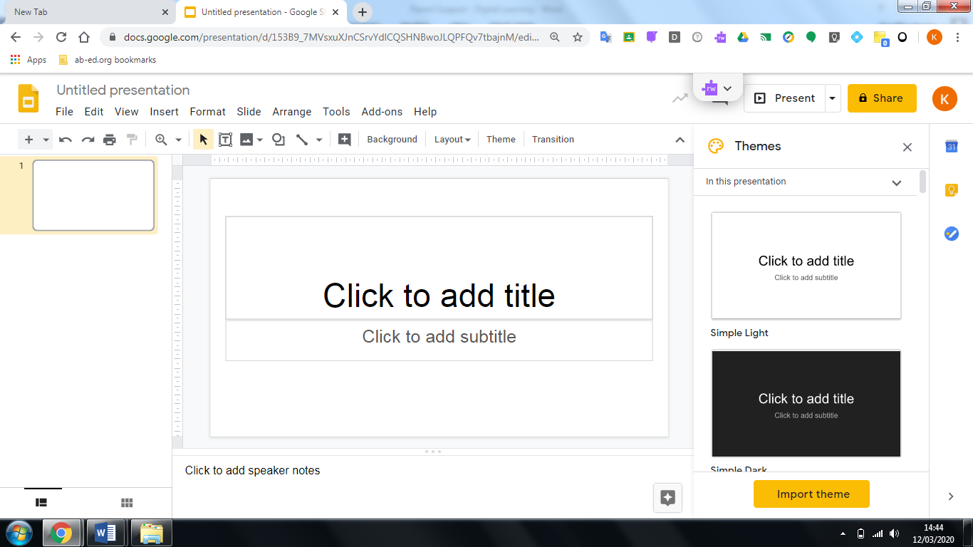

- Then click on the slide and begin typing to add information. Click on the purple puzzle piece for the Texthelp toolbar.
- Google Slides is very similar to Powerpoint.
- You can add slides by going to ‘Slide’ tab.
- You can change the themes by using the ‘Theme’ tab.

- You can insert pictures by clicking here, then ‘search the web’, type in the google search what you’re looking for, select the image and then click insert.
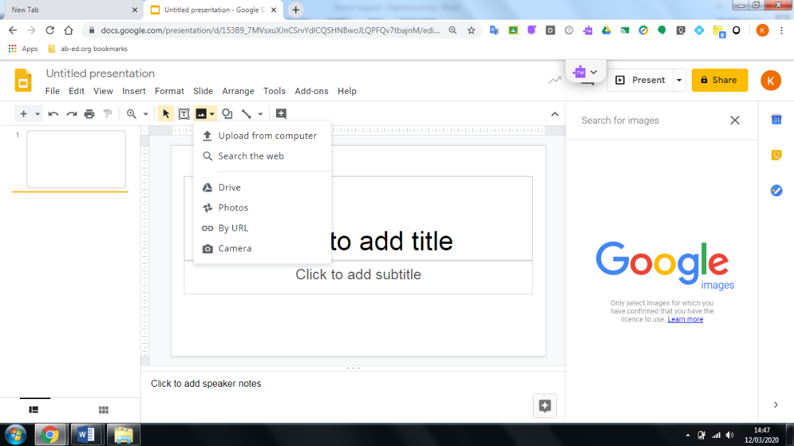

- To share the document with me, click on the yellow ‘SHARE’ button.

- Then type in your teacher’s email address in the people section then click on the yellow ‘SEND’ button (see list of teachers emails). Add a message if you wish.

NOTE: if you are accessing Google Slides from a mobile device:
- Open the Google Slides app.
- Click on the + (bottom right).
- Choose the ‘New Presentation’ option.
- Give your Presentation a name (it would be helpful to include your name, subject and date in this).
- Then you can begin designing.

Teacher’s Emails

Class | Email

