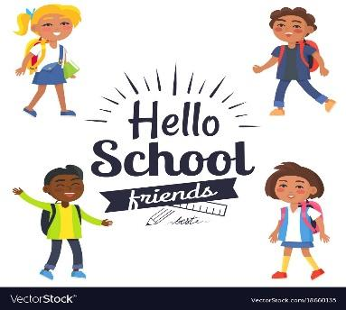

To my Nursery Friend,

We are all looking forward to seeing you in p1. It can be a little scary but we all will help you get through it. It is very easy to make friends and the teachers are nice and helpful. There is lots to do in the playground and the buddies will look out for you.
The food is good as well, I recommend the pizza, it is good!!!!!

Can't wait to meet you, I hope you enjoy it like I did.

Good luck
Logan C
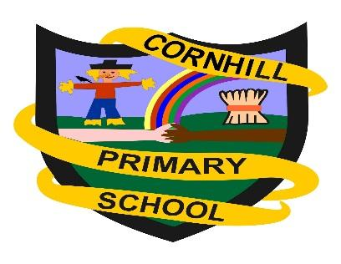
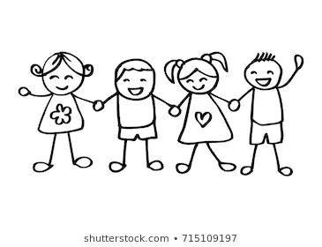

To my Nursery Friend,

I hope you are looking forward to primary 1 Cornhill is a great school. The teachers are all nice and kind. You can do lots of fun stuff like PE, Golden time, Table points and the table who gets the most pom poms or high fives gets extra golden time. The p7s will be your buddy and this means we look after you and play games with you and make sure you dont do anything you are not supposed to.
There are golden rules some of them are be kind, tell the truth, don’t hurt people’s feelings.

Thank you
From Layla :)

To my Nursery Friend,

I 'm really glad that this year you're coming to primary one. It's the first time you will come and it will be a great experience for you. You will have new friends, and new teacher. As I am a senior I will be there to help you. We can meet in the break. Now our school timing will be the same, we can go and come back together.
I hope our house (Cairncry) will be the same. I hope our school will start soon. I'm sure you will like the school. We can sit together during lunch break and talk with each other while eating. I can’t wait until the school starts.
As you are aware about covid pandemic, we should take care of yourself and maintain the social distance. But please don’t be afraid school will also help us to maintain the social distance and will take care of necessary precautions.
Till then bye, see you later.

Your Friend,
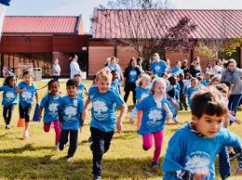
Sejal

To my Nursery Friends,

We are so looking forward to seeing you in P1. Cornhill is great because there you will find lots of fun friends, who will help you in any problem and the teachers are very nice. They will always be there if you need help. There is lots of space to play in the playground. I hope you have fun at Cornhill.

From your buddy
Sanvi

To my Nursery Friend,

Hi everyone that is starting in p1 this year. Our school’s teachers and pupils are looking forward to seeing you all. We are all very friendly and will look after you all and make you feel safe at our school. Our playground is large and safe for you all and there’s lots of fun things for you to play with, there will be lots of friends for you to play with too. My name is Murray and I am one of the buddies that will also be looking after you and play with you.

See you all at the start of the new term

Murray P7.

To my Nursery Friends,

I am writing to tell you I'm really, really excited to see your lovely faces as I’m going to be your buddy at school. You can pick any game you want. We can play duck duck goose, head shoulders knees and toes and we can also sing. I love singing what's your favourite song??? Mine are the three little piglets! I made you laugh. I’m so proud of you all for doing the stuff that you do in nursery. Other than that I hope you see my letter. I can’t wait to know your names.

Yours sincerely Dylan.

To Future P1s,
I am writing to tell you about Cornhill. When you first meet your teacher it can be a little bit scary but once you have met them you will see they are really nice. In the playground you will meet new friends really quickly. I’m sure you will see bigger kids with bright yellow vests on, they are buddies and if you need help you can go to them and they can even play with you! I hope you enjoy your time in P.1!

Love Alesha
To my Nursery Friend, Hello and welcome to my letter. Today I am going to tell you about how excited I am to see you when you come out of nursery. The teachers are so friendly and you will have so much fun. There is so much things to do and I am sure you will enjoy at least one learning experience

From Supreme Neupane.

To my nursery friend,
Everyone is looking forward to seeing you and don’t be scared on your first day!

Since, the primary 6’s are moving up to primary 7’s… we will be your buddies! All the new Primary 1 teachers are really nice and bright, and they will help you if you need anything inside. Your buddies will be outside in your massive playground you’ve probably seen from your nursery. In your playground they will be others just like you trying to find someone to play with, so you could just go over and ask if they could play with you. You could also ask the buddies around you if they could arrange a huge game of your choice! If you see a friend hurt, go and call one of your buddies and then they will call the teacher to take care of you.
I am really excited in seeing all of your smiling faces on the first day back at school.
From,
Sophie xx

To my Nursery Friend,

Are you excited for your new class? School can be a very scary place but don’t worry the teachers are very nice and will do their best to help you. There is a big playground with lots of fun things to do. There are some really good clubs in the school. I do choir and really like it. You will get to learn some really cool things.

I hope you will be happy in your new class.

From Ashley Vallance

