Starting P1  At Cornhill we aim to make the transition to school as smooth as possible by establishing a friendly, caring rapport between child, parents/carers and staff. To begin with children attend for half days, until lunchtime. Children start in small groups so there are several start dates over the first few weeks.  Times  Normally, School starts at 9am. Break is 10.30-10.45, Lunch is 12-12.45, Home time is 3pm. You will be advised of your child’s days and times individually during the Covid crisis.  Entering and leaving school  Normally, the children line up outside the door until their teacher comes at the bell to bring them in. Special arrangements are in place due to Covid this session, the need for social distancing is essential to ensure the wellbeing of all. When you collect your child please step forward to claim them as it can be hard to spot everyone’s mum/dad/gran or childminder! If someone different is collecting your child please inform the teacher in advance to ensure your child’s safety otherwise we will have to telephone parents to ensure the arrangement is agreed.  If a child has a medical appointment during the school day they must be collected from the school office by a parent or adult known to the child. If your child is late for school he/she must come in through the office entrance.  At break time children are encouraged to bring a small, healthy snack and drink. Support staff supervise in the playground. Most days children play outside so please ensure they have suitable outdoor clothing for cold and wet weather. More outdoor activities will take place during Covid crisis.  Inside school  Each child has a peg and space for storing shoes. Please do not bring toys to school as we cannot guarantee their safekeeping. Please encourage your child to be independent, changing shoes, putting jackets on & off, managing zips and buttons, looking after their belongings.  Children change into gym shoes indoors so ones with Velcro rather than laces are helpful.  PLEASE PUT YOUR CHILD’S NAME ON EVERYTHING! | Golden Rules  Our behaviour support policy is based on these Golden Rules:  - We are gentle  - We look after our own and other people’s property  - We listen and follow instructions first time  - We are honest  - We are kind and polite  - We always work hard and do our best  Attendance  Good attendance is very important. If your child is to be absent please telephone the school office on 01224 483234. Unexplained absences will be followed up by the Home School Liaison Officer.  Communication  If you have any concerns please make an appointment with the class teacher or a member of the management team. You can pass on BRIEF messages to the class teacher while dropping off your child but remember the teacher is responsible for the whole class at this time so cannot talk at length.  Uniform - Dark green school sweatshirt, online at myclothing.com and white polo shirts, black or grey trousers or skirts; PE kit, white tshirt and black shorts, no football strips  School lunches - free lunches for all P1-3 children. Please advise us of any allergies or foods your child should not have for other reasons. A packed lunch is is the only option currently. Apply here for free school meals or food vouchers  https://www.aberdeencity.gov.uk/services/education-and-childcare/school-life/apply-free-school-meals  Homework  Homework reinforces learning from school; initially letter sounds are the main things we would like you to practise at home with your child. A termly homework grid will indicate other tasks you are encouraged to do with your child.  Emergency contact information  Please keep your contact details up to date with the office so that we can get in touch whenever necessary.
My P1 teacher is
Ms Clementson

Starting P1
I will need;

School bag
School jumper
Gym shoes
T- shirt and shorts for gym (all named)
Small healthy snack

School Contact details;

Headteacher – Mr Evans
Telephone number – 01224 483234

Email - cornhillprimary@aberdeencity.gov.uk
Website - cornhill.aberdeen.sch.uk

School Information Line
0870 054 1999
Pin 011250
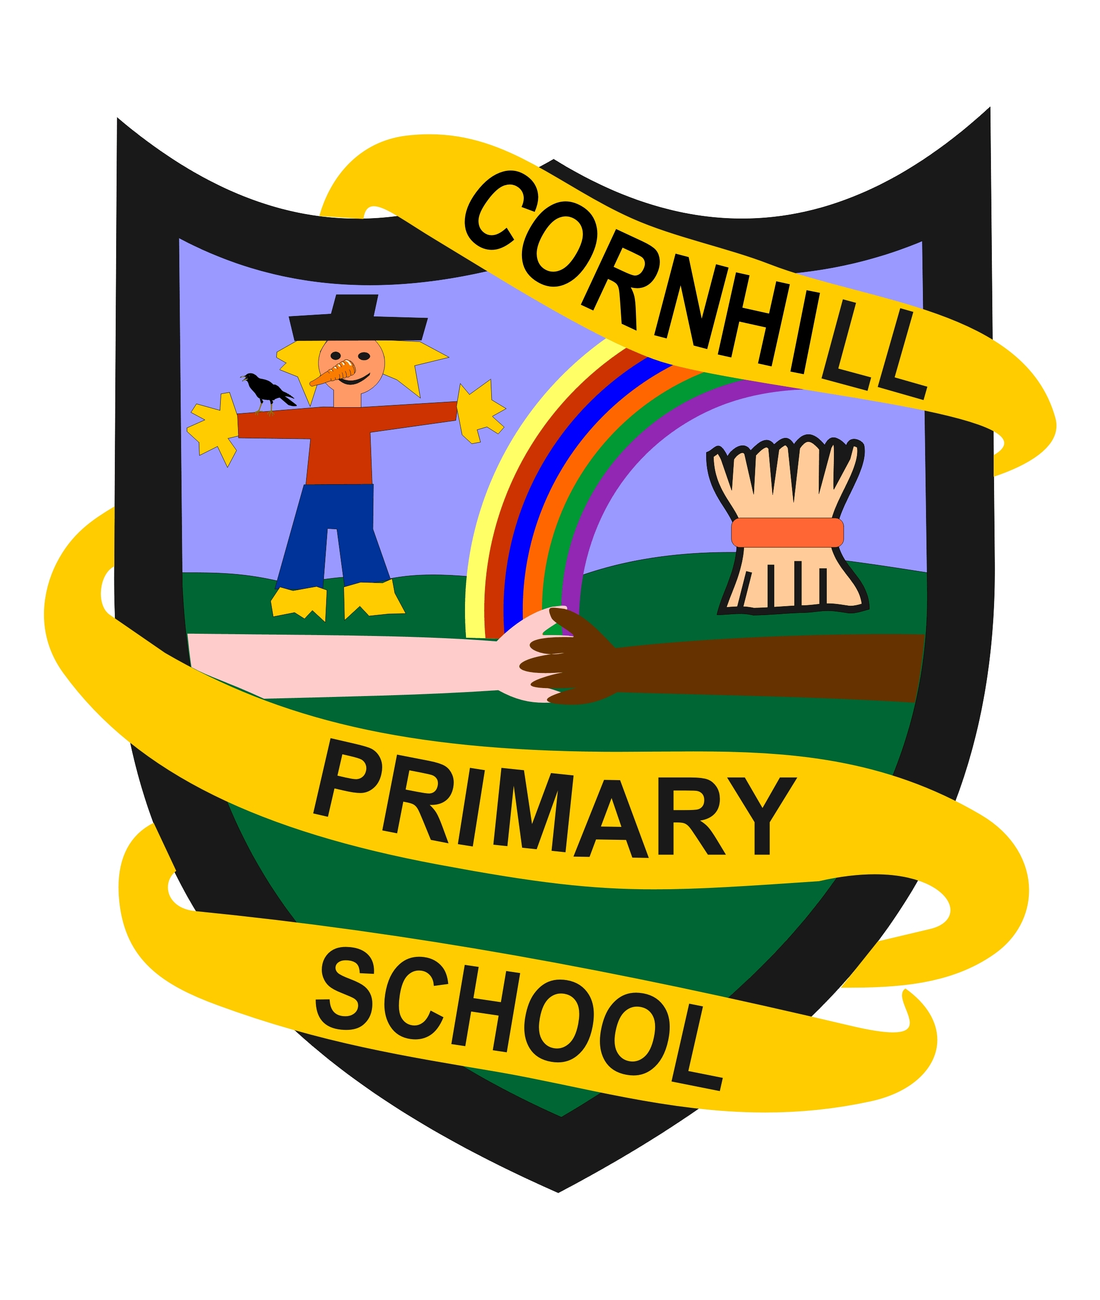

I will need;

Gym shoes
School bag
School jumper
Small healthy Snack

