My new school

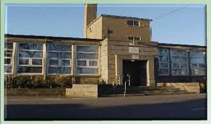

Cornhill Primary

I will be joining Primary 1 after the summer holidays in Cornhill Primary school.
This is the school badge. It will be on my new school jumper.
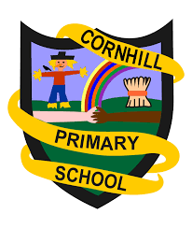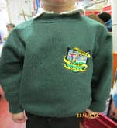

The bell will go and I will line up at these doors in the morning and wait for my teacher.
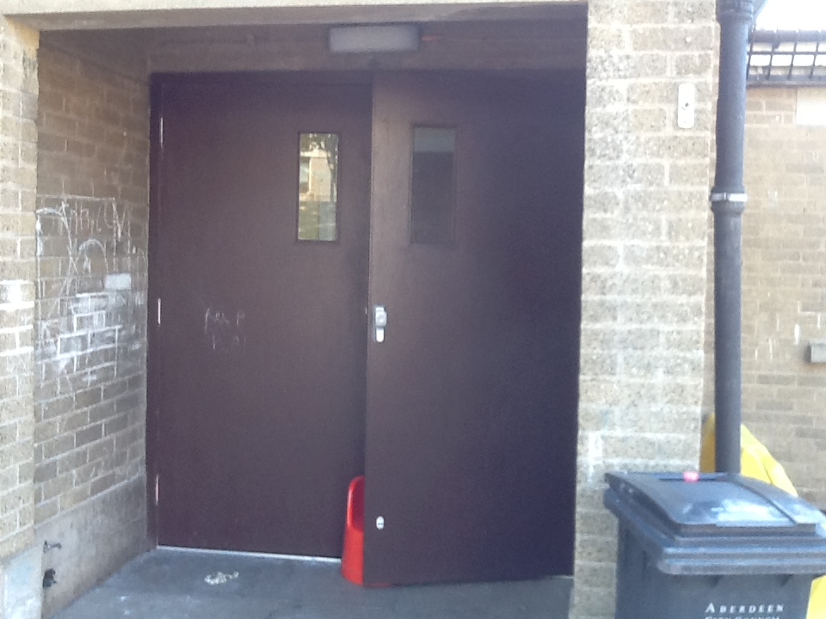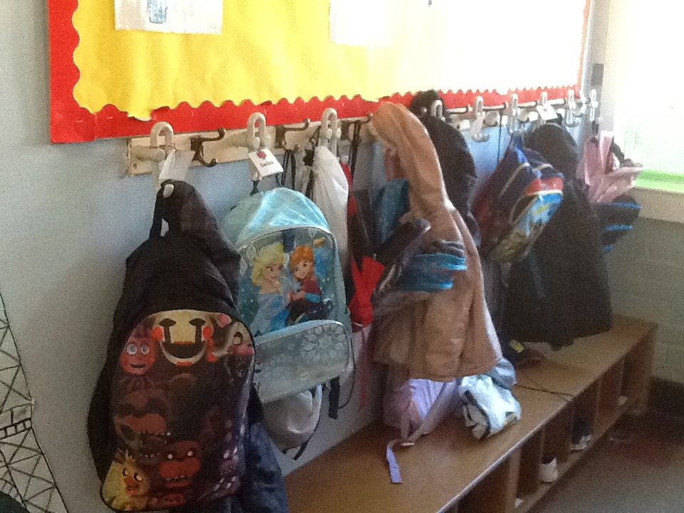

Then I will hang up my coat and put on my indoor shoes at the pegs. We will all wash our hands.
I will be with my new teacher in my classroom. I will play and learn and have fun.
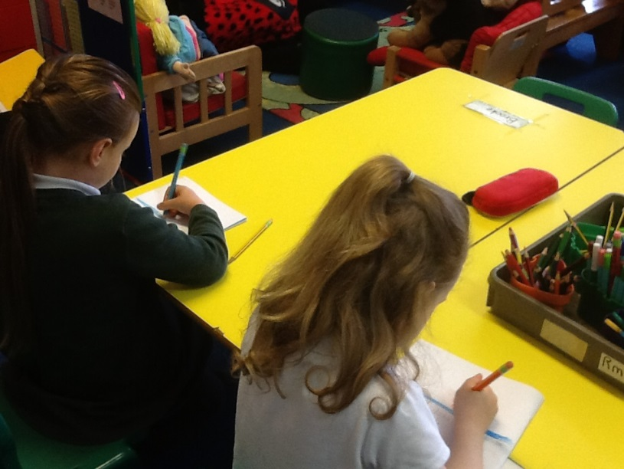
My teacher will tell me the rules about being in school and how to stay safe.
There are other places I might go to in school:
The Enhanced Learning Room
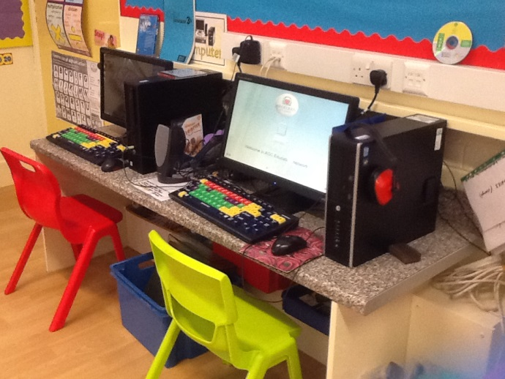

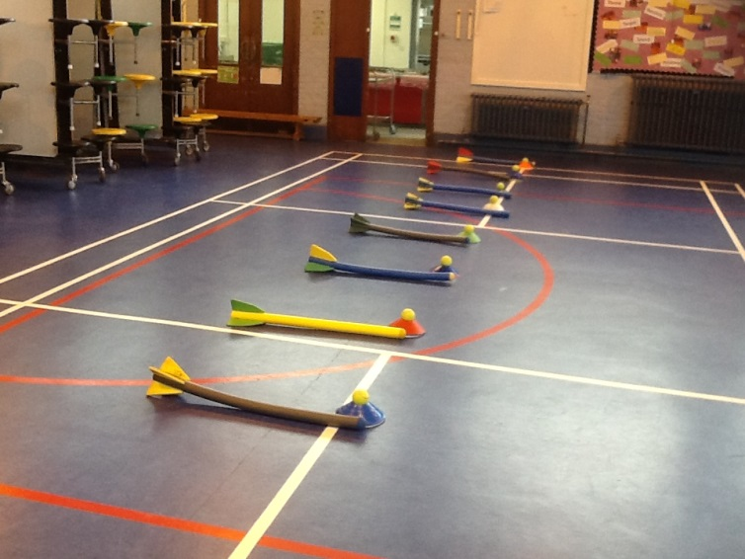

The gym hall

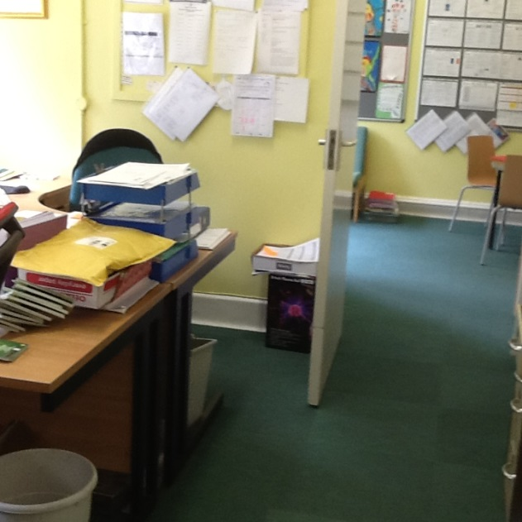

The office

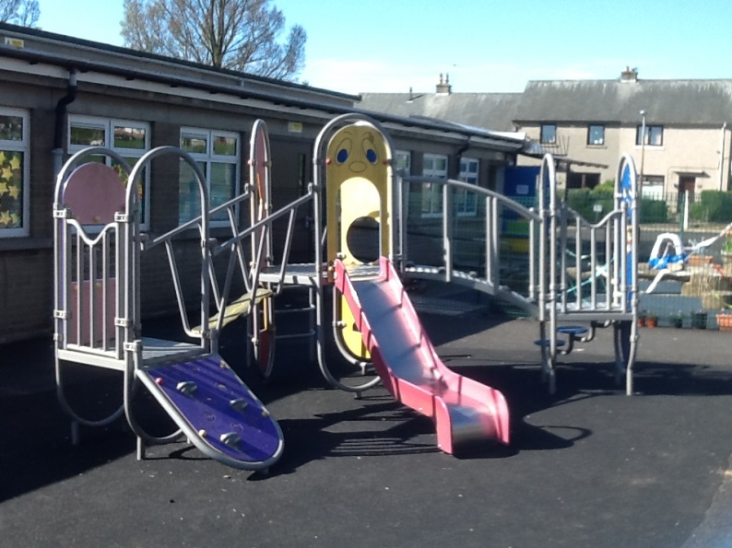
At break time and after lunch I will go outside and play in the playground. I might not get on the equipment for now but I will get other things to play with.

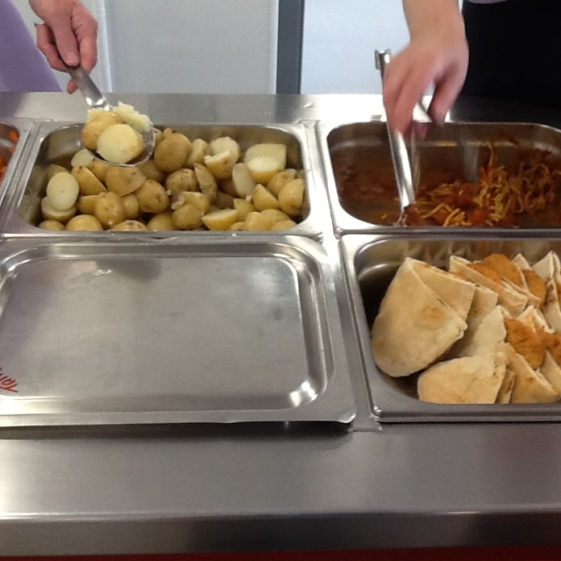
Sometimes, at lunchtime everyone has their food in the lunch hall. I might have a school lunch.
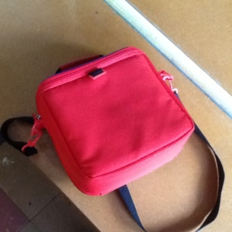
But for now I will have a packed lunch.

I will make lots of new friends at Cornhill Primary School and enjoy learning and playing.
