09.00-10.00 am | Exercise Time | 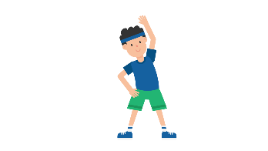 | Try Joe Wicks Daily P.E lessons. He will upload at 9am every day.  https://www.youtube.com/channel/UCAxW1XT0iEJo0TYlRfn6rYQ
10.00-11.00 am | Academic Time |  | Choose a Numeracy task from the school closure grid to complete in your red jotter or your own paper at home.
11.00am-12.00 pm | Creative Time |  | Choose a LAC task from the school closure grid to complete in your red jotter or your own paper at home. Note that some activities will not need paper.
12.00-01.00 pm | Lunch/Relax |  | Enjoy! It’s Lunch time!!!
01.00-01.30 pm | Exercise Time | 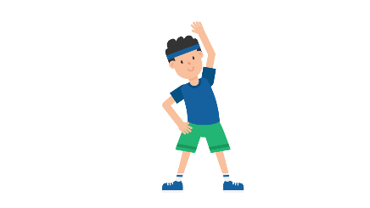 | Try out some dance moves from Go Noodle  https://family.gonoodle.com/
01.30-3.00 pm | Academic Time |  | Choose a Literacy task from the school closure grid to complete in your red jotter or your own paper at home.

The above schedule is only a suggestion for how you could structure your day. Try your best to complete a Literacy and Numeracy task every day but most importantly remember to take time to relax, chill and catch up with your friends and family via technology!

