Cornhill Playing Card Fitness P5-7

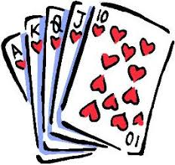
Ace – 15 Squat Jumps
King –9 Burpees
Queen – 20 Line jumps
Jack – 12 Russian Twists
Joker – choose an exercise
10 – 12 Jump Lunges
9 – 14 Arm curls (with tin of beans)
8 – Plank for 30 seconds
7 – 10 Press ups
6 – 16 Mountain climbers
5 – 12 Chair Tricep Dips
4 – 20 Leg Raises
3 - Wall squat for 30 seconds
2 – 10 Sit ups

