Cornhill Playing Card Fitness (P1-4)

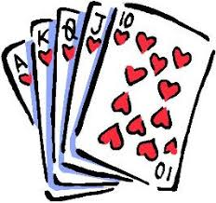
Ace – 20 Star jumps
King – 8 Burpees
Queen – 20 Line jumps
Jack – 15 Spotty dogs
Joker – choose any exercise
10 – 10 Lunges
9 – 12 Arm curls (with tin of beans)
8 – Plank for 30 seconds
7 – 5 Press ups
6 –10 Mountain climbers
5 –4 Chair Tricep Dips
4 – 8 Leg Raises
3 - Wall squat for 30 seconds
2 – Jog up and down the living room x4

