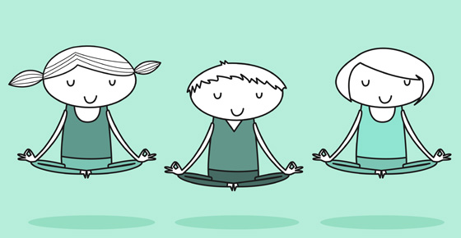

Hello Primary 7s!
We will be assigning work via the Blog/Google Classroom on Monday and this will be in the form of a sheet of activities for you to choose from and work through in the two weeks left till the Easter holidays.
However, the first few days are a time to prioritise your own well-being (and those of your loved ones around you). Be flexible with it, get fresh air when you can (and safely) and email us whenever you need someone to chat to, or ask questions (we are asked to keep to the 9-3pm hours but we’ll respond as soon as we’re able to).
This is a new and unknown experience but we can get through it together, as much as possible. If you haven’t already logged onto Google classroom, please use your login card you took home and leave a comment to show you have managed.

Look after yourselves,
Miss Drever and Mrs Mowat

