Design a Chinese Dragon using  odds and ends from home.  Sign:  Date: | Play the following maths game:  https://www.topmarks.co.uk/maths-games/hit-the-button  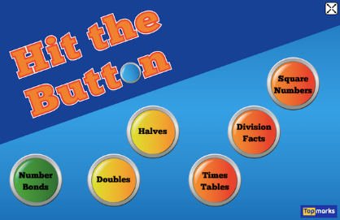  Sign:  Date: | Design a game/activity that you think a Primary 1 pupil would be able to play to help them in an area of their learning. For example, it could be a Literacy game to help with their phonics, a Numeracy game to help them with their numbers or a Health and Wellbeing game to help them with their emotions.  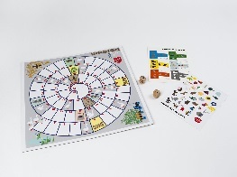  Sign:  Date:
Use the following link to help your write a short story:  http://www.scholastic.com/teachers/story-starters/  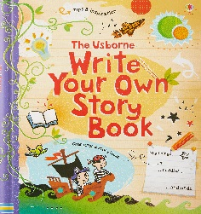  Sign:  Date: | Prepare a dish from a recipe book. Write all the ingredients down and if you have camera take a picture of the finished dish.  Sign:  Date: | Collect natural materials from a local area to create a birdhouse.  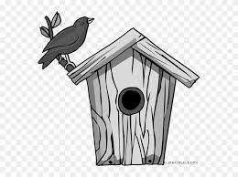  Sign:  Date:
Record as many different species of bird you see in your garden or local area.  Sign:  Date: | Transform a fictional book character into a hand puppet.  Sign:  Date: | Play a game of cards with a family member or friend. Record the score in your homework jotter.  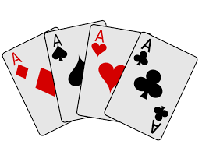  Sign:  Date:
P6 Homework Term 3 - Grid Options

For additional homework in Maths and Literacy please look for suggested website links on the school blog under homework.

