Term 3 Newsletter – P6 Room 8 & 9
Welcome Back!  We hope you enjoyed your December break and are feeling well rested!  Here are some of the things we  will be learning about this  term… | Numeracy  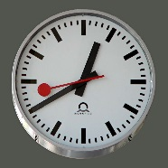  In Maths, we will be learning to use the language of probability to describe the likelihood of simple events occurring. We will also be learning to calculate durations of activities and events as well as selecting most appropriate unit of time for a given task, and justify our choice.  In addition, we learn to calculate simple fractions of a quantity and calculate simple percentages, and use this knowledge to solve problems in everyday contexts. | Literacy  In Literacy, we will be focusing on using creative and interesting vocabulary in our writing to engage a reader. In reading, we will be learning to read with fluency, understanding and expression as well as explain our preferences for particular texts and authors with supporting detail. Furthermore, we are going to learn to identify the purpose of spoken texts with suitable explanation and apply a variety of verbal and non-verbal techniques in oral presentations. We will also continue to practise tricky and common words using different spelling strategies.
Topic  This term the Primary 6’s topic will be ‘Theatre and Film’. We will be creating and performing different roles, experimenting with movement, expression and voice. We will also be creating our own scripts and presenting them to the class. We will be busy creating images and objects which show our awareness and recognition of detail as well as using a variety of media to create interesting images. | French  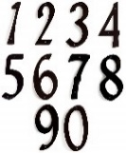  In French we will learn different vocabulary for a range of animals. We will also continue to further our knowledge and skills of counting to 80 in French through songs and fun activities. | Health and Well-being  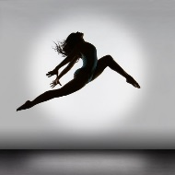  This term we will continue to have PE with Mrs Paul-Bird in which the focus will be Fitness and Dance. P6 also have the chance to play football with RAD’s coaches on a Friday break and lunchtime. There will also be additional, whole class RADS session on Friday so please ensure your child has his/her PE kit.
Music  We will continue to have weekly lessons from Mrs Constable. Children will continue to have the opportunity to take part in the P6/7 choir and we are very excited for the choir to take part in the Glee competition. | Reminders  Thursday – PE Mrs Paul-Bird. (bring gym kit).  Friday- RADS (whole class session)  Please remember to bring in your indoor shoes to school.  Make sure your child wears correct uniform. No hoodies are allowed to be worn in school.

