Dear Parent/Guardian,

Welcome back and a Happy New Year! We hope everyone enjoyed their holidays.
We will be continually revisiting the attributes of a Cornhill learner; respectful, focused, resilient, self-motivated and inquisitive. Expect to continue to see this language being used on yellow slips and encourage your child to talk about these words at home.
Reading  This term we will be using non-fiction books to find new information. We will be learning to take notes from a variety of sources. Home readers will continue to be sent home along with your child’s reading book for that week. Please make sure you are signing the reading record each week.  Writing  This term we will be focusing on creating our own fact files about Ancient Egyptian life. We will be thinking about layout, presentation and interesting information. We have begun looking at proper nouns and how to use these correctly in our writing. We will be continuing to apply our new phonics sounds to our work. |  | Maths  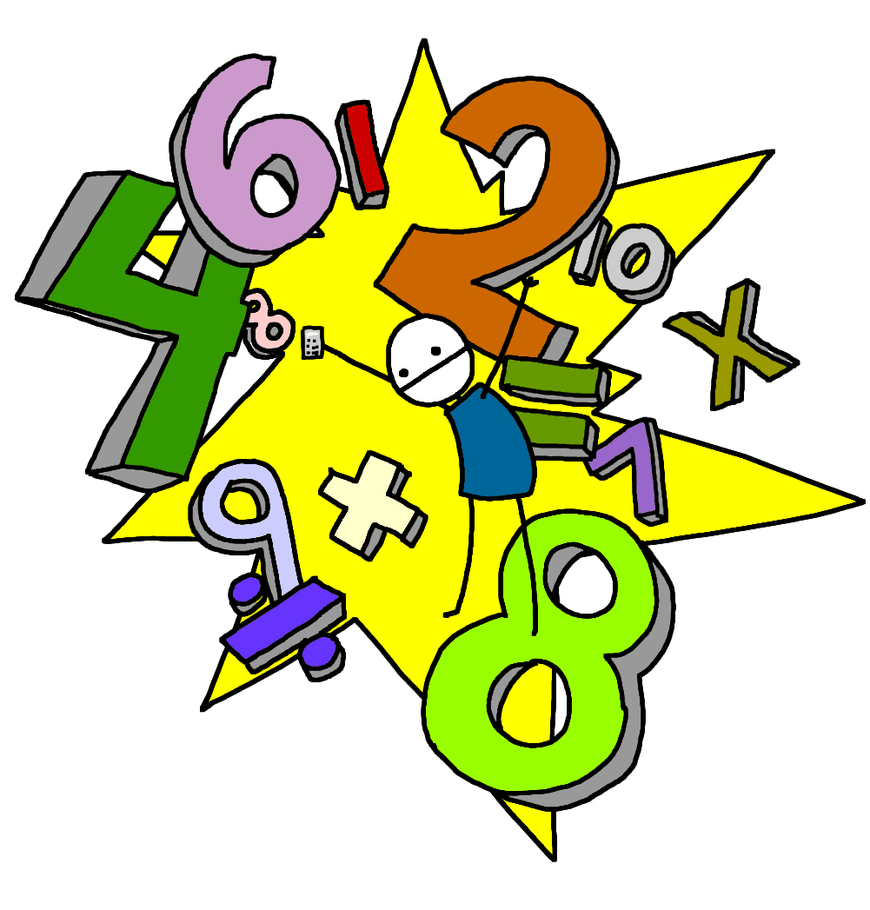  In Maths, we will be starting to learn multiplication and division. We will start by learning our 2, 5 and 10 times tables. Remember the x sign means making equal groups.  e.g. 2 x 5 = 10  2 groups of 5 = 10 altogether  Please practise these at home!!  We will be investigating and naming 2D and 3D shapes. Remember to keep looking for these shapes in the real world.
Topic – Ancient Egypt  We have already started asking questions about Ancient Egypt and are very excited to learn more about this civilisation. We will be comparing life in Ancient Egypt with our own experiences. The Literacy focus of our learning will be exploring artefacts, researching and organising information to suit the audience. We will be creating art and dance based around this topic. |  | Health and Wellbeing  This term Mrs Paul-Bird will be focusing on health and fitness in her P.E lessons. In class, we will be exploring a range of mindfulness and coping strategies which we can use when we find things difficult. Encourage your child to share these with you at home.  Please make sure your child has a suitable gym kit in school. Just a reminder that Aberdeen City Council policy is to have no jewellery worn during P.E. If your child has their ears pierced, please teach them how to remove their earrings as early as possible so as not to disrupt their learning.
Key Things to Remember
Monday P.E with Mrs Paul-Bird  Wednesday  Assembly  Homework Due In  Mrs Massie  Friday Homework Out  Golden Time | Uniform  Please make sure suitable school uniform is always worn to school. Hoodies are not permitted in classrooms so please ensure they have a school jumper.  Your child should have indoor shoes which they can change in to when they get to school. Please check with your child if their shoes still fit.  Now that it is getting much colder and wetter please make sure your child arrives to school with suitable outdoor clothing/footwear. |  | Golden Time  To make golden time a little bit more ‘golden’, we are looking for parental volunteers to run a golden time activity on a Friday afternoon from 2-2.30pm.  This could be a specialist hobby or talent you have, or as simple as playing some of our board games with a group of children.  If you are interested, please could you send in a note with your child or catch us at the end of the day.  Thank you in advance.
Parents Evening
Thu 30th Jan 6-8.30pm
OR
Tue 4th Feb 3.30-6pm

We look forward to seeing you all at the upcoming parents evenings at the end of January. If there are any queries before then please do not hesitate to get in touch with us.

Miss Louttit and Mrs Meen

