Term 2 Newsletter – P6 Room 8 & 9
Welcome Back!  We hope you had a lovely October break and are feeling well rested!  Here are some of the things we  will be learning about this  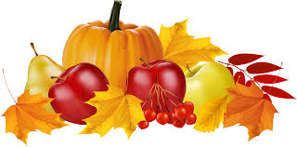  term… | Numeracy  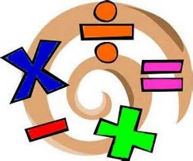  In Maths, we will be learning to multiply and divide whole numbers and decimal fractions (up to 2 decimal places) by 10, 100 and 1000. We will also be learning to use decimals in the context of money and continue to build up our knowledge of payment methods and budgeting. In addition, we learn to collect, organise, display and interpret information using bar graphs, tables and charts and line graphs | Literacy  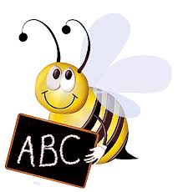  In Literacy, we will be learning to create interesting characters and settings through descriptive detail and figurative language. In reading, we will be learning to make comments on the writer’s style, use of language and other features appropriate to genre, with reference to the text. We will also continue to practise tricky and common words using different spelling strategies.
Topic  This term the Primary 6’s topic will be ‘Festivals and Celebrations Around the World’. We will discuss issues related to cultures, values and customs in our society and compare these to the culture and lifestyles of other countries. | French  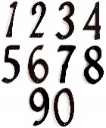  In French we will learn continue to recall numbers up to 79 and identify the numbers in their numeric and written form. We will use songs and games to build our knowledge further. | Health and Well-being  This term we will continue to have PE with Mrs Paul-Bird in which the focus will be Gymnastics. P6 also have the chance to play football with RAD’s coaches on a Friday break and lunchtime.
Music  We will continue to have weekly lessons from Mrs Constable. Children will continue to have the opportunity to take part in the P6/7 choir and we are very excited for the choir to take part in the Evening Express Christmas Carol concert. | Reminders  Thursday – PE Mrs Paul-Bird. (bring gym kit).  Bible Exhibition- 12th November  In-service days- 21st and 22nd November  P6 Assembly- Wednesday 4th December (More info to be given nearer the time)  Please remember to bring in your indoor shoes to school.  Make sure your child wears correct uniform. No hoodies are allowed to be worn in school.

