Issue 2: May/June 2019
The News FLASH
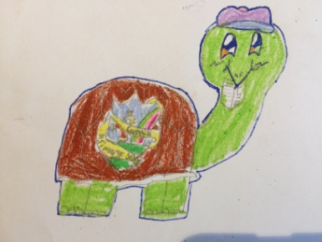

School news and much more.

Welcome Back!
It’s the second edition of News Flash, your school newspaper. We hope you enjoy it even more than the first issue.
A massive thank you to everyone who gave us feedback on our newspaper. We have looked at the results from the suggestion box and we will do our best to improve the news.
Suggestions Box
Your feedback is greatly appreciated. Please feel free to share your ideas and leave your feedback on how to improve our newspaper in the post box located on the table. Thank you.

The Primary 3 girls have organised the ‘Kids Club’ for Primary 1 and 2 classes this term. They prepared different activities for the younger pupils to enjoy during Break Time. Here is what they have said about it:
“It all started when the Primary 6 started doing Fun Club for the ‘big end’ and then the Primary 3 wanted to do something like that down the ‘little end’ too. We made it up and called it the Kids Club. We make sure the little ones have their snack, play games and we give them stickers.” – Eilidh (P3)
What is it like to help out at the Kids Club? “It’s really good, sometimes not many kids want to play with us but it’s still fun”. – Zuzanna
What’s your favourite part of being a part of the Kids Club? “We get to see our younger siblings. It’s also good to see all the kids happy”.
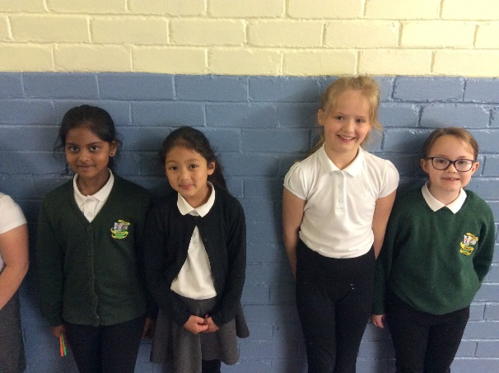
Which games are your favourite? “Sardines and playing with the Obstacle Course because we help them playing”. We also play Hot Chocolate and stuff like that.
By Amy, Rut
and Leyland (P7)

Fact 1: The American flag was designed by a high school pupil.
Fact 2: Snakes can help predict earth quakes.
Fact 3: The Twitter bird is called Larry.
Fact 4: Nutella was invented in WW2.
By Ryan P7 and Amy P7

What do we know about staying safe online and cyber dangers?
- Don’t talk to strangers.
- Don’t send pictures of yourself to strangers.
- Don’t tell strangers where you live.
- Don’t call a stranger.
- You should only talk to/play with people you really know.

What could happen if we are not following the rules?
- Strangers can find you if you are not careful.
- People can take away your money if you give away your credit card number.
- Some people may call you names.
- Only ‘friend’ the people you know.
- Don’t open any unknown files, photos and messages.
We have asked some Primary 3 pupils what they know about cyber safety and here is what they have said:
“Don’t play games with strangers”
“You don’t give your address to people you don’t know”
“You should ignore people you don’t know in a game”
“If someone asks you to send them your pictures, you say No”

By Rut and Leyland (P7)

At Cornhill Primary School we want everyone to be able to communicate with each other. One way of doing it is through using Makaton. Makaton language uses signs and symbols to help people communicate. Makaton promotes inclusivity with those who pupils who struggle to use spoken language.
By Lexi, Katie, Robert and Freya (P4)
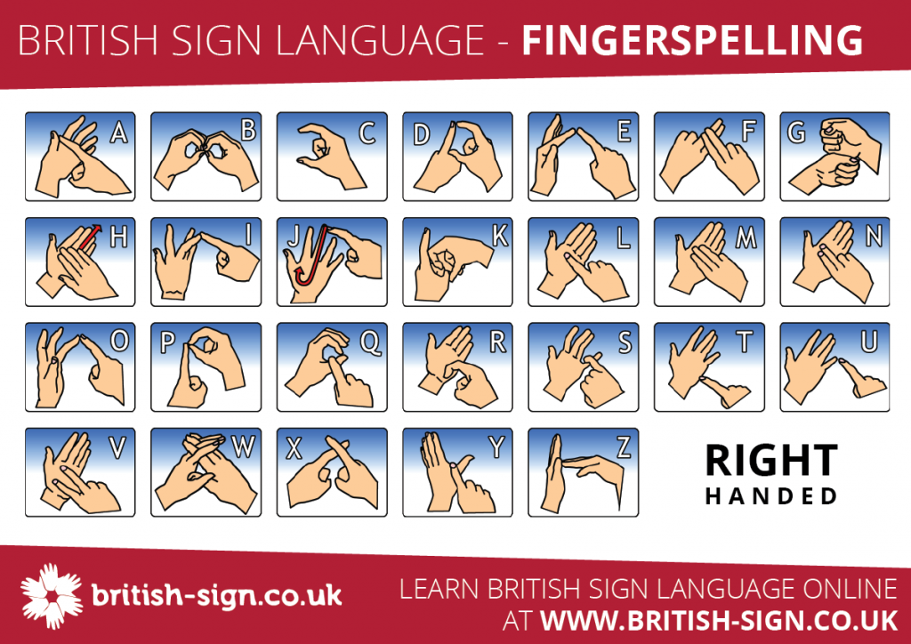
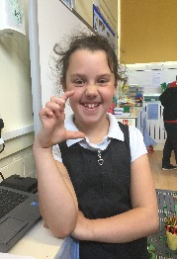
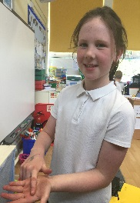
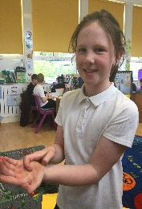
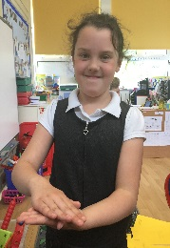
Can you guess the word we have spelled using Makaton language?

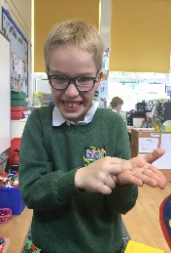
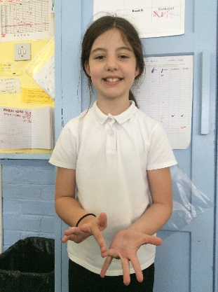
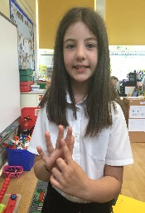

Danny the Champion of the World Book - Review by Isaac (P5)
The book was first published in 1975 and was written by Roald Dahl. ‘Danny the Champion of the World’ is the story of a young boy who lives in a gipsy caravan in the English countryside with his pheasant-catching father. I give it 9 out of 10 points.
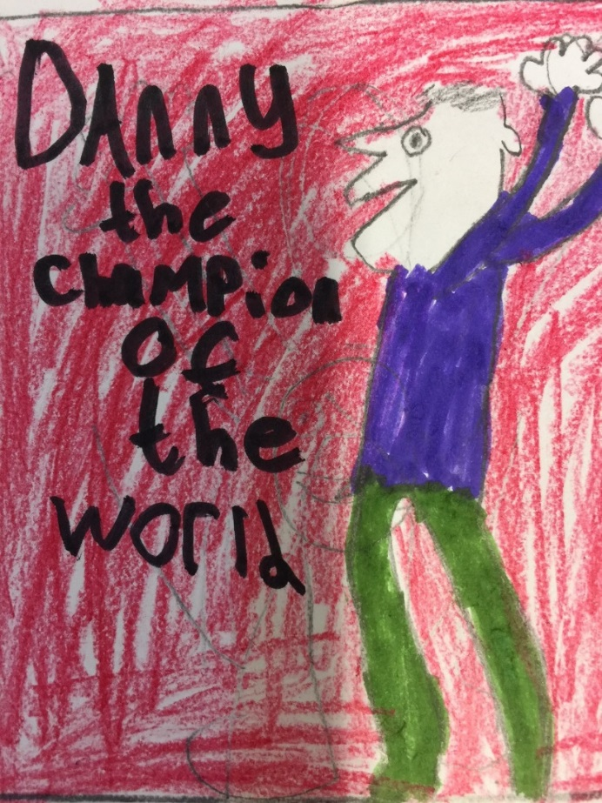
Let us know if you’ve read any interesting books. Write a book review of YOUR favourite book and we will publish it in the next edition of The News FLASH!
We have asked the school staff to tell us something interesting about them. We thought it is a good idea to share it with the readers of the News Flash. Can you guess which teacher we are talking about?
(You can find the answers on the last page of the issue)
- I have auditioned for the X-Factor when I was 16 years old.
- I play a saxophone.
- I have performed on stage at HMT in two shows.
- I used to put silver spray in my hair at secondary school.
- I have climbed Scotland (and Britain’s) highest mountain.
- I have performed ‘Lord of the Dance’ (Irish dancing) when I was at primary school.
- I love cheese and I have a dog named Oscar.
- I was born in London.
- My favourite animal is a horse. I had one called Cameron.
- I went to Sri Lanka on holiday.
- My favourite things are cats and books.
- I was in a rowing club when I was at secondary school.
- I’m an opera singer.
- My favourite colour is purple.
- I have been skydiving.
- I have milked a cow.
- I have lived in Singapore, Dubai and Mascot of Oman.
- I was born in Newcastle.
- I am going to climb Ben Nevis in Summer.
- I was a cub Scout Leader.
- I have worked in Russia and Spain.
- When I was a child, I sang on the Northsound 2 radio.
- I have bench-pressed 72.5 kg.
By Lewis and Kacper P6

How do you feel about going to academy?
Amy D – “I feel nervous but excited” Ryan Simpson – “I feel fine about it”
Rut – “I am a bit scared and worried” Leyland – “I feel good”
Sarah – “I feel nervous” Charlie – “I am happy about it”
Cali- “It feels alright” Steven – “I feel fine but I’m not excited about going”

What are you excited about?
Ryan Simpson – “Subjects are different”
Amy Dunlop – “I am going to learn more”
Rut – “Meeting new friends” Leyland – “Food and PE”
Sarah – “Chemistry” Steven – “Football”
By Phoebe and Cohen P5

The word ‘tax’ is from Latin ‘taxo’ and it means ‘I estimate’.
Roman emperor Vespasian placed a tax on urine in the 1st century. Urine at that time was collected and used as a source of ammonia for tanning laundering garments.

By Kacper (P5)

Interview with Mrs Jayne Addison – school administrator
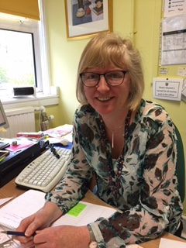

- Do you like working at Cornhill Primary School?
A: Yes I do. I enjoy working here.
- Why do you enjoy your job?
A: I like getting to know all the boys and girls, and the parents. It’s a nice and friendly place to work.
- How long have you been working here for?
A: 8 and a half years.
- What do you like the most about the staff and the teachers?
A: I like them because they are all very friendly and helpful.
- Can you tell us something about yourself?
A: I like Italian food and my favourite animals are cats and dogs.
- What do you like doing in your spare time?
A: I like going on nice long walks within the country.
Interview with Ms Leona McCook – Senior Early Years Practitioner.
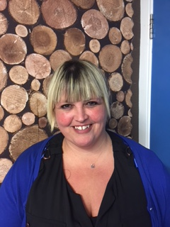
- Do you like working here?
A: Yes, I love it. It’s my favourite place to work.
- Do you enjoy your job and why?
A: I really enjoy it because I look after the boys and girls and they make us laugh, they are funny.
- How long have you been here for?
A: Over 9 years.
- What do you like most about the staff and the teachers of Cornhill?
A: They are nice, friendly and if I need any help, they are very good at sharing things with me.
- Do you have anything to say that most teachers don’t know about yourself?
A: I love my car and I love driving my car. I also enjoy swimming.

By Freya and Robert (P4)

For the past couple of weeks Cornhill Primary School’s IDL topic has been Inspirational Women.
On Thursday 23rd May pupils of Cornhill Primary School invited their families to share their work and learning. The pupils of Primary 3 up to Primary 7 could show their families their hard work and different craft projects of Inspirational Women. The families could find out which women inspire us and why we think it is important to celebrate their achievements.
Activities galore!
Throughout the last 5 weeks, different classes have been doing different activities about inspirational women. Children have loved it!
Pupils work!
Different classes have been doing different inspirational women related activities. For example, Primary 6 were learning about Jessica Ennis and Beatrix Potter. Primary 3 classes were learning about Ellie Simmonds and her achievements.
Inspiring!
We also had a chance to have a few special guests visiting our school such as Kelsey Stewart the athlete and Kristen Fraser the Commonwealth Boxing Champion. Our guests proved that no matter what gender you are, you can do the job you love and break the stereotypes. Women can be inspirational by doing things like being sporty, being a huge part of history or being famous!
By Lewis P6
“Nicola Adams is inspirational to me because I like boxing. It is important to talk about inspirational women because a long time ago women didn’t get the right to vote” by Cohen P5
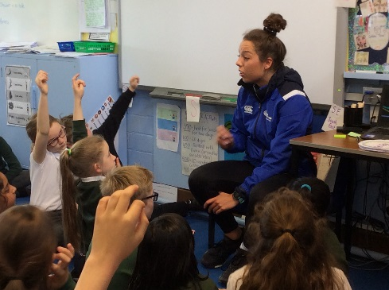
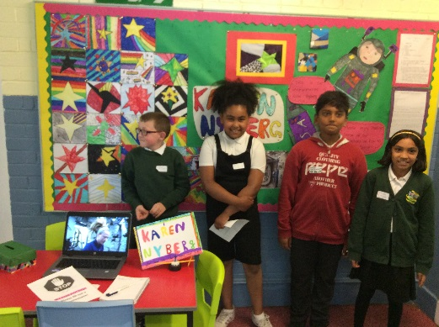
“I have chosen Karen Nyberg as she works in space and she posts heaps of You Tube videos. She has posts about how you wash your hair in space and how to make quilts. My class has loved learning about Karen Nyberg” by Phoebe P5
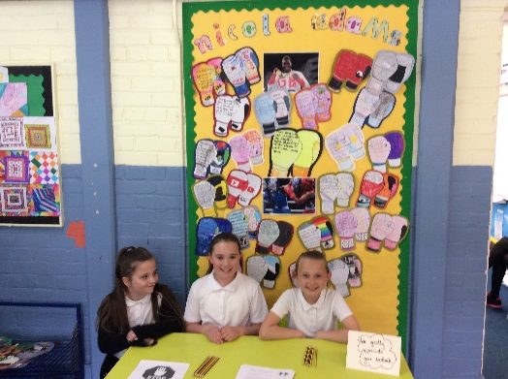
“Beatrix Potter is inspirational to me because she wrote Peter Rabbit and Peter Rabbit is such a big thing. There has been books, TV shows and even movies about it. I was amazing she could put together such an amazing thing” by Lewis P6

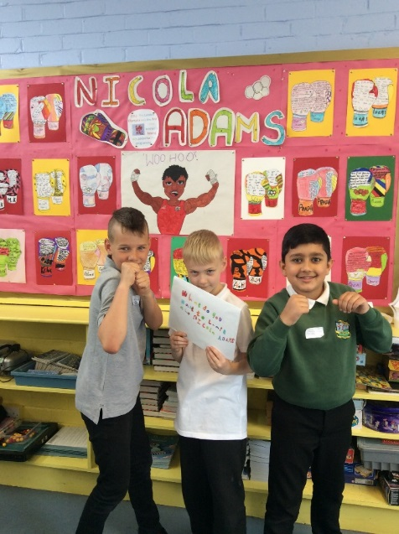
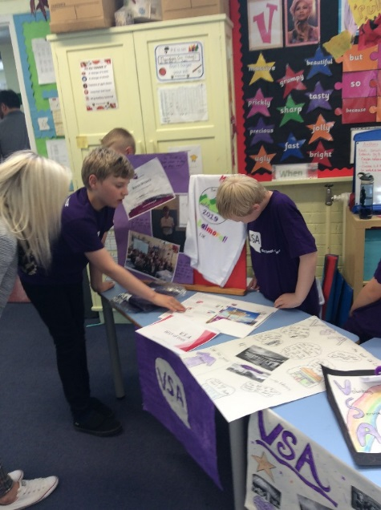
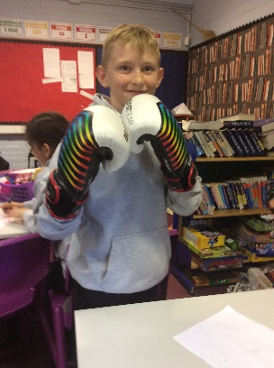

Dear Readers,
In this section we are looking at our favourite subjects. We have asked Cornhill Pupils to tell us about their favourite subjects. These are the results of our survey across the whole school.
Phonics - 9 | Reading - 7 | Writing - 24
Maths - 24 | Science - 87 | Art - 85
PE - 87 | RME - 2 | French - 3
Music - 9 | Listen & Talk - 0 | H&W - 1
Topic - 4 | History - 1 | Spelling - 1
ICT - 1

We are happy to announce that 345 pupils took part in our survey and the majority of the pupils voted SCIENCE, PE and ART as their favourite subjects!
Here is what they have said about the subjects they like:
“Science – I get to learn more about the world” – Leighton P3
“Science – I’m interested about it and it’s great to find facts”
“PE – I like the athletic things we do in PE” – Megan E P6
“Art – I like doing art a lot and it is something I am good at” – Tyler P6
“Art – It is fun!” – Harry T P1/2
“Science – because I enjoy finding out about new things like magnets”
“I like science because it’s more challenging and you get to try experiments” – Olivia P4
“Art, I like painting because I like creating pictures” – Katie A P4
“PE – It’s my most enjoyable subject” – H.M R18
“Art, because you can make a lot of money off of Art. If you want to explain how you feel but can’t say it, you could draw it” – Alfie P7
By Peter and Isaac P5

Summer is round the corner. Don’t let the heat get to you down. When you think ‘I’m bored!’ you can scan the list. Here are 10 summer activities to keep you active and energetic this Summer .

Go to the beach.

Water fight!!

Have a picnic outside.

Go on a bug hunt/ Scavenger hunt.

Go fly a kite.

Summer cleaning – go through all your old toys and clothes and organise a garage sale.

Get chalky – get some sidewalk chalk and try some street art.

Get active – ride a bike, play football or skateboard with your friends.

Day at the beach – collect pretty shells and pebbles.

Camping!

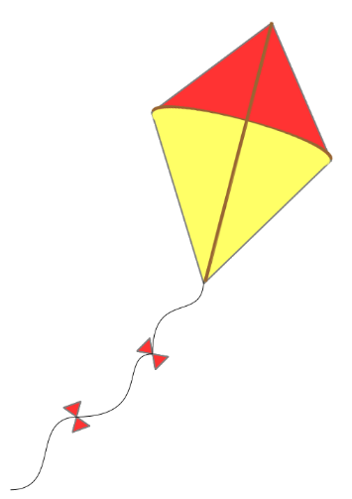
And what is your favourite thing to do in the Summer?

By Rylee and Nicole (P4)

Q: When do you go at red and stop at green?
A: When you are eating a watermelon!!

Q: What did the air conditioning unit say to its owner?
A: I’m your biggest fan!

Q: How did the bees get to school?
A: By school buzz!

Q: If I had 6 oranges in one hand and 7 apples in the other, what would I have?
A: Big hands!

Q: Where do sharks go on summer vacation?
A: Finland!

Q: Why is a baseball game a good place to go on a hot day?
A: Because there are lots of fans.

Answers to the ‘Guess Who..’ quiz.
- I have auditioned for the X-Factor when I was 16 years old. – Miss Adams
- I play a saxophone. – Miss McCook
- I have performed on stage at HMT in two shows – Miss Drever
- I used to put silver spray in my hair at secondary school – Mrs Fraser
- I have climbed Scotland’s highest mountain – Miss Steel
- I have performed Lord of the Dance (Irish dancing) when I was at Primary School –Miss Jackson
- I love cheese and I have a dog named Oscar – Mrs Constable
- I was born in London – Mrs Paul-Bird
- My favourite animal is a horse. I had one called Cameron – Mrs Carrington
- I went to Sri Lanka on holiday – Mrs S. Fraser
- My favourite things are cats and books – Miss Derounian
- I was in a rowing club when I was at secondary school – Mrs Krakowska
- I’m an opera singer – Miss Simpson
- My favourite colour is purple – Mrs Smith
- I have been skydiving – Mr Evans
- I have milked a cow – Mrs Ross
- I have lived in Singapore, Dubai and Mascot of Oman.-Mrs Middleton
- I was born in Newcastle – Mrs Mowat
- I am going to climb Ben Nevis in Summer – Mrs Meen
- I was a cub Scout Leader – Mrs Garlick
- I have worked in Russia and Spain – Miss Dingwall
- When I was a child, I sang on the Northsound 2 radio – Miss Rennie
- I have bench-pressed 72.5 kg – Mrs Bennett

