Welcome Back!  We hope you enjoyed the Easter holidays.  We have another busy term ahead which will include IDL Parents event, sports day and swimming. | Numeracy  In Maths we will be learning the 8 times table, developing our knowledge and understanding of data handling, multiplying and dividing by 10 and 100. We will also be using our problem solving skills to answer word problems. | Literacy  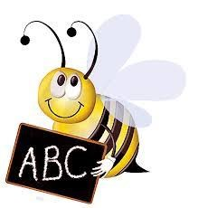  In Literacy we will be learning to use the phoneme ‘oi’ and ‘k’, along with a set list of common and tricky words. When reading we will be learning to summarise the main ideas and identify the features of language in a text.
Topic  This term the Primary 4’s topic will be ‘Inspirational Women’ as part of the school IDL. Each week will have a different focus such as women in the Arts, Sport, Local Heroes, Science and Engineering. We will also discuss how women got the vote and our own rights and responsibilities. | French  We will be learning how to ask someone where they live and if they have any brothers or sisters.  We will also learn how to respond to these questions. | Health and Wellbeing  This term we will continue to have PE with Mrs Paul-Bird in which the focus will be Orienteering. In addition we will be starting Swimming at Bucksburn Pool on Friday the 26th of April.
Music  Mrs Constable will continue to take weekly music lessons which will be related to our IDL topic. The primary 4/5 choir also continues to run on a Tuesday morning. Please remember to take your sheet music. | Reminders  Wednesday – PE with Mrs Paul-Bird (bring your gym kit)  Friday- Swimming kit | Important Dates!  Fri 19th April – Holiday  Mon 6th May – Holiday  Tues 7th May – In-Service Day – school closed to pupils  Thurs 23rd May – Parent’s Event for IDL  Friday 31st May - Sports Day

