Over the term, write a book review about 4 of your reading books. Complete one of the templates found in your Phonics Bag.  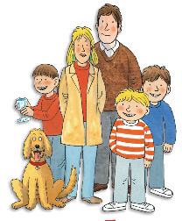 | Play this game at home: https://www.  arcademics.com/games/alien | Now it is the Summer term, try and enjoy the great outdoors!  Draw a picture of yourself having fun in the sun!
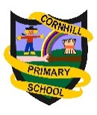Primary 1
Homework Wall
Term 4
2018
After Sports Day, write about your favourite activity. | As we are weighing and measuring in maths, with an adult, make a cake. Make sure to use scales! | Think about your class topic. Is there anything you could take into school to help us learn?

