Due  Wed 27th Feb 2019  Adult  signature  …………………. | Mathematics  Complete the maths sheet provided – remember to pick one up! | Literacy  Write these abbreviations in to your jotters and record what they mean.  Oct e.g.  1st Mr.  Mon kg  WW1 mm  P.E SSPCA  L.I BBC |  | Health and Wellbeing  We have recently done a workshop with NSPCC. Write out 5 facts about the charity and what they do. Bullet point these in your jotter and be prepared to share these with the class. | Wider World Achievements  Think of something you are proud of achieving since the start of the new year. What did it involve and where did it take place? If you have a photograph/certificate etc. that you would like to share with the school, bring that in with your homework.
Due  Wed 6th March 2019  Adult signature  …………………………… | Mathematics  Take turns to choose a decimal number on the board•  Write the number as a fraction.  For example, 9·7 = 9 $\frac{7}{10}$ = $\frac{97}{10}$  • Players check each other’s answers.  • If you are correct, cross out your number in your colour of pen  • Continue playing until someone has covered four connected numbers. | Literacy  Copy a paragraph from a book/article in to your jotter.  Underneath, paraphrase this in to your own words. Remember to think about changing vocabulary and the order of the ideas. |  | Topic  Design your own propaganda poster which could have been around in Britain in WW2.  Examples: to persuade men to join the army, for children to be evacuated, to reduce wasted food etc. | Topic  Make or draw a WW2 evacuee’s suitcase. This should include the items that evacuees would have packed which were essential.  Extra: If you were an evacuee today, what do you think you would pack?
Due  Wed 13th November 2019  Adult  signature  …………………………… | Mathematics  Complete the maths sheet provided – remember to pick one up! | Topic  Please bring in a photograph of yourself from nursery/primary 1. These will be used as part of your end of year work. You may find it easier to email a copy to the teacher:  EmHogg@aberdeencity.gov.uk  GMowat@aberdeencity.gov.uk |  | Health and Wellbeing  Health and Wellbeing  RADS have started to explore different muscle groups. What sports or activities do you do that strengthen one of your muscle groups? Explain which muscle group and why the activity strengthens it. | Health and Wellbeing  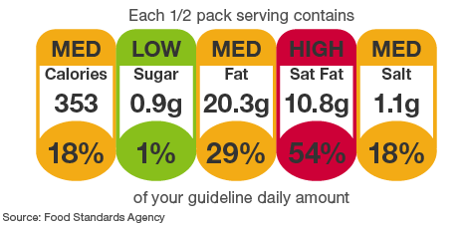  RADS have been teaching you about nutrition and the importance of a healthy diet. Pick 4 of your favourite packaged foods and find out how much sugar and saturated fat are in these. List these in your jotter. Which one is the highest?
Due  Wed 20th November 2019 | Topic  Think back to all your classes from Nursery to Primary 7.  List which teachers you had at each stage. If you attended a different primary school also record the school you went to. |  | Literacy  In class, we will be writing a scene for our leavers’ performance. Think back on your memories of primary school and record information about who, when and what happened in your memory. You might have more than one you want to write about.

