A very important part of your Primary 1 homework is to read over your Reading Books AND Word Walls. Please Remember to remind the adult listening to your reading, to sign your Reading Record. | Ask an adult to give you a number (up to 20) and see if you can tell them what is 1 more and 1 less. | In a good few weeks, can you spot any changes with the weather, plants, trees, etc.  Draw a picture to show your observations.  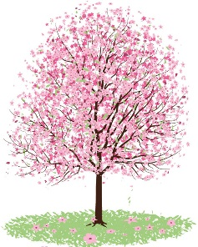
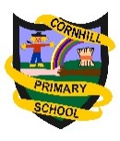 Primary 1
Homework Wall
Term 3
2019
Go to the Library and see if you can find any books about China. These could be factual or fictional. | Make a poster about how to be a good friend. Take this into school to show your class. | Teach someone at home how to say, hello, goodbye and how are you, in French.

